ACLC Lead Facilitator Report – David Hoopes
CLCS Board of Directors
April, 2016

Report Overview
- Graduation and Promotion Reminder
- Multicultural Night Program – April 29th
- Enrollment Presentation – 8th Grade Special presentation
- Washington D.C. Trip
- ACLC Carnival and celebration
- ACLC Science Fair Participation
- Suspension and Expulsion data

Spring is a busy time of year and ACLC in no different. There is a great deal happening in the next few months. WASC committee's, CCEF, PAC and events like ACLC Multicultural Art and Diversity Night are all ways for you to get involved. We would love to have your involvement.

I'd also like to invite you all to attend any of the committee meetings that happen monthly. They are always posted on the school website calendar.
http://www.clcschools.org/page.cfm?p=651

- Mark you Calendars:
  - ACLC High School Graduation - June 14 @ 2:00pm
  - ACLC 8th Grade Promotion - June 15th @ 6:00pm

Multicultural Night Festival
The Multicultural Night Festival is upcoming on Friday, April 29, 6:30-9:30 pm. This eagerly-anticipated evening of art, food, music, and dance is a free event for the whole family. We ask that every family bring a dish to share for our potluck--especially a dish that represents your family's culture or heritage! We also encourage learners and their families to come dressed in clothing or costumes that reflect your family's heritage. Our fun-filled night includes:

• Gallery of learner art
• Multicultural potluck dinner
• Fashion show featuring clothing from cultures around the globe
• Talent show and live music
• Face Painting and arts and crafts for kids of all ages
• Bevy tables hosted by ACLC's learner-led clubs
• Dunk tank
• Hinduism Project Board Game demos from our middle school social science classes

POTLUCK

TALENT SHOW

FASHION SHOW

8th Grade Enrollment Night
Two weeks ago the held a special information night for our eighth graders. The goal was for them to hear more from high school facilitators and learners about the special parts of our high school experience. The event was a packed room and a good deal of information was communicated.

Information Session Agenda
- Lead Facilitator will share how the ACLC model (A-G) aligns with college acceptance and electives
- Facilitators will talk to 8th grade learners and families about ACLC classes and honors courses.
- Leadership Learners will talk to 8th graders about opportunities to lead bevies/clubs and Leadership activities
- Learners will share off campus lunch at ACLC
- Learners will share the their experience taking college classes
- Learners will share their experience taking classes at other local high schools and how they handle additional project periods
- Learners will share their experience participating in sports at Alameda High School
- Lead Facilitator will share how the myth of AP.
- Lead facilitator will share ACLC learning opportunities beyond the classroom.
- Learners will share the Independent PE Program.
- Questions for the panel of facilitators and learners

ACLC's 8th Graders arrived in Washington DC and took the town by storm! Sight-seeing, learning about our nation's capitol, and camaraderie were all part of this trip. Thank you to our facilitator Daniel Cabrales for his leadership in organizing this trip. Over thirty of our learners went on the DC trip this year.
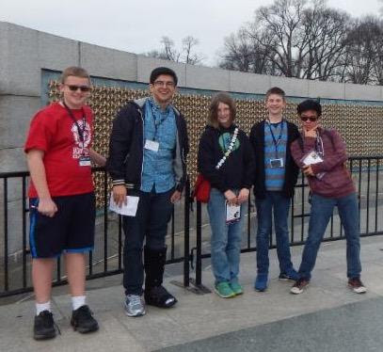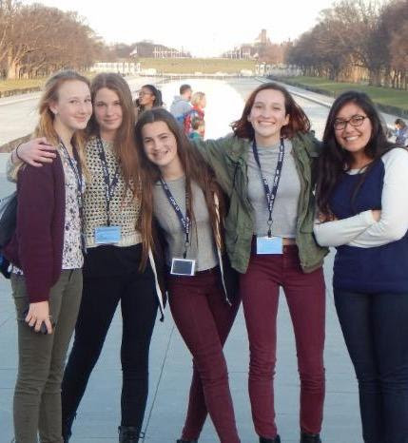

ACLC Science Fair
Congratulations to all of our learners for participating in the Alameda County Science and Engineering Fair. These learners qualified by being the best of the best at the ACLC Science Fair. We are very proud of all earners and facilitators for their hard work. Enjoy a few photos from the event.

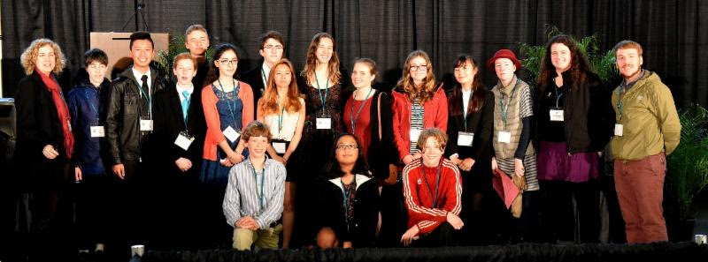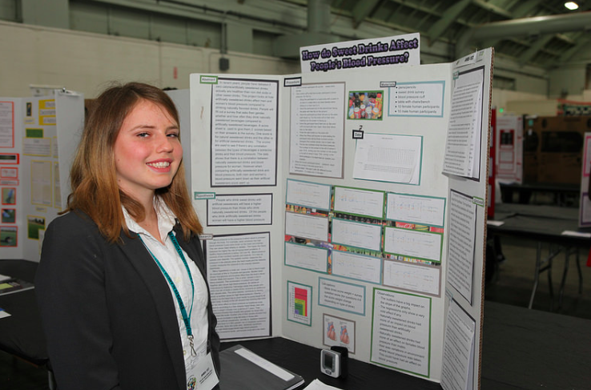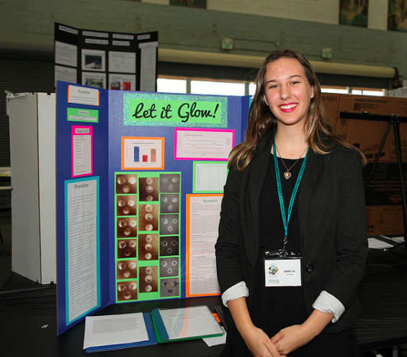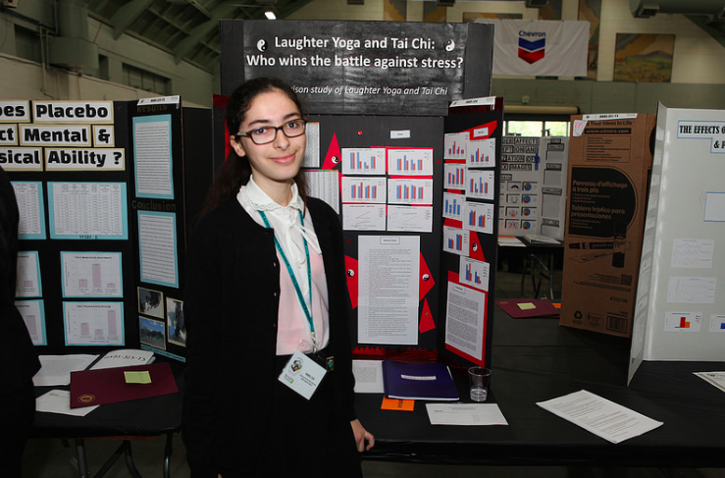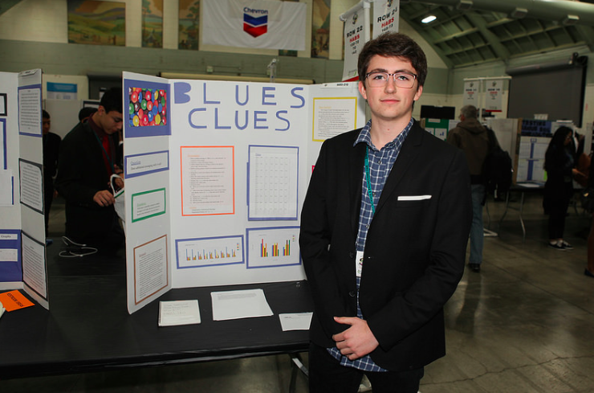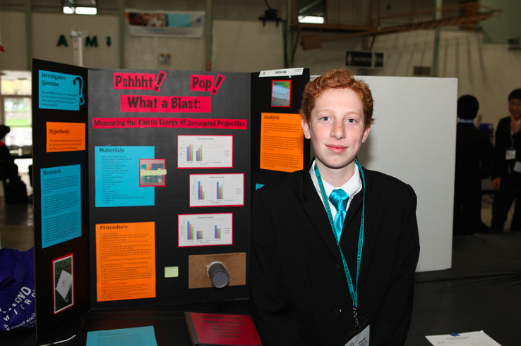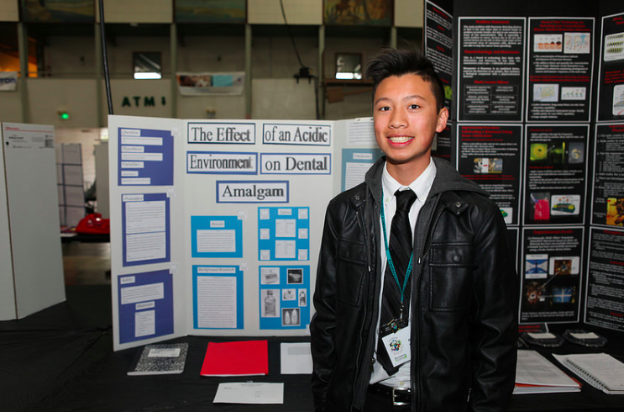

The ACLC Carnival
The junior class was out early on Saturday getting the carnival set up. They took their outside plan and made it work indoors for the rainy day. That included a petting zoo, mini golf, splash tank and much more.

Special appreciation goes to Jake Nations for his inspiration and coordination of the carnival. It was a lot of fun and the event went super smooth. Thanks to everybody who made it out to support CCEF and the 11th grade ACLC Carnival.

2016 Pi Contest - Lola Teeters takes the prize and sets a new record

After 6 years of Michelle Luo as our reigning champion, Lola Teeters has broken Michelle's record! Lola came in first place this year by reciting 333 digits of Pi!!!!!! Because Lola has broken Michelle's record of 260 digits of Pi, the Pi contest will now be called the Lola Teeters Pi contest!
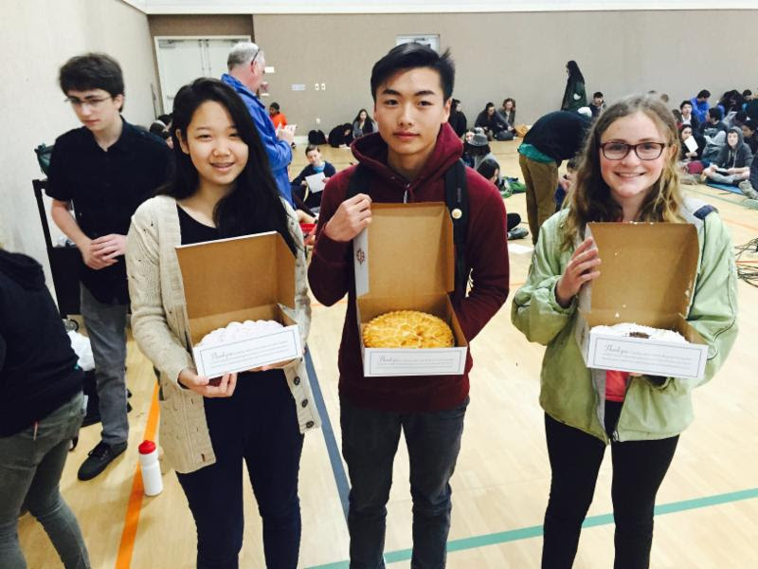
In second place was Windy Zhou(left) who recited 146 digits of Pi and Allen Zhai (center) came in 3rd period with his recitation of 61 digits of Pi. Lola (right) recited 333 digits of Pi.

ACLC February Suspensions and Expulsions
 | November 2015 | December 2015 | January 2016 | February 2016 | March 2016
Expulsions | Zero | Zero | Zero | Zero | Zero
Suspensions by grade level | 6th  7th  8th  9th  10th 3  11th  12th | 6th  7th  8th  9th 1  10th  11th  12th | 6th  7th 1  8th  9th  10th 1  11th  12th | 6th  7th 2  8th  9th  10th 1  11th 2  12th | 6th  7th  8th  9th 1  10th 2  11th  12th 3
Year Total Suspensions:
Year Total Expulsions: Zero
ACLC IEP and 504 update
 | January 2015 | Pending
504’s | 39 | 0
IEP’s | 33 | 1

