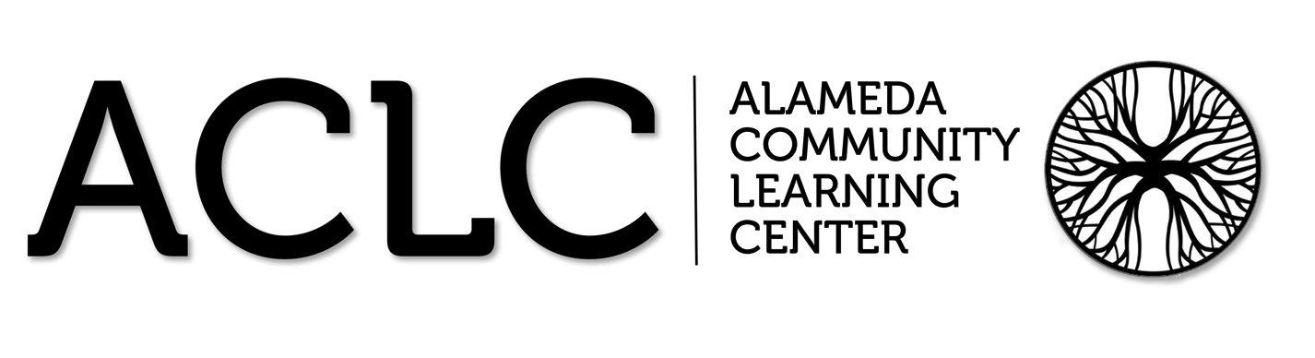

ACLC Lead Facilitator Report – David Hoopes
ACLC Board of Directors’ Planning and Organizational Meeting
April 18th, 2013

Summary of Report:

- Graduation Rates State, County and ACLC Data
- CST on the Horizon –It really matters
- WASC Mid Term Visit update -March 26th visit
- Multi-Cultural night @ ACLC
- Facilities Update –Slides
- Robotics @ ACLC
- CCEF Funding
  - Culinary Arts and Ultimate Frisbee get funded

Graduation Rates State, County and ACLC Data
The state released the 2012 graduation rates. ACLC ‘s graduation rate for last year is 86%. Broken down by ethnicity we see a spike in the drop out rate of Latino learners. It should be noted that the number of Latino learners was one out of five learners. Both state and county graduation rates are lower that ACLC’s.
School Results for Alameda Community Learning
ACLC Direct-Funded Charter School
CDS | Name | Cohort Students | Cohort Graduates | Cohort Graduation Rate | Cohort Dropouts | Cohort Dropouts Rate
01611190130609 | Alameda Community Learning Center | 38 | 33 | 86.8 | * | 13.2

ACLC Race / Ethnicty Results
Race/Ethnicity | Cohort Students | Cohort Graduates | Cohort Graduation Rate | Cohort Dropouts | Cohort Dropouts Rate | Cohort GED Completer Rate
Hispanic or Latino of Any Race | * | * | 77.8 | * | 22.2 | 0.0
Asian, Not Hispanic | * | * | 85.7 | * | 14.3 | 0.0
Filipino, Not Hispanic | * | * | 100.0 | * | 0.0 | 0.0
African American, Not Hispanic | * | * | 100.0 | * | 0.0 | 0.0
White, Not Hispanic | 16 | 14 | 87.5 | * | 12.5 | 0.0

ACLC - Direct-Funded Charter School
Program Name | Cohort Students | Cohort Graduates | Cohort Graduation Rate | Cohort Dropouts | Cohort Dropouts Rate
English Learners | * | * | 75.0 | * | 25.0
Special Education | 13 | 11 | 84.6 | * | 15.4
Socioeconomically Disadvantaged | * | * | 88.9 | * | 11.1
All Students | 38 | 33 | 86.8 | * | 13.2

Countywide Results for Alameda County
CDS | Name | Cohort Students | Cohort Graduates | Cohort Graduation Rate | Cohort Dropouts | Cohort Dropouts Rate | Cohort GED Completer Rate
01 | Alameda | 17,154 | 13,616 | 79.4 | 2,302 | 13.4 | 0.2

Statewide Results
CDS | Name | Cohort Students | Cohort Graduates | Cohort Graduation Rate | Cohort Dropouts | Cohort Dropouts Rate | Cohort Special Ed Completers
N/A | Statewide | 502,856 | 394,648 | 78.5 | 66,523 | 13.2 | 2,777

CST is on the way
CST tests will be administered at ACLC starting April 30th. I’d like to make sure the board is supportive of our schools initiative to have a great showing that week. ACLC learners go to college more than most other AUSD schools. We also want our test scores to reflect that we are a great school. We currently have an API of 827. Our goal this year is to increase our schools API to 850. We have adopted the number 23 (Michael Jordan's number) to rally around.

We are proud to say that we don't teach to standardized tests at ACLC. However, we are extremely proud to know that when standardized tests are given, we have done well. In fact, it's our strong test scores that give us the flexibility to engage in projects and deeper learning. Furthermore, standardized testing is something all learners will encounter for the rest of their lives. It's important to take it seriously so that that learn to do well on tests. The SAT, which they take to apply to college, serves as a gatekeeper to many colleges . Other examples are in Business, Teaching, Law, Medicine, Nursing SAT, CSET, CBEST, GRE, GMAT, MSAT, LSAT...
WASC Mid Term visit March 26th
Alameda Community Learning Center had our midterm visit the week prior to break. In 2010 Alameda Community Learning Center was awarded a six-year accreditation. The accreditation came with a one-time follow-up in year three of the term. They were very complimentary of ACLC and its learners and parents. They identified that progress was made towards our goals in many areas.
The committee complimented our progress in the following areas
- Project Based Learning
- Supporting learners who are struggling with programs like MAS
- Completion of our charter petition and Independent Charter
- Increased enrollment to achieve financial stability
- Improved school culture
- High expectations across the school
The committee stressed that we update our data tools to include both specific and holistic measures of learning.
- WASC requires us to improve how we measure student learning via bencmarks throughout the year
- WASC requires us to improve our capacity and willingness to use data systems
- WASC requires us to act on two of our goals that have been overlooked. Identifying and supporting traditionally undersearved learners and creating benchmarks across the curriculum

CCEF Funds support Ultimate Frisbee and Culinary Arts

- At this months CCEF meeting, the board voted to fund two proposals. First, Dark Meet came to request tournament fees for two the remainder of the season. Also, Randy Covey and the Culinary Arts learns intend to create a Cook Book of their recipes this year. Both proposals were funded.

Facilities Update

It now seems certain that ACLC is moving to 420 Grand Street . The district provided its response to our counter proposal which amounts to their "final offer". The offer was for a shared campus at 420 Grand Street with Wood Middle School.

The newest version of the agreement included three additional classrooms for ACLC. The district team is looking at the potential of portables in order to provide those rooms which is great news.

As we move closer and closer to a resolution, folks are starting to ask how they can help make the transition successful. Currently, we plan to pack at ACLC starting the day after school is out. If you are available the week after school is out, please plan on being here if you can. We do not have firm dates for moving in or beautification at 420 Grand St. I'll let you know as soon as possible.
Pie Robotics

On Saturday, ACLC Learners spent the day at the Pie robotics scrimmage where 30 high school teams tried out their robots on the official playing field. The ACLC community is invited to come to the Pie competition which is at the Laurence Hall of Science on April 27th (qualifying rounds) and the 28th (finals).
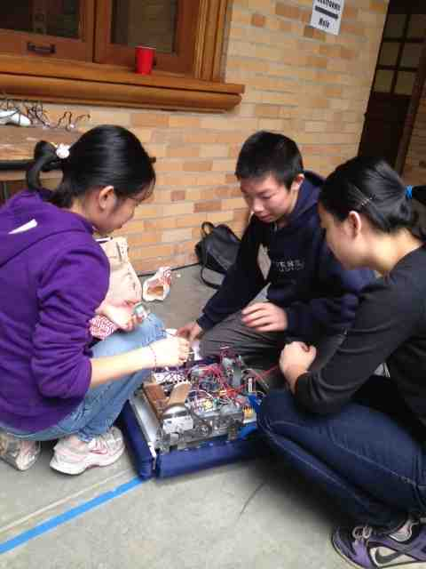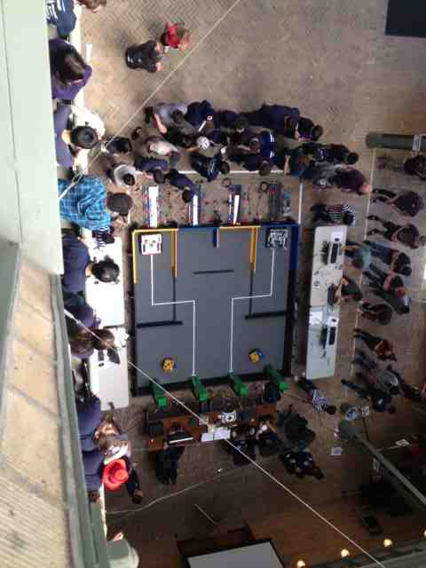
Multicultural Night
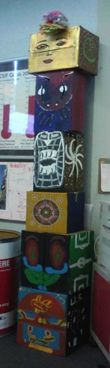
Friday, April 26 at 5:00pm - 8:30pm at ACLC
Celebrate diversity at Multi Cultural Night, an exciting and fresh event featuring a variety of guest performances. Come support ACLC's fantastic community, enjoy delicious food, and explore multiple booths that feature different cultures for a fun night to bond with our community and experience a truly multicultural event. Activities will include

Henna tattoo,
Japanese tea ceremony, and even
Dance Dance Revolution

Entrance to the event is free and food pricing is by plate size - a small plate is $3 and a large plate is $5, be sure to bring extra money to spend on our booths as well! So mark your calendars for April 26th at 5:00PM and get ready for a wonderfully eventful and unique experience!

