CCEF Housewarming

CCEF hosted an ACLC Housewarming. Parents had a great turn out and show of support for our programs.
As Patti said in her comments to the community "average isn't good enough and that is why so many of you
have stepped up to support the efforts of CCEF". I went home feeling such pride in our community and the
opportunities you all provide for learners at ACLC.

Isabelle and the entire CCEF team were out early to dress up the courtyard. It looked great!!!!
Special Guest Artists Cosmic Spin (Robert Cassard and Bara Waters were amazing. Also, we were also treated
to the new courtyard lights on full display. Thank you to Caprice Carter and Ken Carvallo for the hard work getting
those up.
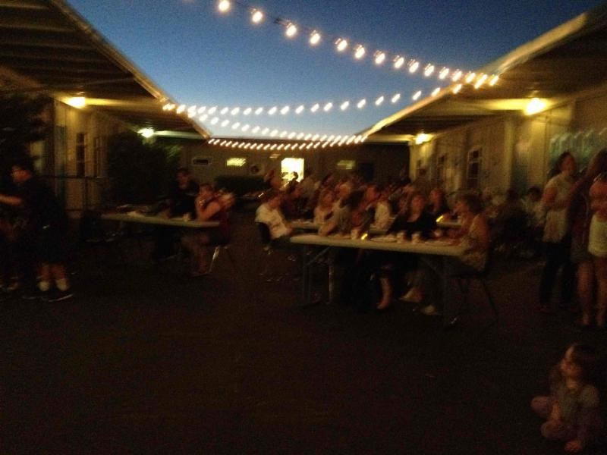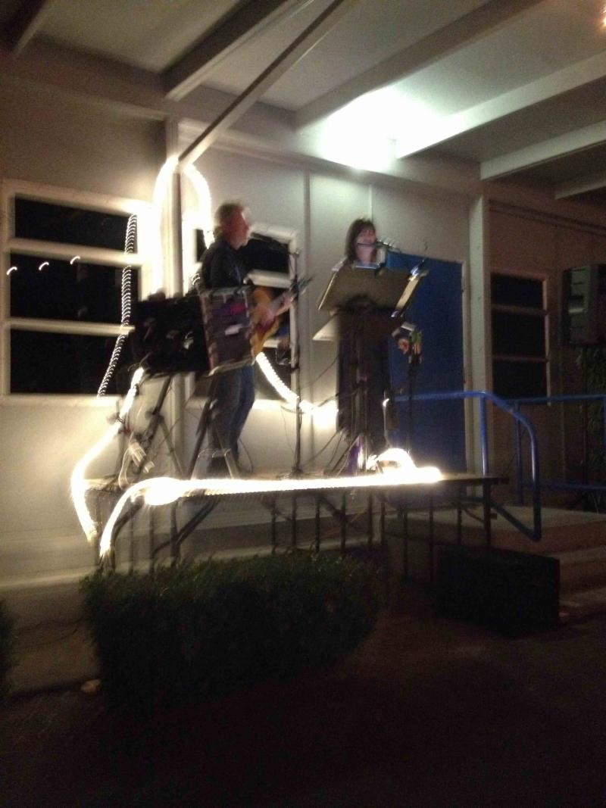

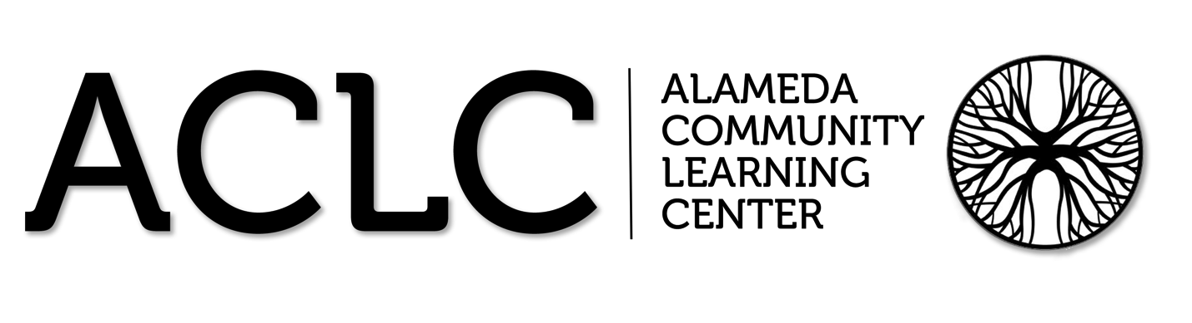

ACLC Lead Facilitator Report – David Hoopes
CLCS Board of Directors’ Planning and Organizational Meeting
October 2013

ACLC Board meeting update
Learners, parents and facilitators will be meeting together at ACLC on Friday at 5:30 to discuss the learner size at ACLC. Learner board member Patrick Melendez has passed a proposal to examine school size at ACLC. They will eventually come here to the CLC Board to share their findings in the form of a recommendation for school size next year.

College Culture in improving

On Tuesday, September 24, ACLC gave a well-attended presentation to senior learners and their parents. Topics included the application process for UC, CSU, and private colleges; Personal Statements, importance of letters of recommendation, SAT and ACT tests, and timeline and important dates for the senior year. Counselor John Maiers and parent Lisa Kharazi each gave a presentation and power point and answered questions. Each senior will also have an individual conference with a counselor to set up a specific senior plan for both graduation and college enrollment.

Enrollment @ ACLC

Please reach out to myself or Lina Miura (lina.miura@clcschools.org) with your questions for next year’s enrollment. Remember, siblings get priority but you have to apply in order to get to the front of the line. Go to: WWW.applytoaclc.org. Also, plan to attend information sessions or pass along these dates to friends, family and colleagues.

Parent Information Nights:
Middle School Presentation @ 6:00 pm
High School Presentation @ 7:30 pm
- Tues Dec 10th
- Sat January 11th 10:00-1:00
- Tues Feb 11th
- Tues April 8th

School Tours will be Thursdays @ 9:00am
- Tues Oct 29
- Thurs Nov 14,
- Thurs Jan 9
- Thurs March 13
New Signs:
I hope you had a chance to see the new signs in front of the school. Thank you to Bara Waters and Robert Cassard for the creativity and follow through. The signs look great.
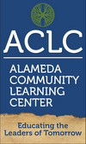

PSAT for ALL Juniors:

PSAT was administered on Wednesday, October 16. Please make sure you sign up in my office, or leave payment in an envelope

Mascots

With our move to a new campus, our community voted that it wanted a permanent school mascot. In the previous years, the senior class would choose a mascot for the school, thus the mascot would change each year. But after a month of presentations, debates, discussions, and voting during CCC, I am glad to announce that ACLC's new official mascot is the HAWK!

ACLC Community,

Last week sixth and seventh grade new learners went to Hannah Camp. I truly want to celebrate the older learners for their leadership and organization. Special thanks goes to Aiyana, Sophia and Jenny for their coordination. Although the evenings were a little cooler than expected, the weather and campsite worked well. Enjoy the photos and look for a more detailed report from Jenny in the coming days.

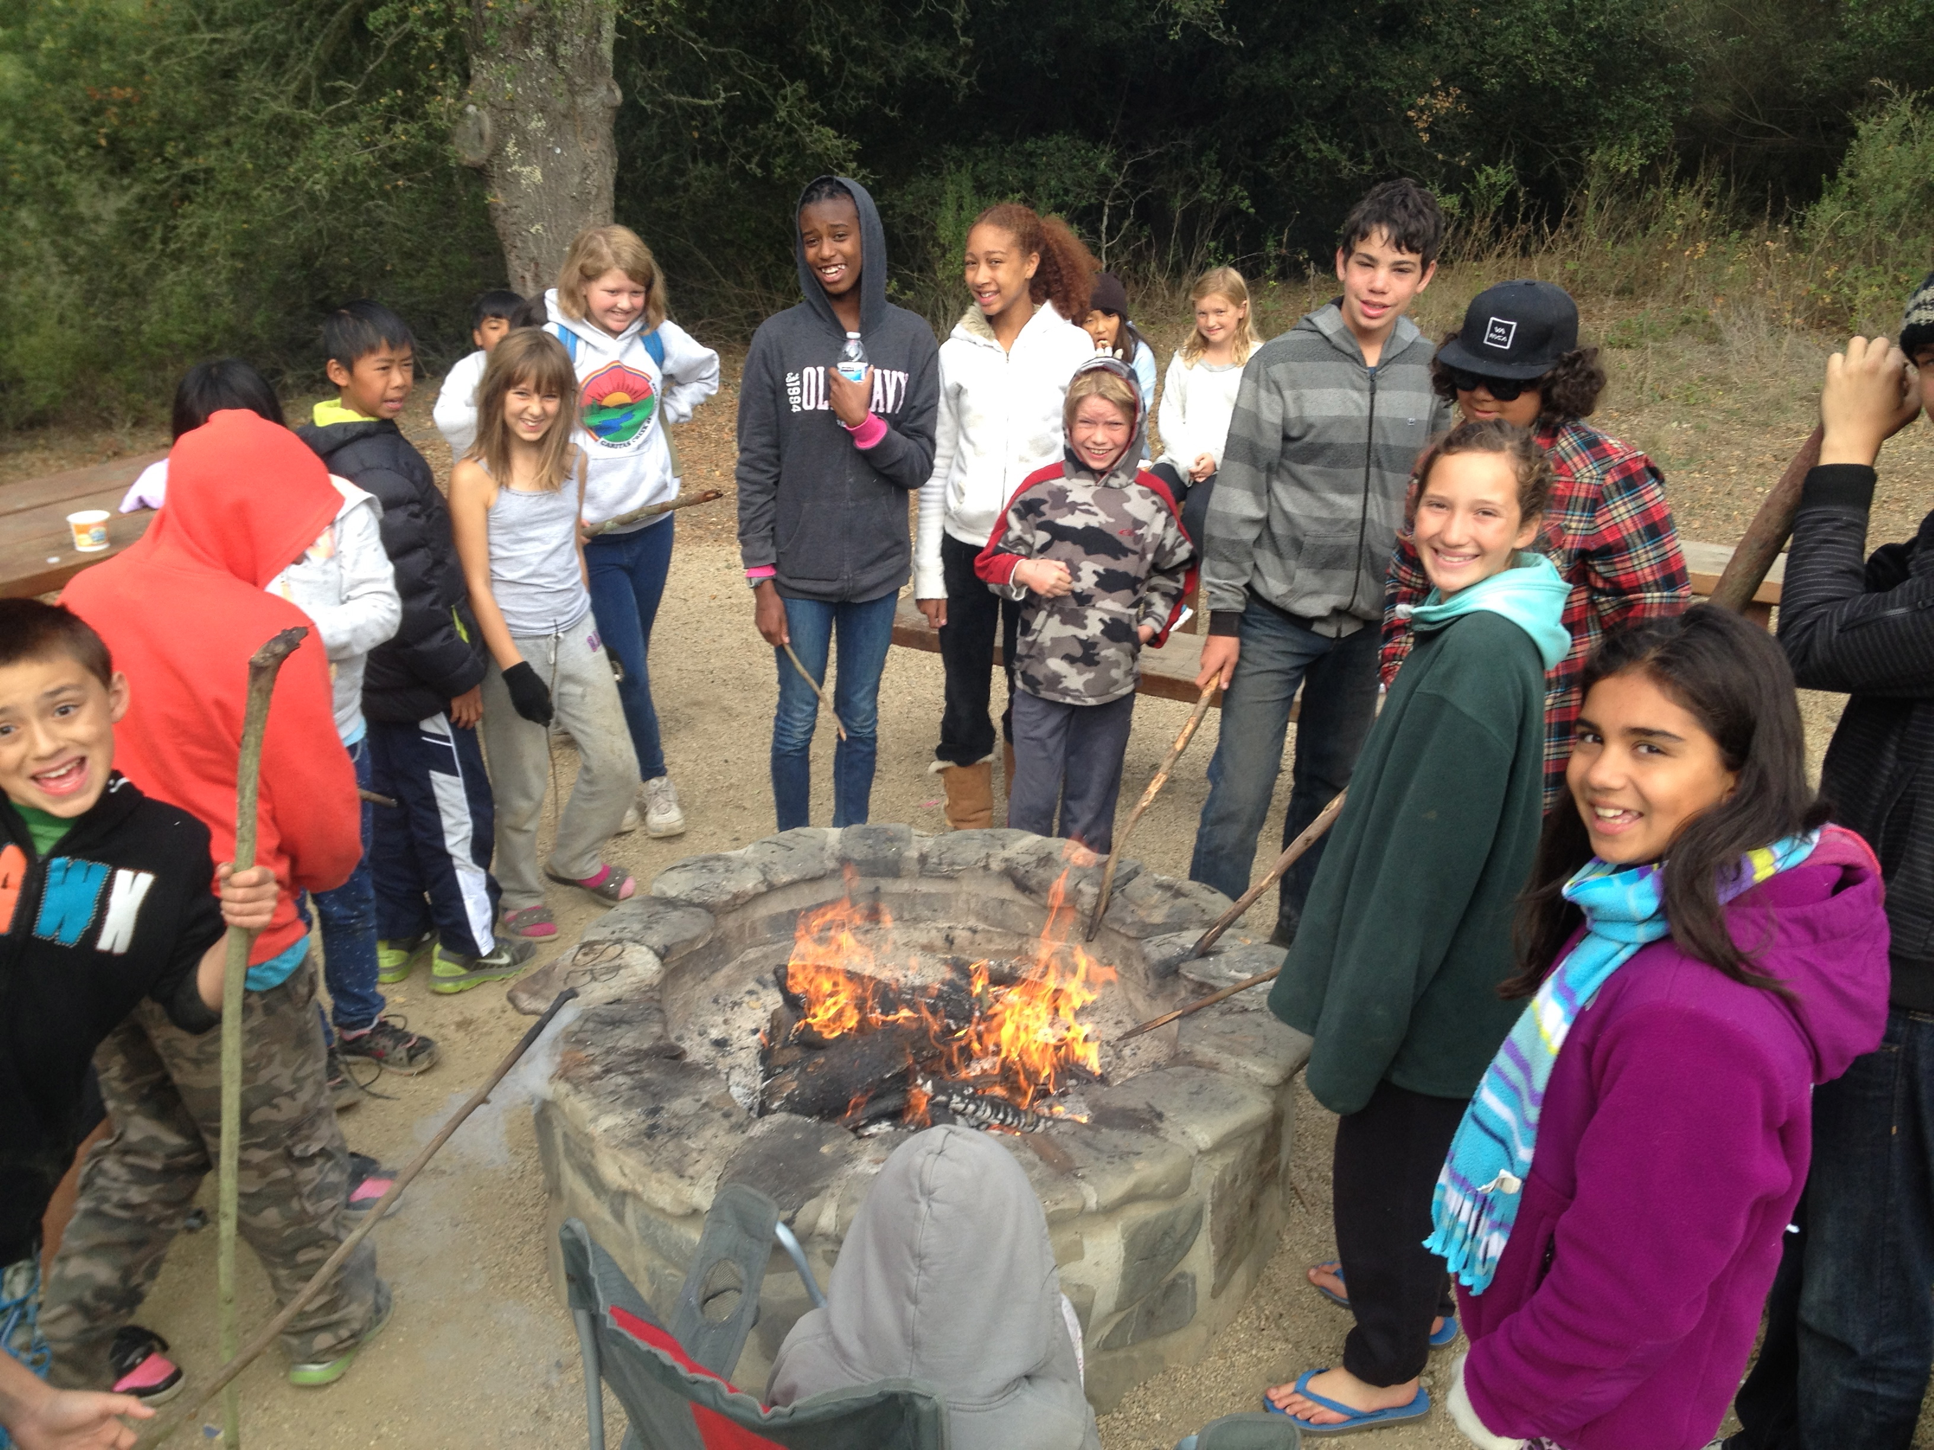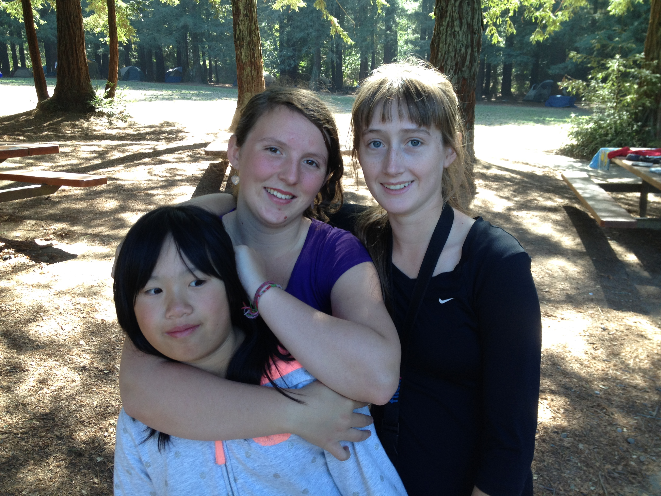

Bethany Kharrazi

Bethany Kharrazi went to Washington DC this summer to advocate on behalf of her brother and ACLC graduate Jeremy who is fighting cystic fibrosis. She a leader that other leaders should emulate. Inside Bay Area published this article highlighting her trip to Capital Hill.
http://www.insidebayarea.com/my-town/ci_24073717/alameda-teen-goes-d-c-talks-lawmakers-about Congats to Bethany!

