ACLC Lead Facilitator Report – David Hoopes
ACLC Board of Directors
February 10th, 2016

Great Schools update
I wanted to share that ACLC Great Schools rating has increased. This is largely due to our exceptional results on SBAC. Thank you to our amazing facilitator team, our amazing parent community and learners for continuing to make ACLC great.
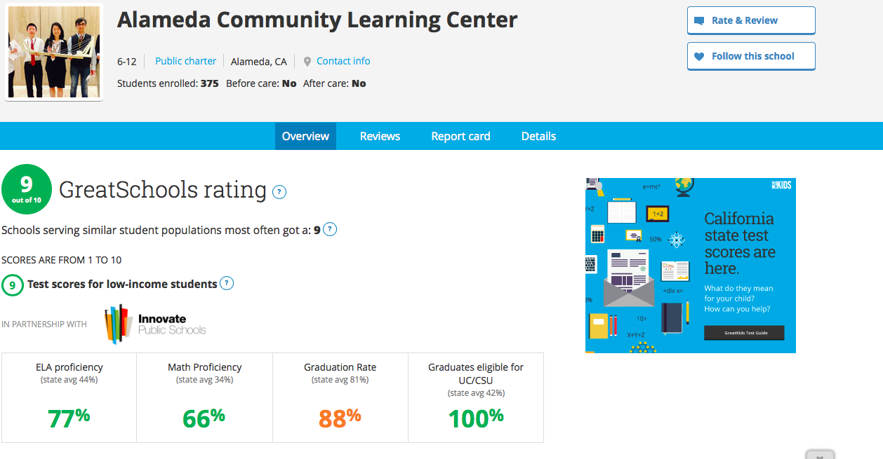

Nightmare on Puberty Street:
Two weeks ago our Middle School Learners attended "Nightmare on Puberty Street", an age-appropriate, live theatrical performance about four young people on their journey through adolescence. This frank and sometimes funny program shows learners how to cope with many of the issues of puberty. It was as advertised. Learners enjoyed it.

Chilly Cook Off:
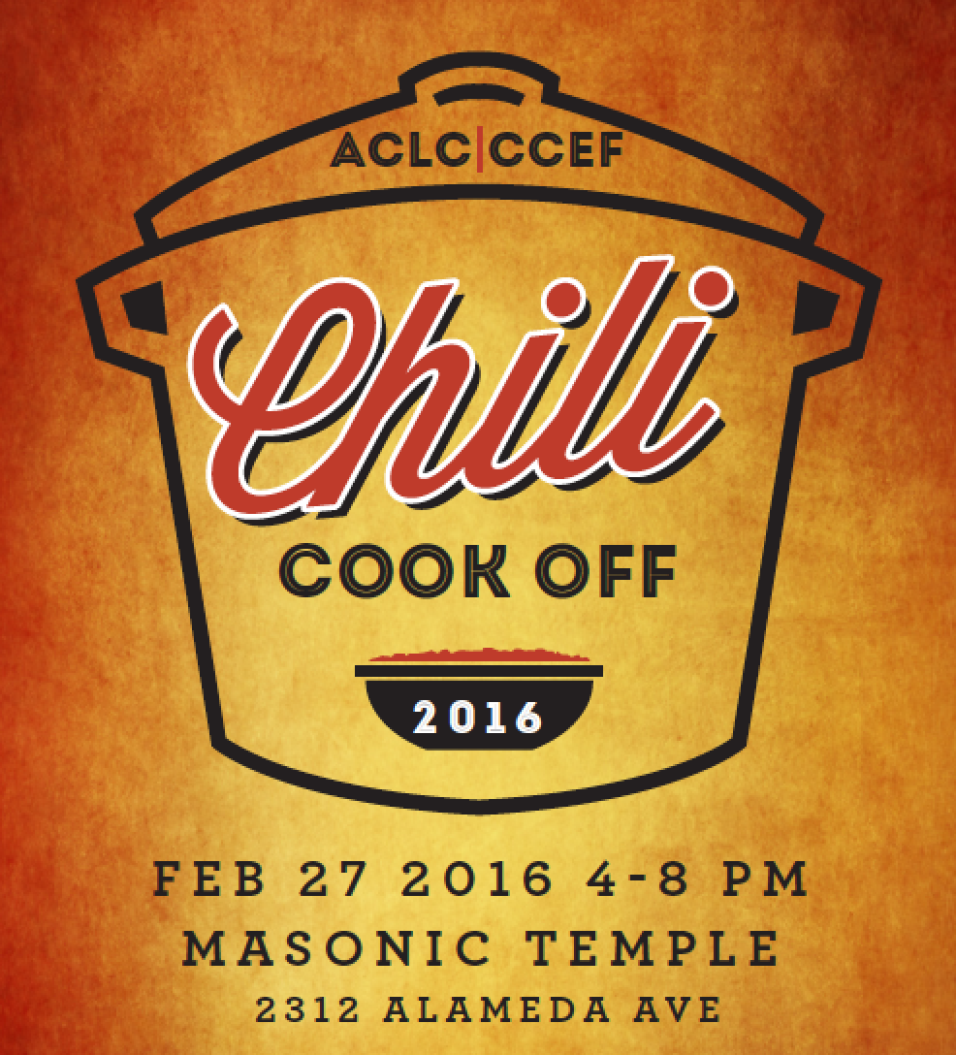
This will be a family-friendly community- building fundraiser for CCEF. CCEF’s fundraising strategy for 2015- 2016 includes the concept of multiple smaller-scale inclusive events. This is the second for the school year. This event is for all ages and includes a chili competition with approx. 15 entries from families and learner teams. Everyone will have the chance to have a small taste of all the entries and then cast a vote. We’ll have prizes for the top 3 winners (and may have a professional chef-judged category as well). After the competition, diners go back with a bowl for a meal of chili, cornbread, salad and dessert. We’ll have a raffle as well. We’ll use wristbands to indicate “Over 21” to create safety with the alcohol.
Leadership Conference
We are excited to announce the ACLC second Leadership Conference! ACLC's model is to "Educate the Leaders of Tomorrow", and on February 11th, the entire school will learn to lead together. The Leadership conference was born from the idea many learners may have felt discouraged that they don't have any leadership skills and/or do not have a strong voice in the community because they are not in Leadership class.

This year, the theme of the conference is "See the Need, Take the Lead". Each session will include the following:

- Introduction of who they are, their background, and what they do.
- Inspirations and support of how they became a leader in the community.
- A connection to the theme of the conference of how to take lead.
- Advice for learners to become effective and successful leaders now and in the future.
- Any questions the learners may have.

If you or someone you know of would like to participate as a guest speaker volunteer for this conference, please email me.

Enrollment Plans for ACLC:
As usual, we are doing a lot to maintain strong enrollment.
- PASS IT ON emails and reminders: We have invited our existing families to share our enrollment information. These reminders and tools are sent directly to families in the newsletter and via Jupiter Grades. This is a screen shot of that email. Obviously I am trying to take of advantage of the data collected in recent years telling us that most families hear about ACLC from friends and family.
  - 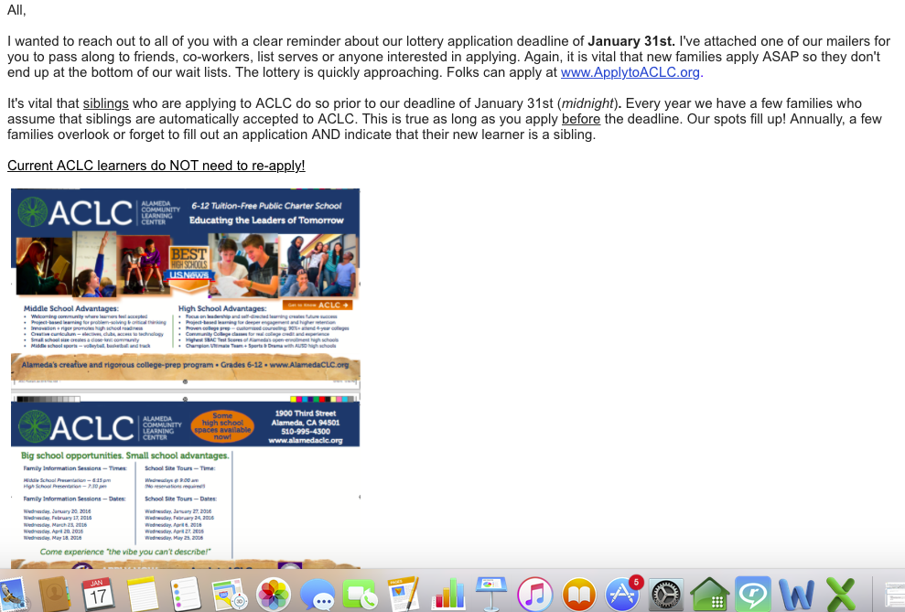

2) Mailings: ACLC has an additional mailing going to Alameda homes this month. We host two monthly opportunities to visit ACLC. There is a daytime tour and evening information session scheduled monthly. This year we are mailing only to Alameda. It is a bit risky but should build our pool of Alameda residents.
3) 8th Grade Retention: ACLC will be hosting an eighth grade parent and learner information Night on February 27th. The evening will include ninth grade facilitators and learners. Our eighth grade families will be able to ask questions and learn about our high school programs.
What is different about our 6-8 experience and 9-12 experience?
Off campus lunch Additional free periods
Honors classes College classes
Electives Additional leadership opportunities
College culture A-G approved classes for all
Why our N/C policy? Athletics
More

Art Field Trip
Caroline Stern led a group of middle and high school learners to the Asian Art Museum in San Francisco. They had a fabulous trip to the Museum. They went to see the Hokusai and Van Gogh original drawings and paintings that were studied in class. They were able to see the East/West Traveling exhibition as part of the trip.
Learner Led Conference Update:
ACLC learners parents and staff participated in our fall Learner Led Conference. Conferences well held across the school during minimum days last week. The fall topic was selected by Leadership Learners as it is annually. I have provided the document for you to read and think about. As members in the ACLC community you have the opportunity to write and submit proposals as well.
This round of Learner Led Conferences went very well. Attendance was excellent and learners all had a chance to produce a proposal and get feedback. This topic and our proposal process in general serve as a reminder that ACLC embraces learner voice and leadership. I expect several exceptional improvements to our school will be implemented as a result of our learners creativity and innovation.
Learner-Led Conference Topic
Fall Semester, 2015-2016

At ACLC, learners have the power to create school change by initiating proposals. Community members submit proposals to host fundraisers and other events, to make permanent changes to the campus, and to change school rules. Proposals are discussed by the Leadership class and either passed or dismissed. Depending on the nature of the passed proposal, it may be sent on to facilitators and the learner body to be passed or dismissed by them. (See attached “Proposal Process” flowchart.) This is similar to how our government works, with legislators submitting proposals to be considered by state assemblies or the United States Congress.

YOUR TASK

Option 1:
- Use the attached proposal form to write a proposal to benefit your community. You can make your proposal ACLC specific OR you can write a proposal about a local (Alameda/Bay Area), state, or national issue. Your LLC panel consisting of a facilitator, other learners, and their families will discuss your proposal and maybe even conduct a mock vote, but remember, they do not have the authority to pass or dismiss your proposal. You may choose to send your proposal on to the Leadership class (if it is ACLC specific) or share it with another appropriate group; however, this is optional. You can also consider this activity as practice for participating in a democracy. Your proposal must:
  - Include ALL the information asked for: name, grade, date, description, benefit to the community, who is responsible for implementation (putting into action), and your contact info
  - Be intended to benefit your community. Ideas for types of proposals:
    - To put on a school event (ACLC specific)
    - To start a school club (ACLC specific)
    - To hold a fundraiser for the school or a school club/bevy/grade level (ACLC specific)
    - To make a permanent change to the Center, like a mural (ACLC specific)
    - To pass, change, or repeal (get rid of) a school rule (ACLC specific)
    - To pass, change, or repeal a law (not ACLC specific)

Option 2:
- If you have already submitted a proposal to Leadership this school year, then bring a copy of it to your LLC (you can find a copy of all proposals in Molly’s room, 16, 4th period or after school any day of the week) AND respond in writing to the following questions:
- What was the outcome of your proposal?
- If your proposal passed, has it been implemented? Why or why not? If it has been implemented, how has it benefited the community? Give specific examples.
- If your proposal did not pass, why do you think it did not? Did Leadership give you any comments in person or on the proposal form? Do you have any other ideas? What will you do now?

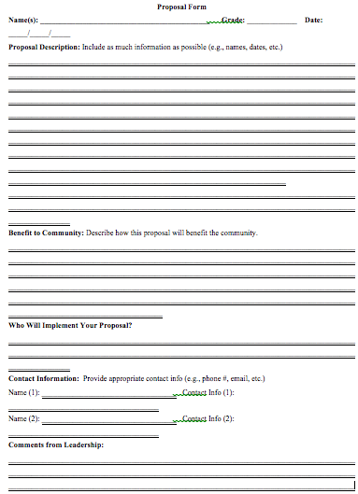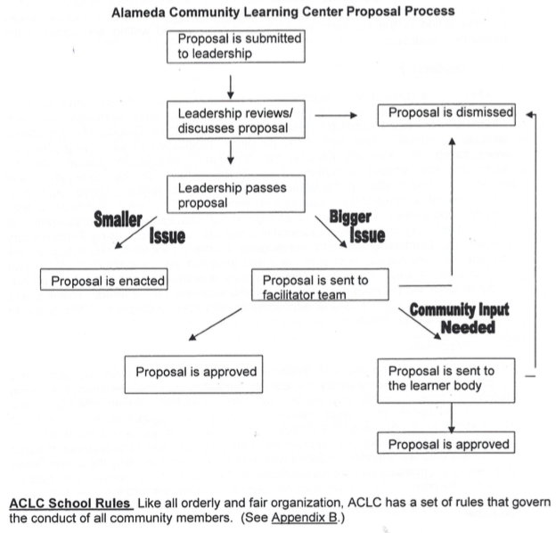

ACLC January Suspensions and Expulsions
 | January 2015
Expulsions | Zero
Suspensions by Grade Level | 5 Suspensions

ACLC IEP and 504 update
 | January 2015 | Pending
504’s | 37 | 2
IEP’s | 33 | 0

