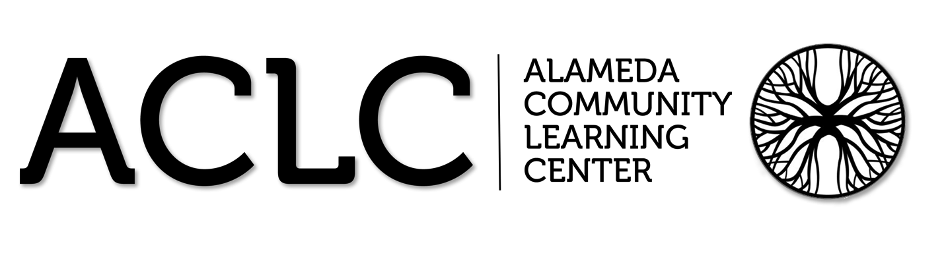

ACLC Lead Facilitator Report – David Hoopes
CLCS Board of Directors
February 18th, 2016

ACLC Board Update
- Committee updates

  - Financial committee reported discussion of the new CLCS positions and Campus supervisor
  - Personnel committee reported the discussion of Campus supervisor
  - Leadership reported on CCC’s and new proposals
  - Program Evaluation reported on Parent Survey and WASC participation
  - Curriculum Committee reported on WASC work

- Discussion Items
  - Introduction of any parent board candidates from our community (5 minutes)
    - We did not have a parent step forward as a new parent member.
  - Updated Enrolment Policy changes
    - The Board was updated on the lottery and Bara, Annalisa and my work to align enrollment policy.
  - Discussion of ACLC Board goals or projects this year (20 minutes)
    - Center improvement -Lynn and Rebekah
    - Discuss ways in which the board can be more involved in the school and to solicit commitments from board members on participation
    - Retention Survey

  - Upcoming events – review school and leadership calendars (standing item - 5 minutes)
    - The Board reviewed upcoming events on the school calendar.
  - Future items for discussion or action (standing item – 5 min)
    - The Board identified future items for discussion.
- Action Items

  - No Action Items for this meeting

Chilly Cook Off:
This event is for all ages and includes a chili competition with approx. 15 entries from families and learner teams. Everyone will have the chance to have a small taste of all the entries and then cast a vote. We’ll have prizes for the top 3 winners (and may have a professional chef-judged category as well). After the competition, diners go back with a bowl for a meal of chili, cornbread, salad and dessert. We’ll have a raffle as well. We’ll use wristbands to indicate “Over 21” to create safety with the alcohol.

There is still room for more cooks to show their best Chili recipe off on Saturday, Feb. 27th, 4 - 8p.m. http://www.clcschools.org/page.cfm?p=744

Leadership Conference
ACLC hosted its second Leadership Conference! ACLC's model is designed to "Educate the Leaders of Tomorrow", and on February 11th, the entire school was focused on learning to lead together. The Leadership conference was born from the idea many learners may have felt discouraged that they don't have any leadership skills and/or do not have a strong voice in the community because they are not in Leadership class. This year, the theme of the conference is "See the Need, Take the Lead". Harriet Turk was our guest speaker. She also led workshops for middle and high school learners. This is a short list of other speakers learners got a chance to hear.

- Robert Cassard: Musician and web development/advertising

- Thomas Miller - Pixar

- Jessica Robinson - Waste Diversion and Presentation "Resilience: Birthright"

- Glenn Steiger - Alameda Municipal Power

- Kathy Work - Director of Community affairs and Education for the Alameda Elder Services Living and Phoenix commons

- Trish Spencer - Mayor of Alameda

- Markus Wiloughby - Lawyer

- Tracy Zollinger - Interact Advisor for ACLC

- Loel Solomon - Public Health

Professional Development
I’d like to give the Board a look at how we are navigating the variety of initiatives ACLC has at this time. Below is our agenda for last weeks professional development. We started with a discussion on school culture by clarifying all of our roles in the Leadership Conference on Thursday. Next, Lynne framed the RTI work for the day, Eryn presented changes to our Google tool and staff was given time to input data and discuss interventions. WASC work also moved forward with the WASC leadership team writing. Finally, Staff headed over for their vote on the contract.
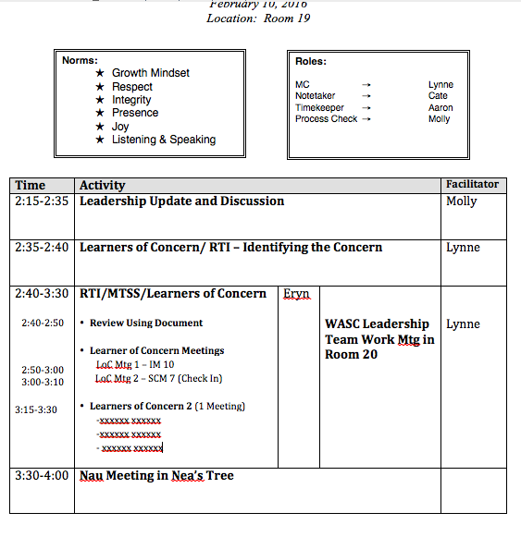

ACLC RtI/ MTSS (Response to Intervention/ Multi-Tiered System of Support)
Lynne Bone is leading the ACLC staff through the evolution towards data driven supports and targeted identification of learners of concern. The phrases “Response to Intervention”, commonly referred to as RtI, and “Multi-Tier System of Supports”, understandably shortened to MTSS, are used interchangeably among most educators. At ACLC RtI refers to the practice of providing effective instruction and intervention across three tiers to all students. Assessment, progress monitoring, and data-driven decision-making are all components of successful RtI implementation. The hope is to provide research and evidence-based, high quality instruction in all tiers. It is usually referred to using a three-tiered triangle like this:
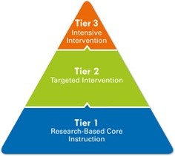

MTSS, is also a newer framework that differs from RtI as it is more comprehensive. Lynne Boone and Eryn Kjelland are collaborating to move us towards MTSS. MTSS requires that facilitators, administrators, and educational specialists change the way that they have traditionally worked together to include a more collaborative and cohesive culture.

The following flow chart has been developed in alignment with our WASC and LPAC Goals to support Learners of Concern and the RtI/MTSS process. These tools along with a comprehensive Google document allow all facilitators to be on the same page in their support of General Education, 504 and IEP learners.
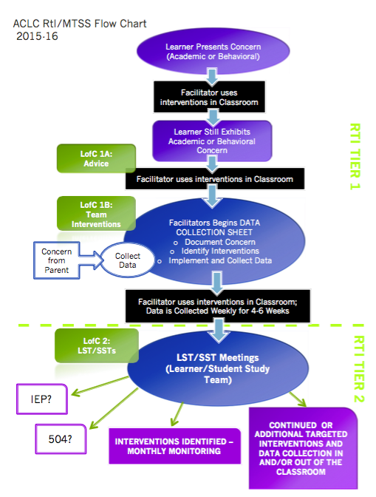

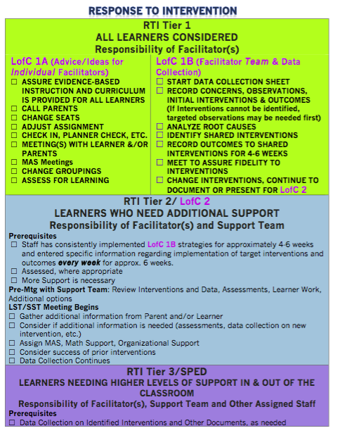

WASC Update
WASC – WESTERN ASSOCIATION OF SCHOOLS and COLLEGES
WASC work is continuing with staff. Lynne Boone is leading this work along with the WASC Leadership team. In our last professional development day, facilitators established focus groups and began developing assignments and evidence tools for writing the report. The Leadership team has developed surveys and observation tools collect data. Focus groups began to grapple with the prompts and questions that are essential for writing the report.
We are using Drop Box for our assembly of documents and evidence. Currently the Leadership Team has three different self-study data gathering files. During the second semester, self-study data will be used to evaluate our progress on goals. I have attached our timeline below for your to look at our plan and timeline.
Writing the school profile will be completed by the end of February. Each WASC Lead Team member is in charge of writing a section.
- General Background and History – David Hoopes
- School program and Data – Danny Bradac
- Demographic Data - Lynne Boone
- Data addressing Eight State Priorities Madeline Ewers
- School wide Learner Outcomes -All
The self-study data gathering is also moving forward. A great deal of this data is gathered or is in the final stages of being pulled together.
- Madeleine Ewers.–Quantifiable
  - Parent Mid year surveys
  - Parent End Year surveys
  - PAC surveys
  - Culture surveys
  - Learners mid year surveys
  - Learner end year surveys
- Molly Fenn -Narrative survey
- Staff interviews (for NARRATIVE data)
  - Commitment to mission: The Alameda Community Learning Center is an educational model that empowers all youth to take ownership of their educational experience, to celebrate their diverse community, and to actively participate as members in a democratic society.
    - How do you demonstrate your commitment to ACLC’s mission in the classes you facilitate?
  - Investment in ACLC community
    - How do you get to know ACLC community members, outside of your classroom?
  - Traditions
    - What is your most valued ACLC tradition and why?
  - Openness to New Ideas
    - How often do you try new things (activities, texts, etc.) in your classroom? Where or from whom do you get new ideas?
  - Flexibility/Willingness to Take Risks
    - How has working at ACLC influenced your flexibility and willingness to take risks in the classroom?
- David H. Danny B.—Observable Data
  - Inter-visitation tracking
  - Questioning
  - Project planning tools
  - Project tracking tools
  - Student centered instruction
  - Class size tracker
  - Learner Engagement

WASC Timeline
 | GENERAL | ADMIN/ LYNNE | LEADERSHIP TEAM | FOCUS GROUPS | HOME GROUPS
AUGUST | INTRODUCTION TO WASC | WASC Webinars
SEPTEMBER | ESTABLISH WASC LEADERSHIP TEAM | Prepare WASC Presentation |  |  | Gather data that can be analyzed for trends
 | ESTABLISH FOCUS & HOME GROUPS | Recruit Leadership Team | Plan and Prepare for Leading Data Collection | Form Focus Groups
 |  | Leadership Team Orientation
 |  | Assign Focus and Home Groups
 |  | Distribute WASC Documents |  | Review Tasks and Prompts
 | EXAMINE PROMPTS AND TASKS | Create Timeline | Review Tasks | Identify Data Needs
OCT |  | Organize Google Docs & Dropbox |  | Communicate data needs and questions to Home Groups | Gather Data that may be used for WASC
NOV/DEC |  | Incorporate Classified onto Focus Groups and provide WASC Orientation for them |  |  | CONTINUE
JANUARY | RE-ESTABLISH FOCUS GROUPS WITH PARENTS & LEARNERS | Gather Data for Profile |  |  | CONTINUE
 | DATA COLLECTION | Gather WASC Reports and Examples | Plan process for sharing profile data and engaging stakeholders in observing trends and identifying needs | Recruit parents and learners to Focus Groups | CONTINUE
 | BEGIN WORK ON PROFILE (CHAPTER 1) | Consider separate parent meeting. Consider separate learner meeting. | Prepare disaggregated data to Leadership Team with vision, mission. Look for trends. | Choose your meeting time/day. Get classified, parents and learners on board (on your own). | CONTINUE
FEBRUARY | TASK 1: PROFILE | Prepare for writing Profile: Task 1: Refine the student/community profile, based on analyzed and disaggregated data. | Clarify the school wide learner outcomes (Choose 2 to focus on; use data to comment on the degree to which the students are achieving the identified outcomes
 |  |  | Write Profile | Pose questions and data requests to Home Groups | Gather data for Focus Groups
 |  |  | Share Profile and Data to involve stakeholders in identifying trends, needs, etc. | Make plans for gathering data that fulfills the need
 |  | Gather materials for Progress Report and Prepare for meetings | Revise Profile based on stakeholder feedback & Disseminate | Analyze data
MARCH | TASK 2: PROGRESS REPORT | Read previous Self-Study and Critical Areas for Follow Up | Review self-study, critical areas for follow up and progress report
 |  |  | Identify significant developments that have impacted the school (funding changes, moving, change in requirement) and consider status of critical areas for follow-up
 |  | Prepare for Meetings Consider where to present the profile and progress report (Staff Meeting? Classified? Leadership? Other classes? PAC? CCEF? Special Parent Meeting?) | Focus on ongoing follow-up process (SPSA) and gather data to support the progress
 |  |  | Prepare for Meetings Consider where to present the profile and progress report (Staff Meeting? Classified? Leadership? Other classes? PAC? CCEF? Special Parent Meeting?)
APRIL | Task 3: Summarize implications of the data and progress; identify 2 to 3 critical learner needs; determine important related questions for use in the Home/Focus Groups | Announce meetings | Write Chapter 2: Progress Report
 |  |  | Disseminate the profile and progress report (ch 1 & 2) to all staff and other stakeholders; hold group discussions based on the schoolwide learner outcomes, and current knowledge about critical learner needs, include the data
 |  |  | Meetings
 |  |  | After Meetings Determine if there is agreement on the identified critical learner needs and important questions. Are there additions? How do these align to the LCAP? What are the 3-4 important questions to be discussed within the Home/Focus groups as they respond to the criteria prompts?
MARCH |  |  | Chapter III: Summary of Data and Progress Write Chapter III, revise Chapters I and II and disseminate
 | Chapter IV: Self-Study Findings |  | Chapter IV: Self-Study Findings
 |  |  |  | Task 4: Analyze the quality of the school program in relation to the ACS WASC/CDE criteria with emphasis on the identified critical learner needs and related schoolwide learner outcomes; synthesize the information, determine strengths and growth needs
 | Task 5: Revise the comprehensive schoolwide action plan | Consider schoolwide and subgroup growth targets | Task 5: Revise the comprehensive schoolwide action plan
 |  |  | Define schoolwide and subgroup growth targets
APRIL
 |  |  | Edit Chapters
 |  |  |  | Finalize Section of Chapter IV
MAY |  |  | Compile Document
 |  |  | Revise
 |  | Prepare for Visit | Add Data to Appendix
 |  |  | Format
JUNE |  | Send Report to Visiting Team
 |  |  | Discuss and Plan for Visit Preparations
 |  |  | Identify next step meetings

LPAC UPDATE
Goal 1 | Improve school culture for targeted groups by increasing the proportion of engaged parents and learners in our inclusive academic model.
 | Identified Need: | Expected Annual  Measurable Outcomes: | Progress to date | Budgeted
 | Equity and fairness in the Judicial Committee process as seen in JC referrals and identified in parent feedback | Increased access to academic counseling, peer mediation and emotional counseling | Achieved - Additional social and emotional counseling is being offered weekly. In addition a  college counseling has been hired to allow for improved social and emotional counseling. | Expenditures
 | Increase emotional and academic support for learners |  |  | Expenditure: 6K in payroll college Councilor
 | Parents surveys indicate some improvement is needed with acceptance and equity | We will increase the effectiveness of our Judicial Committee for all learners | Achieved- Additional JC support hours have been extended. | Expenditure: 10K in payroll for school psychologist
 |  |  |  | Expenditure: Funding of a 4K stipend for JC Facilitator
 |  | Increase engagement of parents and Learners from underrepresented populations | TBD - Parent surveys are currently underway. Data will be forthcoming from the survey. | Expenditure: 10 K in payroll for school psychologist
Goal 2 | Develop a comprehensive professional development plan to enable facilitators to better serve all learners.
 | Identified need: | Expected Annual  Measurable Outcomes: |  | Budgeted
 | We need to develop formative and summative assessments to know if students are learning. Specifically, to know if we are serving learners.  WASC visiting committed identified this as a critical area of need for ACLC. | Learning Professional Development Goals for facilitators and Lead Facilitator | Achieved - All facilitators have developed professional goals. Each facilitator is developing formative assessments to demonstrate learning. | Expenditures
 | The academic achievement gap as identified in STAR and GPA data. | School wide Professional Development Goal | Common Core Assessment has given us a new baseline of data. We will use our year one (14-15 CAASPP) and year two (15-16 CAASPP) data to review this measurable next year. | Expenditure: 7K from professional development budget
 | We need to develop formative and summative assessments to know if students are learning. Specifically, to know if we are serving learners.  WASC visiting committed identified this as a critical area of need for ACLC. | SRI or Lexile for all learners at ACLC to be used in professional development | Established baseline in September | Expenditure: 3K for training on assessment and data analysis
 | Facilitators need strategies to support learning and provide intervention. | Develop criteria for an effective academic support strategies to support ELL, LI and FY  and underserved learners | Achieved - 20% ELL support person hired in October. | Expenditure: 2K for workshops in Illuminate assessment
 |  | Development of 3 formative assessments to know if students are learning. Specifically, to  know if we are serving learners. WASC visiting committed identified this as a critical area of  need for ACLC. | In progress - Facilitator survey was taken as part of our WASC self study. Also part of the evaluation process for CLCS | Expenditure: 2K CELDT Assessments
 |  | The academic achievement gap as identified in CAASPP and GPA data. | In Progress - Baseline was established in September for CAASPP. December GPA Baseline established | Expenditure: 3K for sight license of assessment tool
Goal 3 | Increase academic achievement for Foster Youth, ELL and Low Income learners.
 | Identified need: | Expected Annual  Measurable Outcomes: |  | Budgeted
 | Achievement gap identified in GPA and STAR result |  | € | Expenditures
 | Increase learner achievement by building facilitator capacity to differentiate and support learning directly in the classroom |  |  | Intervention, discipline and professional development  Expenditure: 75K in salary
 | WASC visiting committee identified a clear need for additional Data need to improve intervention | Increase in Back to School Night Attendance | Achieved - Total count increased by 10% this year due to increased invitation of targeted populations and  PAC leadership communication. | Expenditure: Jupiter Grades 4K
 | Increase learner achievement through greater parent awareness of and involvement in learner’s academic performance and development  of an academic support system for all learners. | Increase in LLC parent participation | Not achieved - Mid year LLC parent turn out was lower that last year. | Service: Improved ELL instruction and clear differentiation  Professional Development 3 k PowerSchool
 |  | GPA Increase | In Progress: Baseline established in December. Rates are being tracked in power school
 |  | College Acceptance Rates | €
 |  | Attendance Rates | Overall attendance rates for P1 were down slightly.
 |  | Academic Support Participation | In Progress: methods to Identifying specific attendance rates have not been developed.
 |  | Decrease in suspensions | Αχηιεϖεδ − 20%
 |  | Increase academic achievement for Foster Youth, ELL and Low Income learners | Baseline set in December
Goal 4 | Develop Interdisciplinary projects and methods of measuring the effectiveness of project based learning with  Foster Youth, ELL and Low Income learner engagement. We know that strong PBL makes learning relevant and engaging.
 | Identified need: | Expected Annual  Measurable Outcomes: |  | Budgeted
 | Increase engagement and deeper learning at ACLC during project time | One project per class will incorporate concepts from additional classes | Achieved - survey of facilitators that this is being achieved | Expenditures
 | Increase classroom engagement by increasing real world application of skills |  |  | 15 K computer
 |  | Adopt project tools and best practices to create successful projects | Achieved- Buck institute training tools are being used by facilitators who attended the training. Newer facilitators struggle with project development. Coaching is available for our newer facilitators as part of the facilitator effectiveness grant. | Carts for 3 additional classrooms
 |  | One project per class will incorporate concepts from additional classes | TBD - Facilitator a learner surveys ill be more helpful in determining our progress here.

ACLC February Suspensions and Expulsions
 | January 2015
Expulsions | Zero
Suspensions by Grade Level | 5 Suspensions

ACLC IEP and 504 update
 | January 2015 | Pending
504’s | 37 | 2
IEP’s | 33 | 0

