LCAP Year (select from 2017-18, 2018-19, 2019-20)
2018-19

Local Control Accountability Plan and Annual Update (LCAP) Template
Addendum: General instructions & regulatory requirements.
Appendix A: Priorities 5 and 6 Rate Calculations
Appendix B: Guiding Questions: Use as prompts (not limits)
LCFF Evaluation Rubrics: Essential data to support completion of this LCAP. Please analyze the LEA’s full data set; specific links to the rubrics are also provided within the template.

LEA Name | Contact Name and Title | Email and Phone
Alameda Community Learning Center | Jeremy Goodreau  Principal | Jeremy.goodreau@alamedaclc.org  510-995-4300

2017-20 Plan Summary

The Story
Describe the students and community and how the LEA serves them.
Alameda Community Learning Center (ACLC) is a 6th through 12th grade public charter school in Alameda, California, that facilitates a democratic and leadership-focused college-prep program. Our program empowers learners through leadership opportunities, engages them through experiential learning, creates self-direction through flexible options and scheduling, increases self-esteem through community, provides individualized support, and sets the highest academic, social and ethical expectations.
ACLC is located in Alameda, a suburban island community between the urban centers of Oakland and San Francisco. With many local academic and other resources, ACLC learners have access to opportunities not available to all schools. Alameda is home to several parks and preserves, as well as a few museums, which are all within walking distance of the school. The Alameda Main Street Ferry, also within walking distance, provides access to all that San Francisco has to offer. The Peralta Colleges and UC Berkeley are also within easy access, allowing for many additional learning opportunities.
In the summer of 2014, ACLC moved to a school site on the west end of Alameda. Residents on the west end generally reflect a lower median income level than Alameda as a whole ($68,571 versus $75,212 in 2013), a higher number of single mother households (12.8% versus 6.9%), and a greater percentage of people that speak English “not well or not at all” (10.7% versus 7.7%). Employment trends on the west end also reflect a higher percentage of service occupations and a lower percentage of management occupations then the rest of Alameda. Demographic data shows a clear trend for the school since the move with increases in the number of English Language Learners and learners on Free or Reduced Lunch.

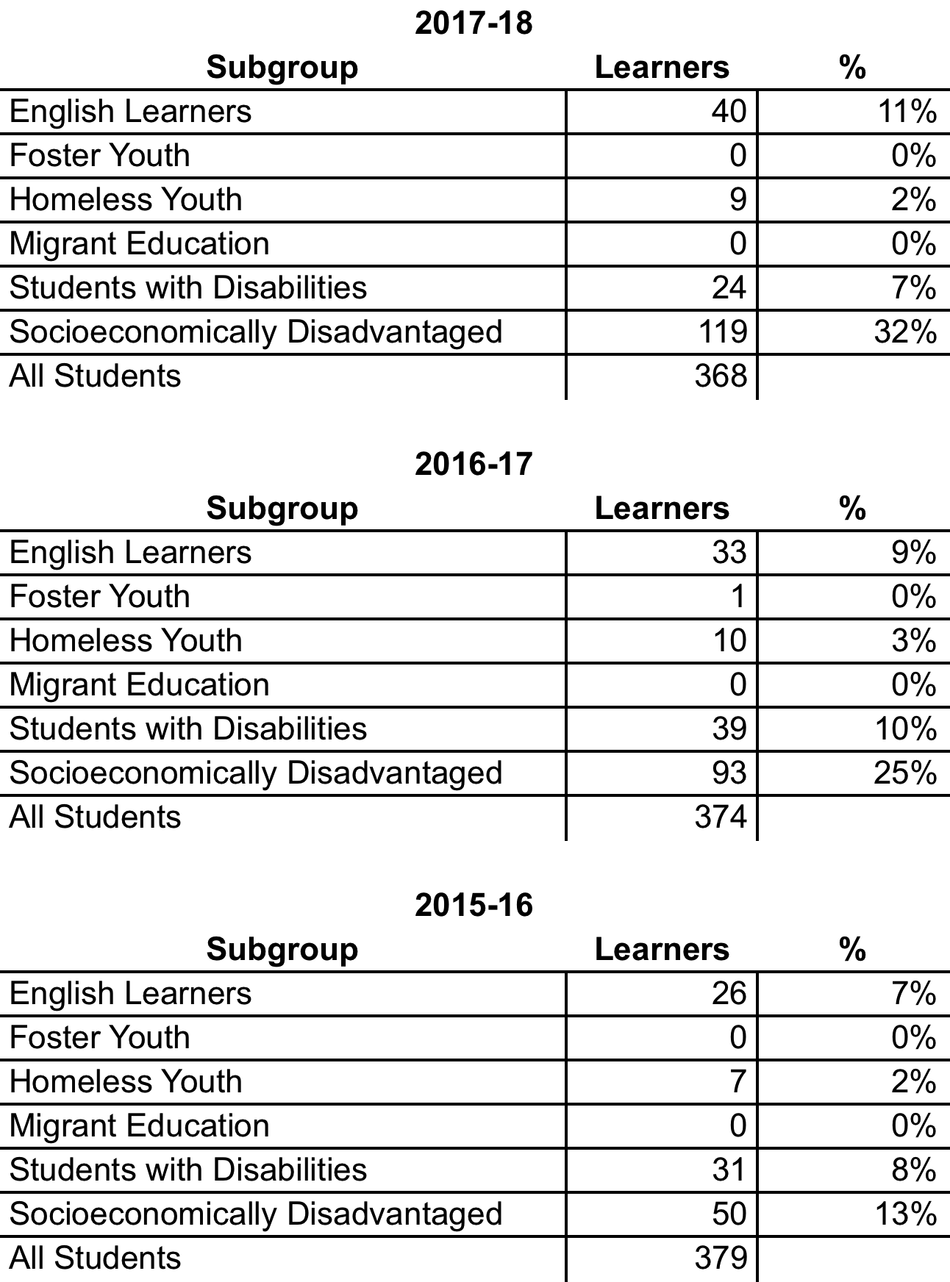

ACLC utilizes a college preparatory curriculum, and provides a collaborative learning environment that encourages active participation and self-directed learning. All graduates complete the UC a-g requirements, successfully complete at least one college course, and serve a 20-hour self-directed internship.
Partnerships with the Alameda Unified School District, Alameda Education Foundation, Alameda Boys and Girls Club and College of Alameda, along with support for our Parent Action Committee (PAC) and Creative Community Education Foundation (CCEF), have allowed us to provide a rich, rigorous program with a full range of offerings for our learners. With the support of our local community colleges, College of Alameda and Laney College, our learners have access to many academic options and graduate with college courses on their transcript.
ACLC has a well-qualified staff serving the community. 19.2 certificated staff members and 5 classified staff work to provide for the needs of ACLC’s learners. The school has 15 full time facilitators (teachers) and all are highly qualified or working toward highly qualified status. ACLC’s Special Education Department is managed by the CLCS Special Education Director, who also oversees our sister school’s special education department. On the ACLC side, there are two full-time Resource Specialists and 2.5 full-time paraprofessionals.
ACLC contracts with outside agencies for School Psychologist, Educational Psychologist, speech, OT, and AT services. ACLC also employs one full-time School Counselor, one part-time College Counselor, one full-time School Manager, one part-time Office Assistant and one part-time Campus Security person. ACLC’s management team consists of a Lead Facilitator (Principal) and an Assistant Lead Facilitator (Assistant Principal).
ACLC has been dedicated to developing important skills in our learners - skills that really make a difference in an ever-changing and globalized world. These skills include critical thinking, creative problem-solving, strong leadership, self-motivation, active participation, investigative interest, technological savvy, personal responsibility, flexibility, and open-mindedness.

ACLC Mission Statement:
The Alameda Community Learning Center is an educational model that empowers all youth to take ownership of their educational experience, to celebrate their diverse community, and to actively participate as members in a democratic society.

Educational Philosophy:
ACLC nurtures and educates the "Leaders of Tomorrow" through innovative, self-directed and project-based learning, systematic educational facilitation and highly efficient application of per-pupil funding.

ACLC's Educational Model:
Self-directed and Project-based — ACLC is based on a self-directed and experiential learning model in which learners (students) are supported by facilitators (teachers) to be actively involved in the learning process, observe, analyze and reflect on the experience, and apply the understanding gained from that experience.
Flexible — We use a college-like schedule with open periods and varied class schedules because it improves learner experience and performance. Flexible scheduling also allows high schoolers to take college classes.
Creative — Facilitators use an eclectic array of creative teaching strategies to engage the multiple intelligences of learners and encourage integration across subjects. Creativity in learner project design and fulfillment is highly valued and promoted.
Rigorous — We utilize best practices of teaching and learning in a non-competitive manner. We provide learners with a rigorous curriculum that promotes mastery of California Common Core Standards.
UC-based Standards — ACLC's graduation requirements are designed meet or exceed the admission requirements for the University of California system. All seniors must participate in a career-oriented internship, present a senior project, complete a college class and be eligible to attend a four-year university or college. ACLC's graduation requirements exceed those of other high schools in Alameda.
Empowering — We empower our learners to take ownership of their education. We emphasize, develop and actively practice leadership skills. Learners discover their potential, recognize their value and worth, and practice involvement and responsibility within the community.
High Expectations — We set high academic, social and ethical expectations for our learners. We have found that an applied learning approach creates initiative and empowers learners, creating more successful learning outcomes than traditional education settings.

Additionally, at ACLC our goal is that all graduates will:

Demonstrate the personal qualities, work habits and attitudes that promote lifelong learning
• Ability to effectively plan and manage time and tasks
• Knowledge of career options and pathway to their achievement
• Effective self-¬reflection, assessment and revision of actions and products

Demonstrate competency in academics and new basics
• Exceed AUSD graduations requirements
• Succeed on traditional assessment measures
• Achieve subject matter competency
• Successfully meet college entrance requirements

Demonstrate critical thinking and reasoning skills
• Use efficient learning techniques to acquire and apply new knowledge and skills
• Generate new ideas and dreams and plan for the future
• Recognize and solve problems
• Understand underlying rules and principles and draw logical conclusions

Demonstrate superior interpersonal and collaborative abilities
• Produce high quality group projects for a variety of audiences
• Function in various group roles
• Contribute cooperatively to a group effort
• Exercise leadership and work with diversity
• Help others learn

Demonstrate technological literacy
• Be able to select and apply appropriate technology to task
• Effectively use technology to critically gather information
• Choose appropriate technology to communicate ideas

Demonstrate the ability to engage in a participatory democracy
• Give back to the community and recognize the needs of others
• Participate in democratic process, including judicial and governance structures
• Take ownership and responsibility for wellbeing of the community and themselves
• Participate in decisions that affect their own learning experience

LCAP Highlights
Identify and briefly summarize the key features of this year’s LCAP.
There has been a great deal of change to the 2018-19 LCAP when compared to the 2019-20 LCAP, which is indicative of the many changes and the growth experienced at the school this year.
Structurally, the LCAP has been reduced from 6 goals to 3, and those goals have been expanded to show the evolving priorities of the school.
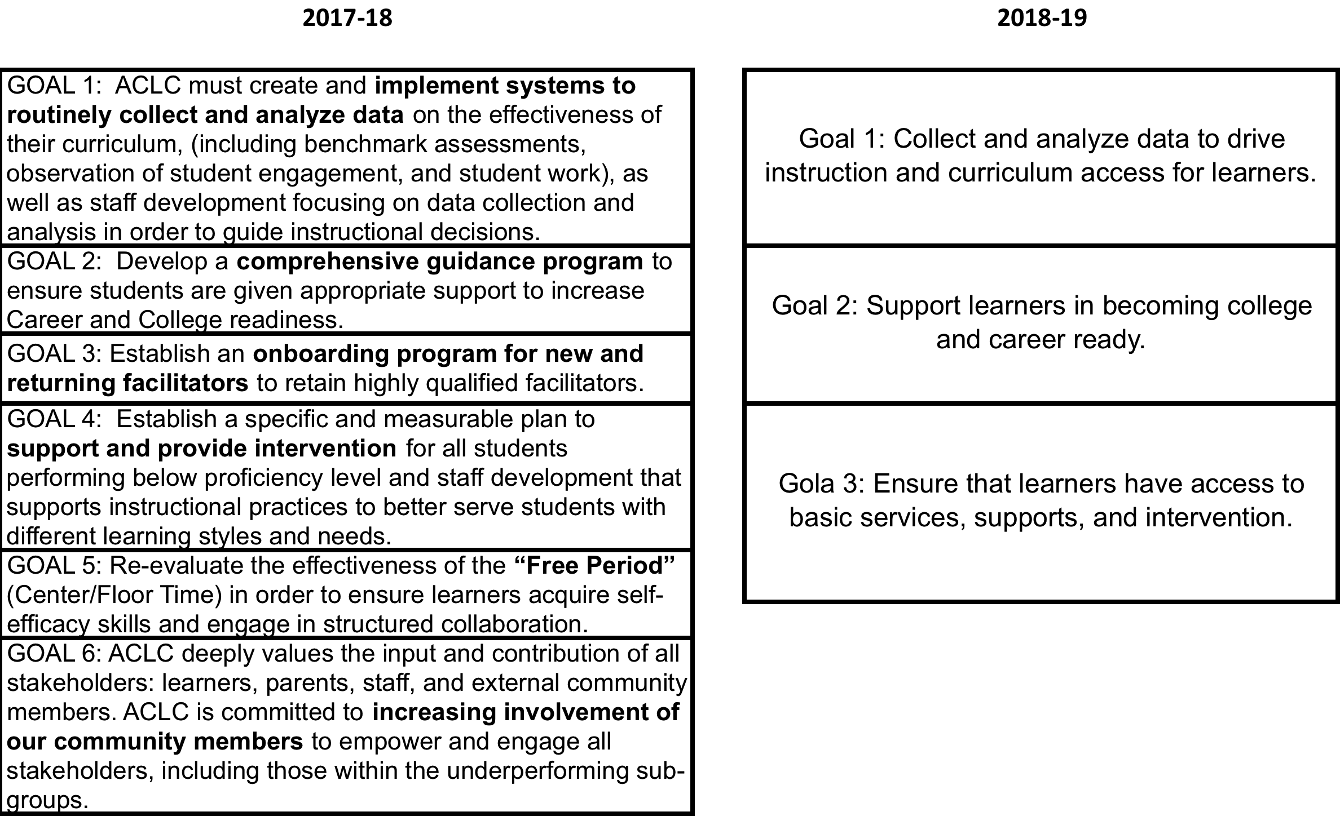

The 2017-18 goals are all still represented as metrics, outcomes, or action steps within the 2018-19 goals, but from workflow, management, and organizational perspectives, the 2018-19 goals are more easily accessible and implementable.
The restructuring of the goals also reflects the restructuring of priorities at ACLC. Through the work on the Sustainability Plan, ACLC has refocused itself as a leadership-focused, college-prep institution that utilizes a democratic model to facilitate knowledge and efficacy development. These goals, and the resulting metrics, outcomes, and action items reflect this work.

Review of Performance
Based on a review of performance on the state indicators and local performance indicators included in the LCFF Evaluation Rubrics, progress toward LCAP goals, local self-assessment tools, stakeholder input, or other information, what progress is the LEA most proud of and how does the LEA plan to maintain or build upon that success? This may include identifying any specific examples of how past increases or improvements in services for low-income students, English learners, and foster youth have led to improved performance for these students.
Greatest Progress
ACLC has made significant progress in all LCAP goals this year, and especially towards goals 1, 2, 4, and 5.
For the first goal, which was centered on using data-driven instructional best practices, ACLC implemented a much more robust data collection, analysis, and use system. Overseeing this system is the newly created position of Curriculum and Instruction Lead, and the primary tools being used to collect benchmark data are the MAP testing system and our own internal grade data. MAP testing is occurring triennially and grade reports are being pulled monthly. These data points are discussed in faculty meetings and the results have been changes in curriculum and instruction in individual classes and for individual learners. Furthermore, this data has been used to drive placement in new extra support programs that have led to significant progress in goal 4.
Regarding goal 4, which concerned helping struggling learners, we saw approximately a 16 percent decrease in our failure rate and approximately a 29 percent decrease in our rate of learners failing multiple classes, as of the May grade report. This progress was undoubtedly caused by the myriad efforts and programs that were put in place, including increased attention to data, mandating tutoring for struggling learners, and having struggling learners enrolled in the much more structured and supportive Learning Labs instead of some of their project periods. Additionally, we have piloted an “on-boarding” approach for new learners where we initially enroll them in a couple of learning labs instead of only project periods. The goal is that learners develop some time management skills and learn to use the Project Period for work first. With the changes, we have also seen a steady rise in MAP scores, and are anticipating a corresponding rise in CAASPP scores as a result.
This year has also seen an affirmation for our college prep focus and a great deal of progress towards overhauling that system, which was a major component of goal 2. Two major initiatives have occurred this year. First, our counseling team has conducted a major evaluation and overhaul of our college counseling program, working from the desired outcome of sending all learners to college back through high school and into the middle school years. A timeline has been created and resources created and/or collected to assist in the implementation of this process in future years. Second, through the creation of a Sustainability plan, ACLC has surveyed its stakeholders and reaffirmed our college prep mission. This has resulted in a more streamlined direction for goal 2, as we now can focus entirely on college prep and post-college career prep.
We have also made substantial progress toward re-evaluating and redefining the Center and our Project Periods, which was the heart of goal 5. From the first week of school, administration, faculty, and learners have worked together to help make the Center a more productive space, whether that is academically or social-emotional learning. Attendance is now taken just like any other class- at the beginning of every period through Powerschool. A newly hired campus supervisor works with the faculty member who is supervising the re-branded Project Periods. The result has been an increase in the safety, decrease in liability, and more upperclassmen working alongside the younger learners and passing on the time management and organization skills that have made them successful ACLC learners. Additionally, time has been devoted at staff meetings, our community-wide Constitutional Convention, and our Winter Learner Led Conferences to further discuss and explain the importance of properly utilizing the Project Periods.
In parts of goals 3 (establishing an onboarding program for new facilitators) and 6 (communication between facilitators and with families) ACLC also made notable progress. This year, we have revised our orientation day for new staff and our coaching model, as well as solicited feedback from new staff as to how they would like to see the process changed for next year. For goal 6, we have worked to improve document and information access for facilitators, and we continue to receive positive feedback around Jupiter use from families.

Per the CA Dashboard ACLC have also increased our graduation rates across the board.
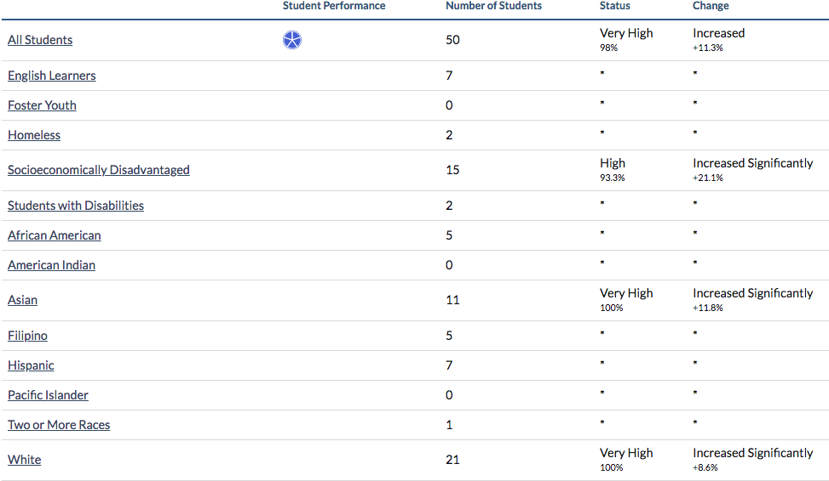

Referring to the LCFF Evaluation Rubrics, identify any state indicator or local performance indicator for which overall performance was in the “Red” or “Orange” performance category or where the LEA received a “Not Met” or “Not Met for Two or More Years” rating. Additionally, identify any areas that the LEA has determined need significant improvement based on review of local performance indicators or other local indicators. What steps is the LEA planning to take to address these areas with the greatest need for improvement?

Greatest Needs
In evaluating our recent WASC visit, the California Dashboard, and our own priorities, for the 2017-18 school year, the following areas need to be addressed:
Suspension Rate: The only state indicator in the Red or Orange for the Fall 2017 Dashboard Report was the Suspension Rate.
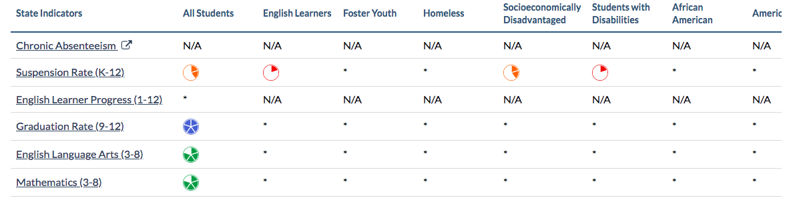
It should be noted that for the 2016-17 school year, many of the subgroups and the overall indicator for All Students Increased or Increased Significantly. This is likely the result of a one year increase in the number of suspensions related to drugs, alcohol, or weapons, which accounted for 23% of suspensions, and that ACLC’s preliminary internal numbers have this rate returning to the Yellow or Green for the 2017-18 school year.
This year, administration has also already taken two steps to help mitigate this problem. First, ACLC has developed a new Discipline Matrix that includes a new, lower category and more emphasis on alternative restorative practices. Second, ACLC and CLCS administration has worked to evaluate the needs of the staff to examine the best way to implement equitable and culturally responsive pedagogical practices.
Still, more work needs to be done, and ACLC is committed to revising and streamlining our progressive discipline practices. This work will be implemented at the outset of the 2018-19 school year and re-evaluated throughout the year as part our LCAP goal 4.

Continued Improvement for Struggling Learners: Although there has been significant improvement toward LCAP goal 4, new learners and learners from traditionally underserved backgrounds continue to show gaps in grades. These problems become more acute in the high school years, as the rigor of the school increases and new learners have a harder time adjusting to the school. More needs to be done to incorporate new learners into the ACLC model and to more rapidly identify and more effectively intervene with struggling learners. ACLC has shown academic success falling in the green on the CA Dashboard for both ELA and Mathematics. Although our academic performance is strong, we did see a decline for Math and ELA that we will address through our continued work towards intervention and supports for struggling learners.
English Language Arts
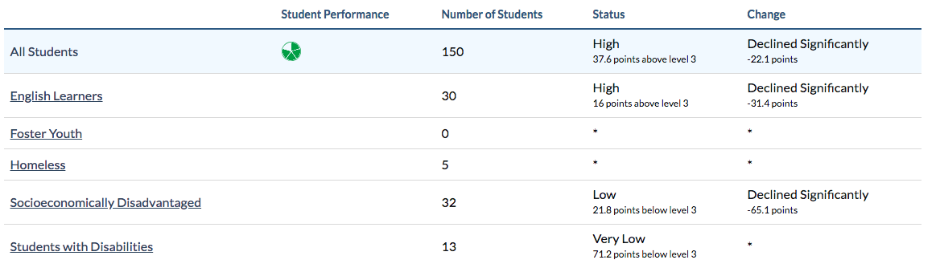

Mathematics
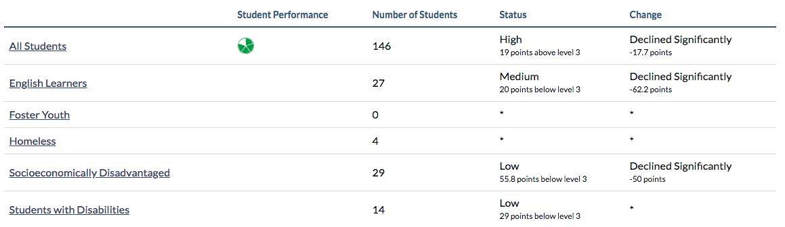

Continued Growth Regarding Data Driven Instruction: As ACLC continues to incorporate data more and more into its educational model, more training and direction is needed to help facilitators effectively use the data that has been collected and analyzed. The staff has made great strides in implementing these systems in the 2017-18 school year, but these initiatives are still too new to be removed from this list.
We have surveyed staff on for feedback on how these initiatives are working so far, and the preliminary results were promising. Staff universally reported using data in their decision-making, although the type of data, and their comfort levels with using various types of data varied. Overall, the impression is that staff need ongoing support and more training at deeper levels to continue the strong progress that was made in the 2017-18 year.

Continued Improvement for Staff Onboarding Process: During the 2017-18 school year, the new staff orientation day was retooled, our instructional support model was revamped, and administration solicited feedback from the new staff to determine further revisions. The feedback was clear. New staff would like more continued orientation and mentorship during this first year, as well as more streamlined communication of documents and in staff meetings. These last two items are action items from goal 6 that will be moving into goal 3.

Continued College Prep Re-evaluation: Throughout the development of a sustainability plan during the 2017-18 school year, ACLC’s college preparation efforts were repeatedly cited as the primary reason families come to the school (45% of respondents) and as a strength of the school. Continued improvement of this already strong program was also named as an area where families want even more! Simply put, families want their learners to go to, be able to pay for, and thrive in college, and they want as much help as possible in making these priorities happen. Our focus is to implement structures that support our struggling learners so that they can be successful in our college preparatory program.
Referring to the LCFF Evaluation Rubrics, identify any state indicator for which performance for any student group was two or more performance levels below the “all student” performance. What steps is the LEA planning to take to address these performance gaps?

Performance Gaps
There are no statistically significant performance gaps at ACLC.
If not previously addressed, identify the two to three most significant ways that the LEA will increase or improve services for low-income students, English learners, and foster youth.

Increased or Improved services
Meeting time to identify struggling learners, including possible ELD or other Unduplicated Pupils. The first step in ensuring that learners with special needs receive extra services and support is to identify those learners. We ask about different potential signs during the admission process, test new learners, and work to determine status through other identifiers. Still, classroom facilitators provide a necessary line of identification, and that feedback needs to be solicited from them. According to the research of Walsh and Farrell, even educators with limited to no training are able to identify and aid learners in underprivileged circumstances.
Learning Labs. Learning labs disproportionately serve low-income learners. These classes provide a more structured environment where all learners also receive support in building basic academic skills. The rate of low-income learners in learning labs is 42% compared to a 31% rate of middle and high income learners.
ELD Classes. English learners have been provided an extra two hours weekly of small group instruction that is based on language acquisition best practices.
Translated Documents. To improve family access to their children’s learning. ACLC will be translating all essential documents into Arabic, Mandarin, and Spanish. If ACLC does not pay to have the documents translated, ACLC will continue to have a gap in the services provided to English and LOTE families.

Budget Summary
Complete the table below. LEAs may include additional information or more detail, including graphics.
DESCRIPTION | AMOUNT
Total General Fund Budget Expenditures For LCAP Year | $3,811,817
Total Funds Budgeted for Planned Actions/Services to Meet The Goals in the LCAP for LCAP Year | $3,157,782
The LCAP is intended to be a comprehensive planning tool but may not describe all General Fund Budget Expenditures. Briefly describe any of the General Fund Budget Expenditures specified above for the LCAP year not included in the LCAP.
The following are the specific budget codes and amounts that are not included in the 2018-19 LCAP.
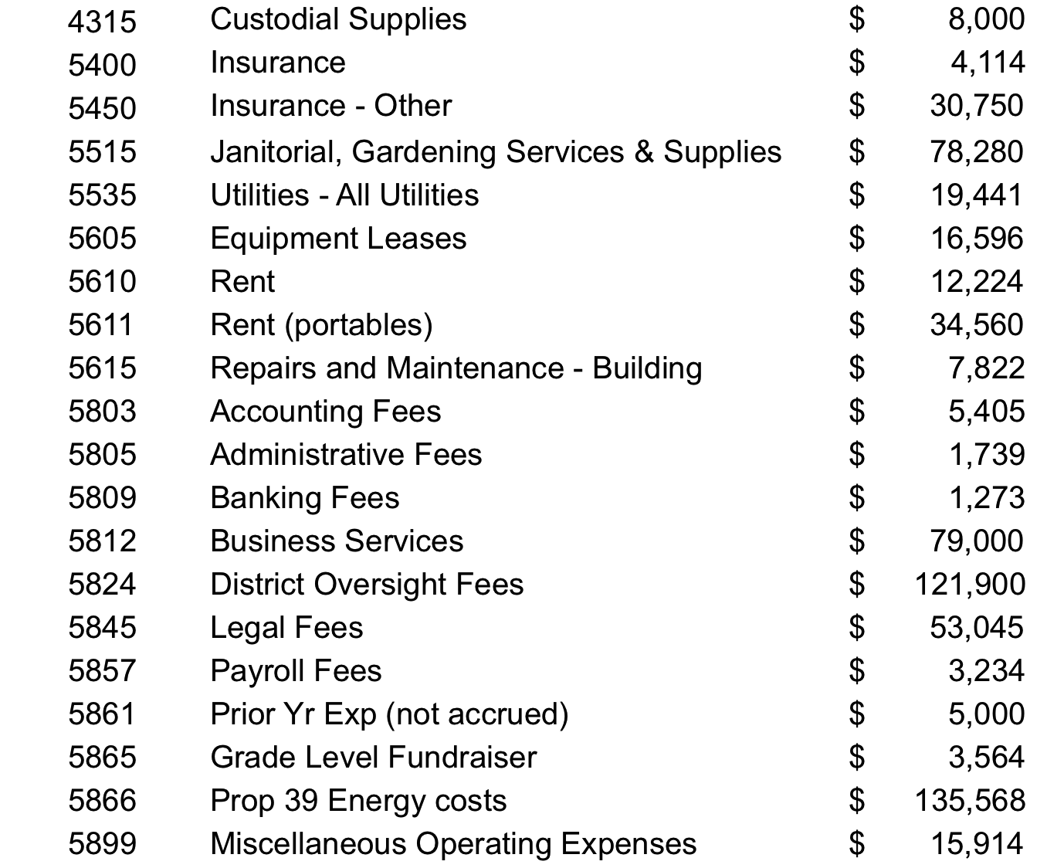
DESCRIPTION | AMOUNT
Total Projected LCFF Revenues for LCAP Year | $3,227,682

Annual Update
LCAP Year Reviewed: 2017-18
Complete a copy of the following table for each of the LEA’s goals from the prior year LCAP. Duplicate the table as needed.

Goal 1
ACLC must create and implement systems to routinely collect and analyze data on the effectiveness of their curriculum, (including benchmark assessments, observation of student engagement, and student work), as well as staff development focusing on data collection and analysis in order to guide instructional decisions.
State and/or Local Priorities addressed by this goal:
State Priorities: 1-5, 7
Local Priorities: 10

Annual Measureable Outcomes
Expected | Actual
Tracking data exists in a useful warehouse tool for all staff and compliance bodies. | Different data lives in different places, including Jupiter, NWEA, Powerschool, and Google Drive. All are accessible for staff.
Create an archive of critical data this includes vital demographic data including:  - State testing (CAASPP)  - College going tests (SAT/ACT)  - College Acceptance rates | An archive was created in the Spring of 2017 and data for 2017-18 will be added to it.
Re-examine school-wide learner outcomes to determine if they are as they need to be. | Through the creation of a Sustainability plan, stakeholders have weighed in on the desired outcomes for our learners. When looking at this data side by side with the graduate profile, a clear picture of the desired outcomes for our learners has emerged. We have begun collecting data on whether or not we are hitting those outcomes.  Furthermore, this year saw an 80% rate of learners going to a four year college or university, and a 96% overall rate of learners going to college.

Actions / Services
Duplicate the Actions/Services from the prior year LCAP and complete a copy of the following table for each. Duplicate the table as needed.

Action 1
Planned  Actions/Services | Actual  Actions/Services | Budgeted  Expenditures | Estimated Actual Expenditures
Tracking data exists in a useful warehouse tool for all staff and compliance bodies. | Different data lives in different places, but all are accessible for staff. | Certified Salaries = $ 1,670,874  Classified Salaries = $191,388  Benefits = $529,154  Instructional Consultants – $56,000  Educational Software = $12,375  Books & Other Reference Materials =$3,750 | $106,500

Action 2
Planned  Actions/Services | Actual  Actions/Services | Budgeted  Expenditures | Estimated Actual Expenditures
PD meeting/planning time to review and discuss our program effectiveness based on data review  Improved levels of performance for targeted demographic groups | Staff meeting time was organized to accommodate for data reviews, collaboration, and discussion around both whole class initiatives and individual learners. These various efforts were allotted roughly two hours each month. | Certified Salaries = $ 1,670,874  Classified Salaries = $191,388  Benefits = $529,154  Instructional Consultants – $56,000  Educational Software = $12,375  Books & Other Reference Materials =$3,750 | $61,650

Action 3
Planned  Actions/Services | Actual  Actions/Services | Budgeted  Expenditures | Estimated Actual Expenditures
Staff and committee meeting time for collaborative discussions & to review data. | An Assessment committee has been newly created this year to facilitate these discussions and evaluations. The Curriculum and Instruction Lead chairs this committee and has come to present to both staff and the board four times each this school year. Discussion time was provided for each. | Certified Salaries = $ 1,670,874  Classified Salaries = $191,388  Benefits = $529,154  Instructional Consultants – $56,000  Educational Software = $12,375  Books & Other Reference Materials =$3,750 | $61,650

Analysis
Complete a copy of the following table for each of the LEA’s goals from the prior year LCAP. Duplicate the table as needed. Use actual annual measurable outcome data, including performance data from the LCFF Evaluation Rubrics, as applicable.
Cell
Describe the overall implementation of the actions/services to achieve the articulated goal.
Data collection, review and analysis, as well as the subsequent action steps, have all been top priority at ACLC this year. Overseeing this system is the newly created position of Curriculum and Instruction Lead, and the primary tools being used to collect benchmark data are the MAP testing system and our own internal grade data. ACLC now uses the NWEA’s MAP testing for benchmark testing in our Math, ELA, and middle school science classes. Social Studies, high school science classes, Spanish classes, and electives use in-house benchmarks to assess their learner’s progress. The data is analyzed and discussed triannually, and is correlated with grade, discipline, and observational data to determine plans for whole classes and individual learners.
Describe the overall effectiveness of the actions/services to achieve the articulated goal as measured by the LEA.
With the large focus on data collection, analysis, and action, staff has become much more comfortable discussing and using data to inform their instruction, according to both informal anecdotal observations and survey results. In terms of academic outputs, ACLC has already seen a rise in MAP scores and a drop in the number of learners that are failing courses, which will be further discussed in the evaluation of goal 4. Specifically, MAP scores indicated an average RIT score increase that corresponds to one year of growth in math classes, and 1.2 years of average growth in ELA classes, based on the national mean scores provided by NWEA.
Explain material differences between Budgeted Expenditures and Estimated Actual Expenditures.
There were obviously large differences between the Budget Expenditures and the Estimated Actual Expenditures. It seems that the previous LCAP writers were unclear on how to appropriately break up the Budgeted Expenditures based on time on task and predicted resources used. Given how imprecise the Budgeted Expenditures were, it is impossible to discuss material differences between what was planned, and what actually occurred. The Estimated Actual Expenditures give an appropriate estimate to how ACLC has spent its funding to further the learners’ education.
These errors have been corrected for the 2018-19 LCAP.
Describe any changes made to this goal, expected outcomes, metrics, or actions and services to achieve this goal as a result of this analysis and analysis of the LCFF Evaluation Rubrics, as applicable. Identify where those changes can be found in the LCAP.
The initial necessary measures to effectively make progress toward this goal have been implemented, and we are already gathering data on the effectiveness of our data driven instruction programs and practices. At this point, the subsequent years from this goal will need to be updated and revised to reflect the successes of this year, and the need for ongoing evaluation and improvement of our data collection, analysis, and action practices.
Additionally, the overall measureable outcomes will need to be revised to reflect the evolved priorities of the school’s efforts around data driven instruction. Due to the large-scale redesign of the ACLC LCAP as a whole, this goal has also been revised to include action items concerning parent communication and community involvement.

Annual Update
LCAP Year Reviewed: 2017-18
Complete a copy of the following table for each of the LEA’s goals from the prior year LCAP. Duplicate the table as needed.

Goal 2
Develop a comprehensive guidance program to ensure students are given appropriate support to increase Career and College readiness.
State and/or Local Priorities addressed by this goal:
State Priorities: 1-6, 8
Local Priorities: 10

Annual Measureable Outcomes
Expected | Actual
Examine what is being provided by the school counselor and college counselor. | Administration worked with the school and college counselor to determine a rough baseline, then quickly moved to what should be provided. The counseling team created and immediately implemented a timeline for the year in August.
Conduct a full examination of career & college readiness curriculum and projects currently in place across all subjects and grades. | Working closely with our sister school, Nea CLC, administration and the counseling team has worked to review and change our approach to college counseling. A new College and Career Prep elective has been added to help interested learners develop further skills, as well. Classroom staff have been largely uninvolved in the redesign process.
Examine the extent to which our “no D-grade” policy | We have discussed our “no D” policy at the board level, and tabled the discussion pending more data from the Sustainability Plan process and surveys. The issue was revisited in May 2018 for the 2018-2019 school year and beyond. It was determined that further data is needed to make an informed decision, and the work has been assigned to the Assessment Committee for spring 2019.

Actions / Services
Duplicate the Actions/Services from the prior year LCAP and complete a copy of the following table for each. Duplicate the table as needed.

Action 1
Planned  Actions/Services | Actual  Actions/Services | Budgeted  Expenditures | Estimated Actual Expenditures
PD/Release time to conduct full examination of classroom assessment data across all grades, disaggregated by subgroups, as well as progress report grades/term. Examine correlation between NC grades and college application, acceptance/denial rates. | Staff has examined grade and assessment data as a whole, as well as disaggregated by subgroups. Data on college application and acceptance/denial rates has proven more difficult to obtain, so the correlations and regressions remain a work in progress. | Certified Salaries = $ 1,670,874  Classified Salaries = $191,388  Benefits = $529,154  Books & Other Reference Materials -$3750 | $95,000

Action 2
Planned  Actions/Services | Actual  Actions/Services | Budgeted  Expenditures | Estimated Actual Expenditures
Career Counseling | The CTE portion of this goal has been suspended, pending the results of a Sustainability Plan. Classroom facilitators have continued to provide a high level of long-term career training through the use of authentic projects and assessments. For example our math classes have looked at investments and career payouts and our seniors have been working on financial literacy and 20 year plans. | Certified Salaries = $ 1,670,874  Classified Salaries = $191,388  Benefits = $529,154  Books & Other Reference Materials -$3750 | $54,150

Action 3
Planned  Actions/Services | Actual  Actions/Services | Budgeted  Expenditures | Estimated Actual Expenditures
1 day per week of college counseling | Our college counselor has worked for the equivalent of one day per week for the year. This has been usually been split into two half days, although that has varied to allow for evening parent information sessions and college field trips. | Certified Salaries = $ 1,670,874  Classified Salaries = $191,388  Benefits = $529,154  Books & Other Reference Materials -$3750 | $12,500

Analysis
Complete a copy of the following table for each of the LEA’s goals from the prior year LCAP. Duplicate the table as needed. Use actual annual measurable outcome data, including performance data from the LCFF Evaluation Rubrics, as applicable.
Cell
Describe the overall implementation of the actions/services to achieve the articulated goal.
During the 2017-18 school year, ACLC staff worked to re-evaluate our guidance plan with the goal of better preparing our graduates for what comes next. Through the simultaneously conducted creation of a sustainability plan, it became clear that the school is moving entirely in a college prep direction. This redirection has led to a great deal of progress on the college readiness side of this goal.

Specifically, the following was accomplished this year:
- Complete re-evaluation and revision of college advising
- Discussions around the appropriateness of the no-D policy
- Creation of a College and Career Prep Elective
- Expansion of College Counseling to 8 hours per week

Describe the overall effectiveness of the actions/services to achieve the articulated goal as measured by the LEA.
These actions have largely centered around the planning and initial implementation phase. We are excited about the progress on these goals, but it remains to be seen how effective the changes will be. Additionally, as we have struggled to collect prior years’ data on college progress and grade correlations, the comparative effectiveness of these changes is impossible to report at this time. We have collected data this concerning college acceptance and process satisfaction, which will serve as a baseline for future evaluations of effectiveness. Those baselines can be found in the action items of Goal 2 of the 2018-19 section. Still, we are very happy with the qualitative measures that we do have available. Seniors report being supported in their college application and financial aid processes, and the initial reviews of the
Explain material differences between Budgeted Expenditures and Estimated Actual Expenditures.
There were obviously large differences between the Budget Expenditures and the Estimated Actual Expenditures. It seems that the previous LCAP writers were unclear on how to appropriately break up the Budgeted Expenditures based on time on task and predicted resources used. Given how imprecise the Budgeted Expenditures were, it is impossible to discuss material differences between what was planned, and what actually occurred. The Estimated Actual Expenditures give an appropriate estimate to how ACLC has spent its funding to further the learners’ education.
These errors have been corrected for the 2018-19 LCAP.
Describe any changes made to this goal, expected outcomes, metrics, or actions and services to achieve this goal as a result of this analysis and analysis of the LCFF Evaluation Rubrics, as applicable. Identify where those changes can be found in the LCAP.
As ACLC has reflected and made plans for the future this year, the school will be moving away from the career prep pathway, at least in the sense of college vs career preparation. However, we have already begun to refocus our efforts for careers after college. This includes renewed attention to building life-long skills through project-based learning and building career skills (e.g. self-advocacy and financial literacy). To build off of our progress from this year, to continue to work on our existing goals, and to reflect the priorities of the school, major revisions have been made to this goal. Specifically, metrics and action items have been added to incorporate a more holistic view of college preparation. These include items concerning staff retention and program facilitation that were housed in goals 3 and 5 of the 2017-18 LCAP.

Annual Update
LCAP Year Reviewed: 2017–18
Complete a copy of the following table for each of the LEA’s goals from the prior year LCAP. Duplicate the table as needed.

Goal 3
Establish an onboarding program for new and returning facilitators to retain highly qualified facilitators.
State and/or Local Priorities addressed by this goal:
State Priorities: 1-7
Local Priorities: none

Annual Measureable Outcomes
Expected | Actual
Continue to develop a new facilitator/staff orientation program. | Before the school year started, new staff reported a day early and were led through an orientation day. This day focused on a culture and practical welcome to the school, giving facilitators a fly-over orientation so they would be prepared for the first week. As an ongoing area of focus this year, the Personnel Committee worked on creating an ongoing onboarding model that mentors new facilitators/staff through their first year at the school.
Create and implement a support plan that includes means to support experienced educators and new-to-the profession teachers. | Administration deployed a new model of professional coaching at ACLC this year centered on mutually built professional goals for each individual employee.
Create an annual plan for professional community building to foster a sense of belonging for all staff, and comfort among colleagues | As a subset of the Personnel Committee, the Sunshine Committee was created in the fall of 2017. This committee works toward the goal of more staff camaraderie through planning events both on and off campus. Further, planning has already begun to build more professional efficacy in the 2018-19 school year. This will include more peer professional learning and staff collaboration on long term planning.

Actions / Services
Duplicate the Actions/Services from the prior year LCAP and complete a copy of the following table for each. Duplicate the table as needed.

Action 1
Planned  Actions/Services | Actual  Actions/Services | Budgeted  Expenditures | Estimated Actual Expenditures
1 full day of professional development | A full day of new staff professional development occurred. | Certified Salaries = $ 1,670,874  Classified Salaries = $191,388  Benefits = $529,154  Instructional Materials & Supplies =$30,900  5110 -Conference Fees = 2700  5220 -Travel and Lodging= $5,175  5305 -Dues & Membership – Professional= $4,670  5310 –Subscriptions = $82 | $13,000

Action 2
Planned  Actions/Services | Actual  Actions/Services | Budgeted  Expenditures | Estimated Actual Expenditures
Survey to evaluate facilitator onboarding  Incorporated department teams into the PD scope and sequence. | While a formal survey was not conducted, feedback was solicited through focus groups and one on one meetings.  Department and grade level teams were both given dedicated PD time on an approximately monthly basis. | Certified Salaries = $ 1,670,874  Classified Salaries = $191,388  Benefits = $529,154  Instructional Materials & Supplies =$30,900  5110 -Conference Fees = 2700  5220 -Travel and Lodging= $5,175  5305 -Dues & Membership – Professional= $4,670  5310 –Subscriptions = $82 | $163,000

Action 3
Planned  Actions/Services | Actual  Actions/Services | Budgeted  Expenditures | Estimated Actual Expenditures
Improved BTSA support, new facilitator coaching and reduced load for new team members. | New facilitators were provided higher levels of coaching through both a contractor and one of the site administrators. For most, this took the form of approximately 3 times per month observations and meetings. This included helping to manage stress and workload when appropriate. | Certified Salaries = $ 1,670,874  Classified Salaries = $191,388  Benefits = $529,154  Instructional Materials & Supplies =$30,900  5110 -Conference Fees = 2700  5220 -Travel and Lodging= $5,175  5305 -Dues & Membership – Professional= $4,670  5310 –Subscriptions = $82 | $208,000

Action 4
Planned  Actions/Services | Actual  Actions/Services | Budgeted  Expenditures | Estimated Actual Expenditures
PD meetings, individual and small group professional coaching, BTSA, curriculum development and classroom management support | These services all occurred this year, although to varying degrees. | Certified Salaries = $ 1,670,874  Classified Salaries = $191,388  Benefits = $529,154  Instructional Materials & Supplies =$30,900  5110 -Conference Fees = 2700  5220 -Travel and Lodging= $5,175  5305 -Dues & Membership – Professional= $4,670  5310 –Subscriptions = $82 | $168,000

Action 5
Planned  Actions/Services | Actual  Actions/Services | Budgeted  Expenditures | Estimated Actual Expenditures
Staff survey results; feedback from new staff during performance review processes | Feedback was not universally gathered during the performance review, and new staff were asked to share their opinions through alternative mediums to surveys due to the complex nature of how each individual experienced the onboarding process. | Certified Salaries = $ 1,670,874  Classified Salaries = $191,388  Benefits = $529,154  Instructional Materials & Supplies =$30,900  5110 -Conference Fees = 2700  5220 -Travel and Lodging= $5,175  5305 -Dues & Membership – Professional= $4,670  5310 –Subscriptions = $82 | $68,500

Analysis
Complete a copy of the following table for each of the LEA’s goals from the prior year LCAP. Duplicate the table as needed. Use actual annual measurable outcome data, including performance data from the LCFF Evaluation Rubrics, as applicable.
Cell
Describe the overall implementation of the actions/services to achieve the articulated goal.
Steps were taken this year to help bring our new staff up to speed and support them through their first year at ACLC. The New Staff Orientation Day was retooled and new staff were provided high levels of instructional support via an outside contractor and site administration. A few of the new staff also took advantage of an offer from administration for a “personal care” day. Feedback was gathered from them in the second semester as to the effectiveness of these new efforts and the system in general.

The Personnel Committee is now reviewing this feedback and designing suggestions for next year.
Describe the overall effectiveness of the actions/services to achieve the articulated goal as measured by the LEA.
All schools have their own unique culture and way of doing things, and ACLC is an extra unique place to work. The egalitarian culture and emphasis on learner efficacy lead to many situations that require guidance for our new facilitators. While we have made strong progress towards this goal, there is still clearly work to be done. We have received both positive feedback and suggestions for continued improvement around our orientation day, coaching model, and the feedback process itself. This feedback has been incorporated into the continued re-evaluation for next year.
Still, celebration is in order. To begin the 2017-18 school year, 40% of all staff were new employees and 47% of full time facilitators were new. For the 2018-19 school year, those numbers will less than half.
Explain material differences between Budgeted Expenditures and Estimated Actual Expenditures.
There were obviously large differences between the Budget Expenditures and the Estimated Actual Expenditures. It seems that the previous LCAP writers were unclear on how to appropriately break up the Budgeted Expenditures based on time on task and predicted resources used. Given how imprecise the Budgeted Expenditures were, it is impossible to discuss material differences between what was planned, and what actually occurred. The Estimated Actual Expenditures give an appropriate estimate to how ACLC has spent its funding to further the learners’ education.
These errors have been corrected for the 2018-19 LCAP.
Describe any changes made to this goal, expected outcomes, metrics, or actions and services to achieve this goal as a result of this analysis and analysis of the LCFF Evaluation Rubrics, as applicable. Identify where those changes can be found in the LCAP.
Staff retention remains a high priority for ACLC for the 2018-19 school year, and the overall Measureable Outcomes will remain unchanged in this LCAP, although this goal has been folded into Goal 2 for 2018-19. The individual action items will be revised to reflect the progress made toward this goal and the results of our survey. Specifically, more attention and further resources need to be allotted toward ongoing mentorship for our new facilitators and staff camaraderie can still be improved. Through fostering higher retention rates of highly impactful staff, ACLC looks to create a stable culture of college-going success.

Annual Update
LCAP Year Reviewed: 2017-2018
Complete a copy of the following table for each of the LEA’s goals from the prior year LCAP. Duplicate the table as needed.

Goal 4
Establish a specific and measurable plan to support and provide intervention for all students performing below proficiency level and staff development that supports instructional practices to better serve students with different learning styles and needs.
State and/or Local Priorities addressed by this goal:
State Priorities: 1-8
Local Priorities: 10

Annual Measureable Outcomes
Expected | Actual
Establish a multi-tiered support system Leadership Team and Fully Implement | A multi-tiered support system (MTSS) leadership team, consisting of the Curriculum and Instruction Lead, the Director of Special Education, and the Counselor, was created. This team was responsible for training staff on MTSS and overseeing its implementation.
Examine discipline process and implement Restorative Practices as part of a multi-tiered support system | With a new Lead Facilitator, the examination of the existing process was delayed into the second semester, but it did occur. Restorative practices have been integrated into the system in an ad hoc way. A full overhaul of ACLC’s discipline practices remains to be completed. We have identified that our suspension rates remain higher than desired for all subgroups.
Engage families of subgroups, encouraging involvement and increasing communication with these families | Faculty and administration has been active in family outreach this year for academic and discipline issues. For daily and minor issues and successes faculty have reached out to families through phone and Jupiter messages. When low level interventions have not led to complete success, the MTSS leadership team and administration have organized formal and informal Learner Support Team meetings to bring parents into the system. These actions have been used across all subgroups.

Actions / Services
Duplicate the Actions/Services from the prior year LCAP and complete a copy of the following table for each. Duplicate the table as needed.

Action 1
Planned  Actions/Services | Actual  Actions/Services | Budgeted  Expenditures | Estimated Actual Expenditures
Multi-tiered support system Team | A multi-tiered support system (MTSS) leadership team, consisting of the Curriculum and Instruction Lead, the Director of Special Education, and the Counselor, was created. | Certified Salaries = $ 1,670,874  Classified Salaries = $191,388  Benefits = $529,154  Text materials – $20,900  Books & Other Reference Materials -$3750  Art & Music Supplies = $3000 | $176,000

Action 2
Planned  Actions/Services | Actual  Actions/Services | Budgeted  Expenditures | Estimated Actual Expenditures
Padlet SELPA Google Docs | ACLC elected not to utilize Padlet, but did provide three trainings with resources to staff on Universal Design Learning and MTSS implementation. | Certified Salaries = $ 1,670,874  Classified Salaries = $191,388  Benefits = $529,154  Text materials – $20,900  Books & Other Reference Materials -$3750  Art & Music Supplies = $3000 | $52,000
Action 3
Planned  Actions/Services | Actual  Actions/Services | Budgeted  Expenditures | Estimated Actual Expenditures
PD on Restorative Practices; Culturally-Sensitive Approaches to Discipline | The new Lead Facilitator chose to delay the implementation of this action item to the 2018-19 school year in order to assess how best to effectively implement a potentially delicate topic. | Certified Salaries = $ 1,670,874  Classified Salaries = $191,388  Benefits = $529,154  Text materials – $20,900  Books & Other Reference Materials -$3750  Art & Music Supplies = $3000 | $0
Action 4
Planned  Actions/Services | Actual  Actions/Services | Budgeted  Expenditures | Estimated Actual Expenditures
Engage families of subgroups, encouraging involvement and increasing communication with these families | ACLC continued a strong tradition of community and stakeholder engagement. Community surveys were conducted and parent communication and family engagement remained high. | Certified Salaries = $ 1,670,874  Classified Salaries = $191,388  Benefits = $529,154  Text materials – $20,900  Books & Other Reference Materials -$3750  Art & Music Supplies = $3000 | $105,000

Action 5
Planned  Actions/Services | Actual  Actions/Services | Budgeted  Expenditures | Estimated Actual Expenditures
School surveys with increased satisfaction from sub-groups | The overall results from our community survey declined sharply this year. The subgroup responses were largely so small that they became statistically insignificant. The overall results did show mostly high levels of satisfaction in most assessed areas. | Certified Salaries = $ 1,670,874  Classified Salaries = $191,388  Benefits = $529,154  Text materials – $20,900  Books & Other Reference Materials -$3750  Art & Music Supplies = $3000 | $22,000

Analysis
Complete a copy of the following table for each of the LEA’s goals from the prior year LCAP. Duplicate the table as needed. Use actual annual measurable outcome data, including performance data from the LCFF Evaluation Rubrics, as applicable.
Cell
Describe the overall implementation of the actions/services to achieve the articulated goal.
Much of ACLC’s progress on Goal 4 was achieved outside of the previously articulated action steps. While an MTSS leadership team took charge of fully implementing MTSS at ACLC, administration also worked with faculty and staff to launch two other major initiatives: Mandatory MAS and Learning Labs. More Academic Support (MAS) is a half hour of tutoring and extra help provided by staff on each Tuesday and Thursday after school. This year, ACLC has mandated participation for failing learners. Additionally, ACLC has replaced some Project Periods with a more structured Learning Lab for those same learners. During Learning Labs, learners also have a facilitator or instructional aid helping to hold learners accountable and provide academic skill development.

These three major initiatives, along with dedicated meeting time to discuss struggling learners and the continued strong support from our community, have led to a gradual decrease in the number of learners failing classes and the number of learners failing three or more.
Describe the overall effectiveness of the actions/services to achieve the articulated goal as measured by the LEA.
At the beginning of the fall 2017 semester, prior to finishing our PD rounds, implementing the intervention systems outlined above, and routinizing our regular meeting times to discuss our learners of concern, ACLC recorded 35% of its learners failing at least one class, with approximately 22% of learners failing more than one class. On the most recent grade report, run May 4th, 2018, 30% of learners were failing a course and only 17% were failing multiple courses.
Explain material differences between Budgeted Expenditures and Estimated Actual Expenditures.
There were obviously large differences between the Budget Expenditures and the Estimated Actual Expenditures. It seems that the previous LCAP writers were unclear on how to appropriately break up the Budgeted Expenditures based on time on task and predicted resources used. Given how imprecise the Budgeted Expenditures were, it is impossible to discuss material differences between what was planned, and what actually occurred. The Estimated Actual Expenditures give an appropriate estimate to how ACLC has spent its funding to further the learners’ education.
These errors have been corrected for the 2018-19 LCAP.
Describe any changes made to this goal, expected outcomes, metrics, or actions and services to achieve this goal as a result of this analysis and analysis of the LCFF Evaluation Rubrics, as applicable. Identify where those changes can be found in the LCAP.
The overall goal will be left in place for the 2018-19 school year, as will the action steps dealing with MTSS implementation and developing staff capacity in regards to culturally responsive pedagogy and restorative justice. The measureable goals will be rewritten to reflect the emphasis on Cultural Bias training and Restorative Justice, continuing to decrease ACLC’s failure rates, and involving more parents of struggling learners. These changes can be found in 2018-19 Goal 3, which will encompass all of this goal, several expanded metrics to account for more equity, as well as pieces of 2017-18 goal 6.
Annual Update
LCAP Year Reviewed: 2017-18
Complete a copy of the following table for each of the LEA’s goals from the prior year LCAP. Duplicate the table as needed.

Goal 5
Re-evaluate the effectiveness of the “Free Period” (Center/Floor Time) in order to ensure learners acquire self-efficacy skills and engage in structured collaboration.
State and/or Local Priorities addressed by this goal:
State Priorities: 1-8
Local Priorities: 10

Annual Measureable Outcomes
Expected | Actual
Clarify the purpose, challenges, and the extent to which floor periods foster learners’ time management and academic independence. | Through board and faculty meetings, learner Leadership classes, and Constitutional Convention, the purpose, challenges, and current efficacy of Project Periods was made clear to the community. Learners all conducted presentations during the Winter on how to remake the ideal Project Period.
Identify and implement any adjustments or supports needed to increase the intended outcomes and address safety | Attendance is now mandatory at the beginning of the period, and the Campus Supervisor and Floor Monitor conduct periodic sweeps to ensure that everyone stays on campus. Learning Labs were created as a more focused alternative for learners that struggle to produce quality work in the existing model. A physical remodel is scheduled for summer 2018.
Assess the effectiveness of the adjustments and continue to plan ways to strengthen positive outcomes and address safety concerns. | Attendance tracking is occurring. A monthly report on the progress and successes of the completed initiatives has been given to the ACLC Board since November 2017.

Actions / Services
Duplicate the Actions/Services from the prior year LCAP and complete a copy of the following table for each. Duplicate the table as needed.

Action 1
Planned  Actions/Services | Actual  Actions/Services | Budgeted  Expenditures | Estimated Actual Expenditures
Google Doc with Identified Purpose, Outcomes and Challenges to Safety and Accountability | To foster more community buy-in and involvement, this quickly grew past a single Google Doc. The most simplified version of this presentation, with the information stated in Measureable Outcome 1 can be found in the Constitutional Convention materials. | Certified Salaries = $ 1,670,874  Classified Salaries = $191,388  Benefits = $529,154  Leadership =$1,030 | $27,500

Action 2
Planned  Actions/Services | Actual  Actions/Services | Budgeted  Expenditures | Estimated Actual Expenditures
Systems identified and put into place, such as Sign-ins/Attendance, etc that address needs | Attendance is now taken in Powerschool and Project Periods are treated as any other class for discipline and truancy issues. Faculty and/or Leadership learners launched a renewed focus on a particular facet of Project Period oversight three different times this year. | Certified Salaries = $ 1,670,874  Classified Salaries = $191,388  Benefits = $529,154  Leadership =$1,030 | $27,500

Analysis
Complete a copy of the following table for each of the LEA’s goals from the prior year LCAP. Duplicate the table as needed. Use actual annual measurable outcome data, including performance data from the LCFF Evaluation Rubrics, as applicable.
Cell
Describe the overall implementation of the actions/services to achieve the articulated goal.
There have been several changes to the Center and Project Periods throughout the 2018-19 school year. From the first few weeks of the school, learners were required to sign in with the faculty on duty and the “Free Period” was rebranded as the Project Period. Learners and faculty alike made these changes topics of official conversations, even requiring all learners to present on their ideal Center and Project Period during the Winter Learner Led Conferences. During this time learners evaluated both the physical space and rules themselves. Their suggestions have been compiled, and several changes will be made to the physical space during the fall of 2018.
Describe the overall effectiveness of the actions/services to achieve the articulated goal as measured by the LEA.
Anecdotally, learners and faculty alike that have been at the school for two or more years have often commented on the change in productivity and inclusivity in the Center this year. The Executive Director has commented three separate times on the productive hum during the largest project period, and several parents have described the changes in the culture around the time. It should be noted that many of these changes were brought about through small programmatic adjustments and more rigorously following our own guidelines and rules. With the changes to the physical space, an additional renewed push to follow our supervision guidelines in August 2018, and an on-boarding program for new learners, we are hopeful that the Center can once again become a model for learner efficacy.
Explain material differences between Budgeted Expenditures and Estimated Actual Expenditures.
There were obviously large differences between the Budget Expenditures and the Estimated Actual Expenditures. It seems that the previous LCAP writers were unclear on how to appropriately break up the Budgeted Expenditures based on time on task and predicted resources used. Given how imprecise the Budgeted Expenditures were, it is impossible to discuss material differences between what was planned, and what actually occurred. The Estimate Actual Expenditures give an appropriate estimate to how ACLC has spent its funding to further the learners’ education.
These errors have been corrected for the 2018-19 LCAP.
Describe any changes made to this goal, expected outcomes, metrics, or actions and services to achieve this goal as a result of this analysis and analysis of the LCFF Evaluation Rubrics, as applicable. Identify where those changes can be found in the LCAP.
While this goal has not been accomplished in its entirety, so much progress has been made this year that this goal will be folded into goals 2 and 3, concerning support for struggling learners to make it to college. Throughout observations this year and in the 2016-17 WASC Visiting Committee Report, it was identified that new learners often struggle to adjust to the freedom of the Project Period and thus fall behind academically. To prevent new learners from becoming struggling learners, we will be addressing “on-boarding” new learners in Goal 3 in 2018-19.
Annual Update
LCAP Year Reviewed: 2017-18
Complete a copy of the following table for each of the LEA’s goals from the prior year LCAP. Duplicate the table as needed.

Goal 6
ACLC deeply values the input and contribution of all stakeholders: learners, parents, staff, and external community members. ACLC is committed to increasing involvement of our community members to empower and engage all stakeholders, including those within the underperforming sub-groups.
State and/or Local Priorities addressed by this goal:
State Priorities: 1,2,5,6
Local Priorities:

Annual Measureable Outcomes
Expected | Actual
Create classroom protocols to include daily or advanced homework posting (Jupiter Grades) and calendar updates. | All staff was trained on Jupiter and Juno usage throughout the year, with particular attention given to new staff in both how to use Jupiter effectively, and what the expectations are around homework posting.
Fully adopt Google drive, including a fully developed organizational plan for all Google documents & folders, to improve Internal Communication of policies, traditions and program, as well as to provide information regarding emergent issues. | All staff use Google Drive for internal document sharing and collation. It is still a work in progress to locate, house, and share all of ACLC’s historical documents. Continual progress is made in this regard.
Develop an annual communication plan for external communication. | While a formal communication plan has not been drafted and adopted by the board, the groundwork for such a plan has been laid. Particularly, the new administrative team has worked with staff and other community members to determine the need for various components of a future plan.

Actions / Services
Duplicate the Actions/Services from the prior year LCAP and complete a copy of the following table for each. Duplicate the table as needed.

Action 1
Planned  Actions/Services | Actual  Actions/Services | Budgeted  Expenditures | Estimated Actual Expenditures
Increased Mid and End year survey results on communication | The participation rate for the mid year survey was lower than in previous years. The Culture Committee is investigating the reasons and is retooling the End of Year survey and communication around it to make sure participation increases. | Certified Salaries = $ 1,670,874  Classified Salaries = $191,388  Benefits = $529,154 | $22,000

Action 2
Planned  Actions/Services | Actual  Actions/Services | Budgeted  Expenditures | Estimated Actual Expenditures
Improved Survey results that demonstrate improved schoolwide communication | Due to the fact that the survey was revised this year, there was not a direct comparison available between questions. Still, Jupiter grades and facilitator communication remain highly reviewed in the community. | Certified Salaries = $ 1,670,874  Classified Salaries = $191,388  Benefits = $529,154 | $22,000

Action 3
Planned  Actions/Services | Actual  Actions/Services | Budgeted  Expenditures | Estimated Actual Expenditures
Google drive, shared communication folder and PD time to populate. | A single universally shared communication folder was not created, but several smaller folders have been shared, and PD time has been set aside to update individual documents and folders. | Certified Salaries = $ 1,670,874  Classified Salaries = $191,388  Benefits = $529,154 | $195,000

Action 4
Planned  Actions/Services | Actual  Actions/Services | Budgeted  Expenditures | Estimated Actual Expenditures
PD to train all users in the developed system | Due to the relative tech comfort and skills of our staff, this was not necessary in a substantial way. | Certified Salaries = $ 1,670,874  Classified Salaries = $191,388  Benefits = $529,154 | $5,000

Action 5
Planned  Actions/Services | Actual  Actions/Services | Budgeted  Expenditures | Estimated Actual Expenditures
Develop an annual communication plan for external communication | While a formal communication plan has not been drafted and adopted by the board, the groundwork for such a plan has been laid. Particularly, the new administrative team has worked with staff and other community members to determine the need for various components of a future plan. | Certified Salaries = $ 1,670,874  Classified Salaries = $191,388  Benefits = $529,154 | $48,000

Analysis
Complete a copy of the following table for each of the LEA’s goals from the prior year LCAP. Duplicate the table as needed. Use actual annual measurable outcome data, including performance data from the LCFF Evaluation Rubrics, as applicable.
Cell
Describe the overall implementation of the actions/services to achieve the articulated goal.
Overall, ACLC have worked this year to create both formal and informal lines of communication with the ACLC community. Internally this has led to more shared folders and a better record keeping system so that staff can more easily access the information they need. Both Google Drive and Jupiter were used for warehousing the various information.

On the family facing side of this goal, survey results were down, but the Culture Committee has identified three easily implementable steps to boost response rate. These include dedicated class time for learners to fill out the survey and wider, earlier, and more frequent distribution of the survey to community members.
Describe the overall effectiveness of the actions/services to achieve the articulated goal as measured by the LEA.
Overall, the basis for improved internal communication was laid throughout the 2017-18 school year. The practice of sharing folders that house several documents instead of individual documents with staff has been established, and new staff have been trained on Jupiter to make sure they are able to find learner information when needed. This has led to greater access of learner information and performance data, enabling more informed instructional decisions (see 2017-18 goal 1).

On the family facing side of this goal, survey results were down, but the Culture Committee has identified three easily implementable steps to boost response rate. These include dedicated class time for learners to fill out the survey and wider, earlier, and more frequent distribution of the survey to community members.
Explain material differences between Budgeted Expenditures and Estimated Actual Expenditures.
There were obviously large differences between the Budget Expenditures and the Estimated Actual Expenditures. It seems that the previous LCAP writers were unclear on how to appropriately break up the Budgeted Expenditures based on time on task and predicted resources used. Given how imprecise the Budgeted Expenditures were, it is impossible to discuss material differences between what was planned, and what actually occurred. The Estimate Actual Expenditures give an appropriate estimate to how ACLC has spent its funding to further the learners’ education.
These errors have been corrected for the 2018-19 LCAP.
Describe any changes made to this goal, expected outcomes, metrics, or actions and services to achieve this goal as a result of this analysis and analysis of the LCFF Evaluation Rubrics, as applicable. Identify where those changes can be found in the LCAP.
This goal will be folded into Goals 1 (Data Driven Instruction) and 2 (College Going Culture) for the 2018-19 school year. Improving parent communication around their learner’s performance is a crucial part in building a data-driven instructional model, and increased staff communication and their ease of finding information and documents directly ties learner success in college preparation.

Final Budget Analysis for 2017-18 LCAP

While reviewing last year’s LCAP action items, it is noted that there is a lack of goals that explicitly target classroom instruction and special education pupil access. These services account for approximately 60% of ACLC staff time, as well as a large number of instructional resources. As such, in reviewing the expenditures for the actual action items, only about half of total expenditures are accounted for.

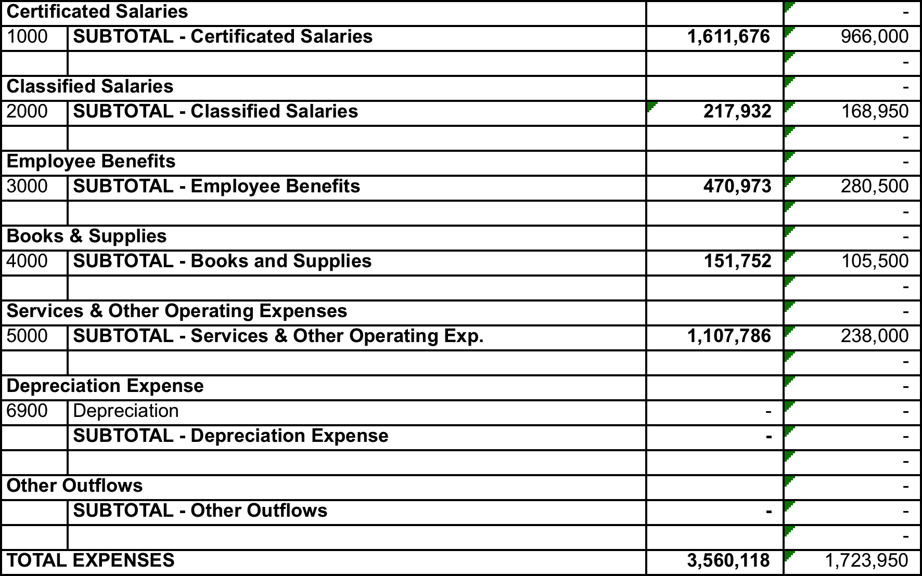

Even when accounting for operating costs (approximately $580,000 for 2017-18) that should not be accounted for, there remains approximately $1,285,000 unaccounted for in this annual review. The majority of these funds can be accounted for in the following way:

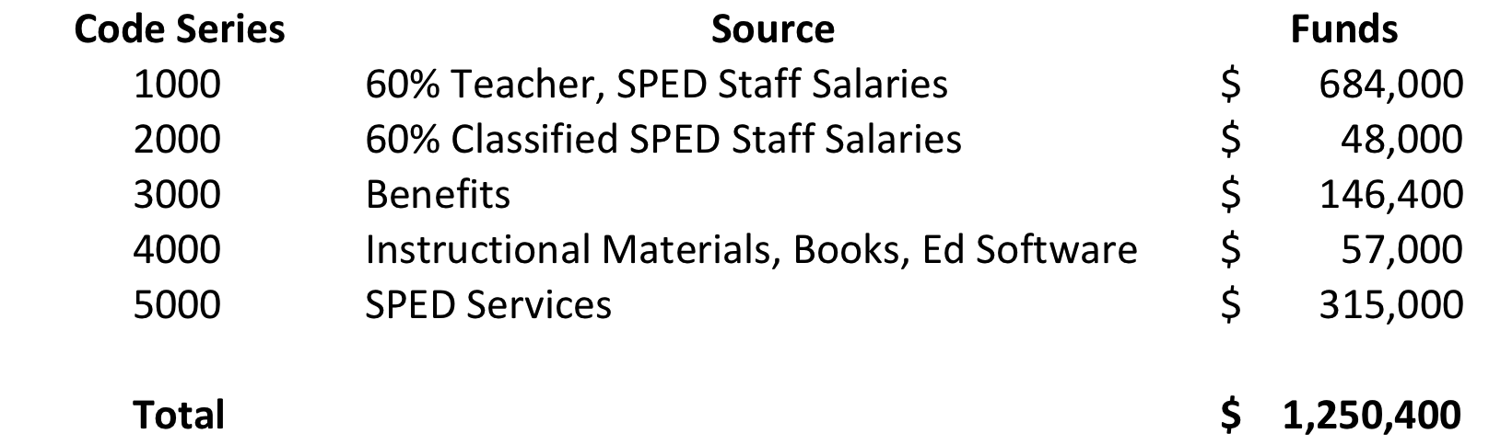

Stakeholder Engagement

LCAP Year: 2017-18

Involvement Process for LCAP and Annual Update
How, when, and with whom did the LEA consult as part of the planning process for this LCAP/Annual Review and Analysis?
Throughout the 2017-18 school year, ACLC administration worked with the site-level board, the charter management organization’s (CLCS’s) board, families and learners to make progress on these goals and to evaluate the processes. During the formal writing, both boards and the faculty have been asked for direct input and feedback, and learner and other community member feedback from a variety of sources has been incorporated as well. It is important to note here that the ACLC site-level board functions as a site-based management council. It is comprised of learners, facilitators, families, administration, and alumni. It is an invaluable group for purposes of providing multiple lenses of feedback on items like the LCAP.
Below is a partial list of different events and sources of information from which information was pulled to create this LCAP:
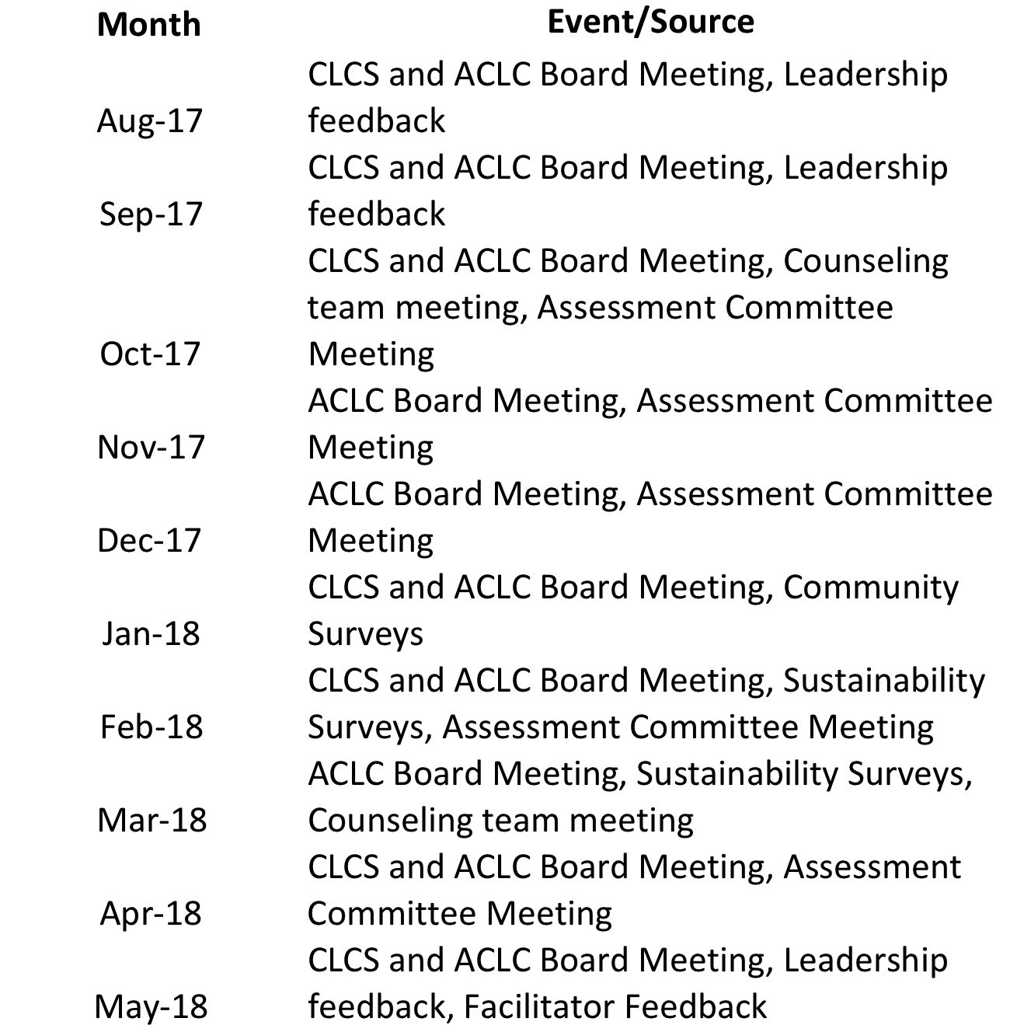

During these different events and in these different surveys, feedback was solicited on goals progress, data analysis and results, and goal development for both current and future years.

Impact on LCAP and Annual Update
How did these consultations impact the LCAP for the upcoming year?
In order to determine the priorities for this plan and honor the democratic tradition of the school, we surveyed the ACLC board, staff, and broader community, including all of those that still subscribe to our listserve. The following is the breakdown of the responses.

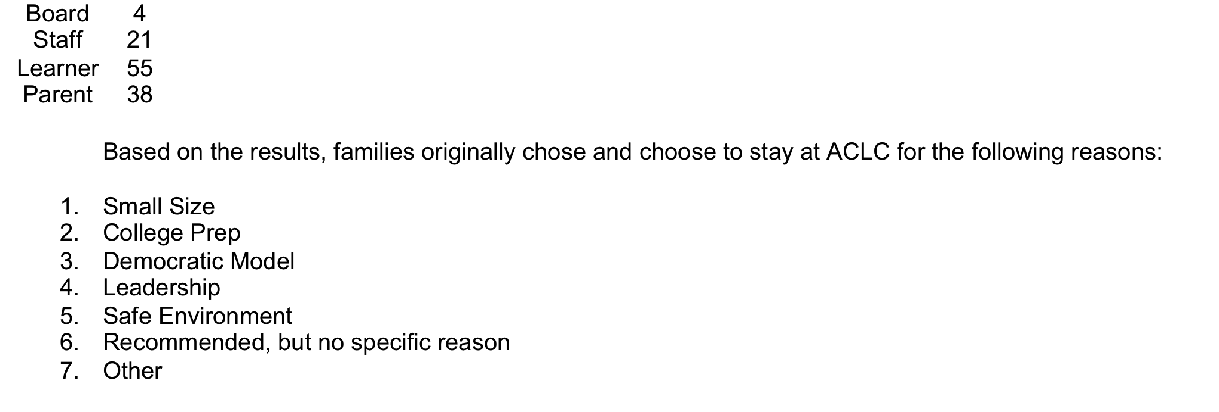

In the open-ended portion of the survey, the themes of College Prep, Leadership, and Democratic Principles came up more than any others, including in answers for the questions regarding initial reasons families chose ACLC, current program, and possible future improvements. It is clear from these results that ACLC has a clear and attractive brand on Alameda as a college prep school that builds leaders through democratic principles. Furthermore, our current stakeholders want to see even more in these areas. Based on this, our work will largely be centered on improving the existing programs and remarketing our existing brand. These efforts will be focused primarily on the Leadership and College Prep components of our program, as our democratic model and methods serve as a means to those ends.

These survey results, as well as the continuous conversations at the events outlined above, have led to a complete restructuring of the LCAP. We have streamlined our goals and how we hope to accomplish them into a more explicit and manageable plan, outlined both in the LCAP Highlights section at the beginning of this document and the specific goals, metric, and action items listed below. Namely, we have focused out efforts to build efficacy and leadership using a democratic model so our learners may thrive in college and beyond.

Goals, Actions, & Services
Strategic Planning Details and Accountability
Complete a copy of the following table for each of the LEA’s goals. Duplicate the table as needed.
(Select from New Goal, Modified Goal, or Unchanged Goal)
New Goal

Goal 1
Collect and analyze data to drive instruction and curriculum access for learners.

State and/or Local Priorities addressed by this goal:
State Priorities: 1-8
Local Priorities: 1-4

Identified Need:
While ACLC has a strong history of standardized test scores, although the 2016-17 school year saw declines in state scores.
Additionally during the most recent WASC visit, the visiting committee commented, “ACLC must create and implement systems to routinely collect and analyze data on the effectiveness of their curriculum, (including benchmark assessments, observation of student engagement, and student work), as well as staff development focusing on data collection and analysis in order to guide instructional decisions.” Clearly ACLC must do more to empirically evaluate what is working for the kids, and what needs to be revised or discontinued.
During the 2017-18 school year, ACLC made great progress toward this goal. As ACLC continues to incorporate data more and more into its educational model, more training and direction is needed to help facilitators effectively use the data that has been collected and analyzed. The staff has made great strides in implementing these systems in the 2017-18 school year, but these initiatives are still too new to be removed from this list.
We have surveyed staff on for feedback on how these initiatives are working so far, and the preliminary results were promising. Staff universally reported using data in their decision-making, although the type of data, and their comfort levels with using various types of data varied. Furthermore, the new benchmark results and other data is still so new that the overall effectiveness and correlations to desired results is still unknown. Overall, staff need ongoing support and more training at deeper levels to continue the strong progress that was made in the 2017-18 year.
Additionally, communication of learner testing and outcomes is currently infrequent and the effectiveness of those communication methods is unknown. More data needs to be collected about how we involve families in their children’s education through the use of data and test scores.

Expected Annual Measureable Outcomes
Metrics/Indicators | Baseline | 2017-18 | 2018-19 | 2019-20
Tracking data exists in a useful warehouse tool for all staff and compliance bodies, including:  - State testing (CAASPP)  - College going tests (SAT/ACT)  - College Acceptance rates  - Grade data  - MAP Testing Data | 50% Completion | 75% Completion | 100% completion | On-going Maintenance
Professional development and meeting time for staff on accessing, analyzing, and using data to inform decision making is facilitated. | N/A | Two hours per month | Two hours per month | Two hours per month
Learner data is effectively and regularly communicated to families of all subgroups. | 50% Completion | 60% completion | 80% completion | 100% completion

Planned Actions / Services
Complete a copy of the following table for each of the LEA’s Actions/Services. Duplicate the table, including Budgeted Expenditures, as needed.

Action 1
For Actions/Services not included as contributing to meeting the Increased or Improved Services Requirement:
Students to be Served:  (Select from All, Students with Disabilities, or Specific Student Groups) | Location(s):  (Select from All Schools, Specific Schools, and/or Specific Grade Spans):
All | ACLC

Actions/Services
Select from New, Modified, or Unchanged for 2017-18 | Select from New, Modified, or Unchanged for 2018-19 | Select from New, Modified, or Unchanged for 2019-20
Modified | Modified | Unchanged

2017-18 Actions/Services | 2018-19 Actions/Services | 2019-20 Actions/Services
Different data lives in different places, including Jupiter, NWEA, Powerschool, and Google Drive. All are accessible for staff. | Learner performance data will be warehoused in a common Google Drive system. | Reports run from different data sources are warehoused in one common, easily accessible location.

Budgeted Expenditures
Year | 2017-18 | 2018-19 | 2019-20
Amount | $105,000 | $105,815 | $105,815
Source | - Certificated Personnel Salaries  - Classified Personnel Salaries  - Employee Benefits  - Books and Supplies  - Services and Other Operating Expenses | - Certificated Personnel Salaries  - Classified Personnel Salaries  - Employee Benefits  - Books and Supplies  - Services and Other Operating Expenses | - Certificated Personnel Salaries  - Classified Personnel Salaries  - Employee Benefits  - Books and Supplies  - Services and Other Operating Expenses
Budget Reference | 1000 series  2000 series  3000 series  4000 series  5000 series | 1000 series  2000 series  3000 series  4000 series  5000 series | 1000 series  2000 series  3000 series  4000 series  5000 series

Planned Actions / Services
Complete a copy of the following table for each of the LEA’s Actions/Services. Duplicate the table, including Budgeted Expenditures, as needed.

Action 2
For Actions/Services not included as contributing to meeting the Increased or Improved Services Requirement:
Students to be Served:  (Select from All, Students with Disabilities, or Specific Student Groups) | Location(s):  (Select from All Schools, Specific Schools, and/or Specific Grade Spans):
All | ACLC

Actions/Services
Select from New, Modified, or Unchanged for 2017-18 | Select from New, Modified, or Unchanged for 2018-19 | Select from New, Modified, or Unchanged for 2019-20
New | New | New

2017-18 Actions/Services | 2018-19 Actions/Services | 2019-20 Actions/Services
Six hours allotted annually for professional development on data-driven instruction. | Four hours allotted annually for professional development on data-driven instruction. | Two hours allotted annually for professional development on data-driven instruction.

Budgeted Expenditures
Year | 2017-18 | 2018-19 | 2019-20
Amount | $20,000 | $14,418 | $10,000
Source | - Certificated Personnel Salaries  - Classified Personnel Salaries  - Employee Benefits  - Books and Supplies  - Services and Other Operating Expenses | - Certificated Personnel Salaries  - Classified Personnel Salaries  - Employee Benefits  - Books and Supplies  - Services and Other Operating Expenses | - Certificated Personnel Salaries  - Classified Personnel Salaries  - Employee Benefits  - Books and Supplies  - Services and Other Operating Expenses
Budget Reference | 1000 series  2000 series  3000 series  4000 series  5000 series | 1000 series  2000 series  3000 series  4000 series  5000 series | 1000 series  2000 series  3000 series  4000 series  5000 series

Action 3
For Actions/Services included as contributing to meeting the Increased or Improved Services Requirement:
Students to be Served:  (Select from English Learners, Foster Youth, and/or Low Income) | Scope of Services:  (Select from LEA-wide, Schoolwide, or Limited to Unduplicated Student Group(s)) | Location(s):  (Select from All Schools, Specific Schools, and/or Specific Grade Spans)
ELL, Low Income | Schoolwide | ACLC

Actions/Services
Select from New, Modified, or Unchanged for 2017-18 | Select from New, Modified, or Unchanged for 2018-19 | Select from New, Modified, or Unchanged for 2019-20
Modified | Unchanged | Unchanged

2017-18 Actions/Services | 2018-19 Actions/Services | 2019-20 Actions/Services
Two hours per month allotted for analysis and decision making in group meetings and individual coaching sessions. | Two hours per month allotted for analysis and decision making in group meetings and individual coaching sessions. | Two hours per month allotted for analysis and decision making in group meetings and individual coaching sessions.

Budgeted Expenditures
Year | 2017-18 | 2018-19 | 2019-20
Amount | $62,000 | $62,019 | $62,019
Source | - Certificated Personnel Salaries  - Classified Personnel Salaries  - Employee Benefits  - Books and Supplies  - Services and Other Operating Expenses | - Certificated Personnel Salaries  - Classified Personnel Salaries  - Employee Benefits  - Books and Supplies  - Services and Other Operating Expenses | - Certificated Personnel Salaries  - Classified Personnel Salaries  - Employee Benefits  - Books and Supplies  - Services and Other Operating Expenses
Budget Reference | 1000 series  2000 series  3000 series  4000 series  5000 series | 1000 series  2000 series  3000 series  4000 series  5000 series | 1000 series  2000 series  3000 series  4000 series  5000 series

Action 4
For Actions/Services not included as contributing to meeting the Increased or Improved Services Requirement:
Students to be Served:  (Select from All, Students with Disabilities, or Specific Student Groups) | Location(s):  (Select from All Schools, Specific Schools, and/or Specific Grade Spans):
All | ACLC

Actions/Services
Select from New, Modified, or Unchanged for 2017-18 | Select from New, Modified, or Unchanged for 2018-19 | Select from New, Modified, or Unchanged for 2019-20
New | New | Unchanged

2017-18 Actions/Services | 2018-19 Actions/Services | 2019-20 Actions/Services
Learner grades are communicated to parents four times each year, and a weekly, automated email goes out to families of failing learners. | Communicate grade and other performance data to all families at least eight times per year. | Communicate grade and other performance data to all families at least eight times per year.

Budgeted Expenditures
Year | 2017-18 | 2018-19 | 2019-20
Amount | $310,000 | $379,044 | $379,044
Source | - Certificated Personnel Salaries  - Classified Personnel Salaries  - Employee Benefits  - Books and Supplies  - Services and Other Operating Expenses | - Certificated Personnel Salaries  - Classified Personnel Salaries  - Employee Benefits  - Books and Supplies  - Services and Other Operating Expenses | - Certificated Personnel Salaries  - Classified Personnel Salaries  - Employee Benefits  - Books and Supplies  - Services and Other Operating Expenses
Budget Reference | 1000 series  2000 series  3000 series  4000 series  5000 series | 1000 series  2000 series  3000 series  4000 series  5000 series | 1000 series  2000 series  3000 series  4000 series  5000 series

Action 5
For Actions/Services not included as contributing to meeting the Increased or Improved Services Requirement:
Students to be Served:  (Select from All, Students with Disabilities, or Specific Student Groups) | Location(s):  (Select from All Schools, Specific Schools, and/or Specific Grade Spans):
All | ACLC

Actions/Services
Select from New, Modified, or Unchanged for 2017-18 | Select from New, Modified, or Unchanged for 2018-19 | Select from New, Modified, or Unchanged for 2019-20
New | New | Unchanged

2017-18 Actions/Services | 2018-19 Actions/Services | 2019-20 Actions/Services
Learner CAASPP and MAP data are currently sent to parents, but if they read and understand it is unknown. | Survey families on their understanding of assessment data and its importance. | Survey families on their understanding of assessment data and its importance.

Budgeted Expenditures
Year | 2017-18 | 2018-19 | 2019-20
Amount | $9,500 | $9,418 | $9,418
Source | - Certificated Personnel Salaries  - Classified Personnel Salaries  - Employee Benefits  - Books and Supplies  - Services and Other Operating Expenses | - Certificated Personnel Salaries  - Classified Personnel Salaries  - Employee Benefits  - Books and Supplies  - Services and Other Operating Expenses | - Certificated Personnel Salaries  - Classified Personnel Salaries  - Employee Benefits  - Books and Supplies  - Services and Other Operating Expenses
Budget Reference | 1000 series  2000 series  3000 series  4000 series  5000 series | 1000 series  2000 series  3000 series  4000 series  5000 series | 1000 series  2000 series  3000 series  4000 series  5000 series

Goals, Actions, & Services
Strategic Planning Details and Accountability
Complete a copy of the following table for each of the LEA’s goals. Duplicate the table as needed.
(Select from New Goal, Modified Goal, or Unchanged Goal)
New Goal

Goal 2
Support learners in becoming college and career ready.

State and/or Local Priorities addressed by this goal:
State Priorities: 1, 2, 4-8
Local Priorities: 2-4

Identified Need:
Throughout the development of a sustainability plan during the 2017-18 school year, ACLC’s college preparation efforts were repeatedly cited as one of the primary reasons families come to the school (45% of respondents) and as a strength of the school. Continued improvement of this already strong program was also named as an area where families want even more! Simply put, families want their learners to go to, be able to pay for, and thrive in college, and they want as much help as possible in making these priorities happen.
Part of ensuring learners are ready to thrive in college upon graduation from ACLC is making sure that they have access to rigorous, college-prep aligned materials. A plethora of journalistic and scholarly articles have been published in the last decade on the rising rates of remediation in college and high college drop out rates of students who are under-prepared for college classes and extra-curricular demands.
To begin the 2017-18 school year, 40% of all staff were new employees and 47% of full time facilitators were new. The negative effects of this turnover on student achievement, behavior, and outcomes have been well studied. To improve upon our strong college going program and culture, a highly qualified, dedicated staff must be hired, on-boarded, and supported throughout their career at ACLC.
ACLC began this work during the 2017-18 school year. The new staff orientation day was retooled, our instructional support model was revamped, and administration solicited feedback from the new staff to determine further revisions. The feedback was clear. New staff would like more continued orientation and mentorship during this first year, as well as more streamlined communication of documents and in staff meetings. These last two items are action items from goal 6 that will be moving into this goal.

Expected Annual Measureable Outcomes
Metrics/Indicators | Baseline | 2017-18 | 2018-19 | 2019-20
The counseling team provides quality college counseling as assessed by learner surveys and college going rate. | Undetermined. | 80% of learners plan to attend a four-year university.  82% of learners are satisfied with college counseling. | 75% of learners are accepted to a four-year university.  >80% of learners are satisfied with college counseling. | 90% of learners are accepted to a four-year university.  >90% of learners are satisfied with college counseling.
Hire, onboard, and adequately support qualified staff. | Unknown staff satisfaction | Unknown Staff Satisfaction | 60% Staff Satisfaction | 80% Staff Satisfaction
All learners have access to rigorous, college prep-aligned curriculum. | 98% Access | 99% Access | >95% Access | Maintain >95% Access

Planned Actions / Services
Complete a copy of the following table for each of the LEA’s Actions/Services. Duplicate the table, including Budgeted Expenditures, as needed.

Action 1
For Actions/Services not included as contributing to meeting the Increased or Improved Services Requirement:
Students to be Served:  (Select from All, Students with Disabilities, or Specific Student Groups) | Location(s):  (Select from All Schools, Specific Schools, and/or Specific Grade Spans):
All | ACLC

Actions/Services
Select from New, Modified, or Unchanged for 2017-18 | Select from New, Modified, or Unchanged for 2018-19 | Select from New, Modified, or Unchanged for 2019-20
Modified | Modified | Unchanged

2017-18 Actions/Services | 2018-19 Actions/Services | 2019-20 Actions/Services
Administration and the counseling team have worked to review and change our approach to college counseling. | Implement and evaluate effectiveness of new College Guidance Program. | Implement and evaluate effectiveness of new College Guidance Program.

Budgeted Expenditures
Year | 2017-18 | 2018-19 | 2019-20
Amount | $18,500 | $18,550 | $18,550
Source | - Certificated Personnel Salaries  - Employee Benefits  - Books and Supplies | - Certificated Personnel Salaries  - Employee Benefits  - Books and Supplies | - Certificated Personnel Salaries  - Employee Benefits  - Books and Supplies
Budget Reference | 1000 series  3000 series  4000 series | 1000 series  3000 series  4000 series | 1000 series  3000 series  4000 series

Action 2
For Actions/Services not included as contributing to meeting the Increased or Improved Services Requirement:
Students to be Served:  (Select from All, Students with Disabilities, or Specific Student Groups) | Location(s):  (Select from All Schools, Specific Schools, and/or Specific Grade Spans):
All | ACLC High School Learners

Actions/Services
Select from New, Modified, or Unchanged for 2017-18 | Select from New, Modified, or Unchanged for 2018-19 | Select from New, Modified, or Unchanged for 2019-20
New | New | Unchanged

2017-18 Actions/Services | 2018-19 Actions/Services | 2019-20 Actions/Services
A new College and Career Prep elective has been added to help interested learners develop further skills, as well. | Implement and evaluate effectiveness of College and Career Elective. | Implement and evaluate effectiveness of College and Career Elective.

Budgeted Expenditures
Year | 2017-18 | 2018-19 | 2019-20
Amount | $18,000 | $18,050 | $18,050
Source | - Certificated Personnel Salaries  - Employee Benefits  - Books and Supplies | - Certificated Personnel Salaries  - Employee Benefits  - Books and Supplies | - Certificated Personnel Salaries  - Employee Benefits  - Books and Supplies
Budget Reference | 1000 series  3000 series  4000 series | 1000 series  3000 series  4000 series | 1000 series  3000 series  4000 series

Action 3
For Actions/Services not included as contributing to meeting the Increased or Improved Services Requirement:
Students to be Served:  (Select from All, Students with Disabilities, or Specific Student Groups) | Location(s):  (Select from All Schools, Specific Schools, and/or Specific Grade Spans):
All | ACLC High School Learners

Actions/Services
Select from New, Modified, or Unchanged for 2017-18 | Select from New, Modified, or Unchanged for 2018-19 | Select from New, Modified, or Unchanged for 2019-20
New | New | Unchanged

2017-18 Actions/Services | 2018-19 Actions/Services | 2019-20 Actions/Services
New staff reported a day early and were led through an orientation day, focusing on a culture and practical welcome to the school. Admin solicited feedback on onboarding program. | Establish and evaluate a year-long onboarding program, based on staff feedback. | Continued evaluation of onboarding program.

Budgeted Expenditures
Year | 2017-18 | 2018-19 | 2019-20
Amount | $75,000 | $137,875 | $137,875
Source | - Certificated Personnel Salaries  - Classified Personnel Salaries  - Employee Benefits  - Services and Other Operating Expenses | - Certificated Personnel Salaries  - Classified Personnel Salaries  - Employee Benefits  - Services and Other Operating Expenses | - Certificated Personnel Salaries  - Classified Personnel Salaries  - Employee Benefits  - Services and Other Operating Expenses
Budget Reference | 1000 series  2000 series  3000 series  5000 series | 1000 series  2000 series  3000 series  5000 series | 1000 series  2000 series  3000 series  5000 series

Action 4
For Actions/Services not included as contributing to meeting the Increased or Improved Services Requirement:
Students to be Served:  (Select from All, Students with Disabilities, or Specific Student Groups) | Location(s):  (Select from All Schools, Specific Schools, and/or Specific Grade Spans):
All | ACLC High School Learners

Actions/Services
Select from New, Modified, or Unchanged for 2017-18 | Select from New, Modified, or Unchanged for 2018-19 | Select from New, Modified, or Unchanged for 2019-20
New | New | Unchanged

2017-18 Actions/Services | 2018-19 Actions/Services | 2019-20 Actions/Services
Administration deployed a new model of professional coaching at ACLC this year centered on mutually built professional goals for each individual employee and observations and check-ins occurring as needed by the staff member. | Implement and evaluate effectiveness of coaching model for all staff. | Implement and evaluate effectiveness of coaching model for all staff.

Budgeted Expenditures
Year | 2017-18 | 2018-19 | 2019-20
Amount | $92,000 | $91,980 | $91,980
Source | - Certificated Personnel Salaries  - Classified Personnel Salaries  - Employee Benefits  - Services and Other Operating Expenses | - Certificated Personnel Salaries  - Classified Personnel Salaries  - Employee Benefits  - Services and Other Operating Expenses | - Certificated Personnel Salaries  - Classified Personnel Salaries  - Employee Benefits  - Services and Other Operating Expenses
Budget Reference | 1000 series  2000 series  3000 series  5000 series | 1000 series  2000 series  3000 series  5000 series | 1000 series  2000 series  3000 series  5000 series

Action 5
For Actions/Services not included as contributing to meeting the Increased or Improved Services Requirement:
Students to be Served:  (Select from All, Students with Disabilities, or Specific Student Groups) | Location(s):  (Select from All Schools, Specific Schools, and/or Specific Grade Spans):
All | ACLC High School Learners

Actions/Services
Select from New, Modified, or Unchanged for 2017-18 | Select from New, Modified, or Unchanged for 2018-19 | Select from New, Modified, or Unchanged for 2019-20
New | New | Modified

2017-18 Actions/Services | 2018-19 Actions/Services | 2019-20 Actions/Services
Several shared documents and folders exist with no purposeful architecture or maintenance. | Develop a shared Google Drive system for documents with a purposeful architecture | Maintain a shared Google Drive system for documents with a purposeful architecture.

Budgeted Expenditures
Year | 2017-18 | 2018-19 | 2019-20
Amount | $30,000 | $95,815 | $95,815
Source | - Certificated Personnel Salaries  - Classified Personnel Salaries  - Employee Benefits  - Books and Supplies  - Services and Other Operating Expenses | - Certificated Personnel Salaries  - Classified Personnel Salaries  - Employee Benefits  - Books and Supplies  - Services and Other Operating Expenses | - Certificated Personnel Salaries  - Classified Personnel Salaries  - Employee Benefits  - Books and Supplies  - Services and Other Operating Expenses
Budget Reference | 1000 series  2000 series  3000 series  4000 series  5000 series | 1000 series  2000 series  3000 series  4000 series  5000 series | 1000 series  2000 series  3000 series  4000 series  5000 series

Action 6
For Actions/Services not included as contributing to meeting the Increased or Improved Services Requirement:
Students to be Served:  (Select from All, Students with Disabilities, or Specific Student Groups) | Location(s):  (Select from All Schools, Specific Schools, and/or Specific Grade Spans):
All | ACLC High School Learners

Actions/Services
Select from New, Modified, or Unchanged for 2017-18 | Select from New, Modified, or Unchanged for 2018-19 | Select from New, Modified, or Unchanged for 2019-20
New | New | Modified

2017-18 Actions/Services | 2018-19 Actions/Services | 2019-20 Actions/Services
A Sunshine Committee was created to work toward the goal of more staff camaraderie through planning events both on and off campus. | Increase opportunities for faculty efficacy through peer professional learning and staff collaboration.  Evaluate faculty efficacy and morale through surveys | Continue effective efforts, evaluate faculty efficacy and morale through surveys

Budgeted Expenditures
Year | 2017-18 | 2018-19 | 2019-20
Amount | $80,000 | $142,050 | $142,050
Source | - Certificated Personnel Salaries  - Classified Personnel Salaries  - Employee Benefits  - Books and Supplies  - Services and Other Operating Expenses | - Certificated Personnel Salaries  - Classified Personnel Salaries  - Employee Benefits  - Books and Supplies  - Services and Other Operating Expenses | - Certificated Personnel Salaries  - Classified Personnel Salaries  - Employee Benefits  - Books and Supplies  - Services and Other Operating Expenses
Budget Reference | 1000 series  2000 series  3000 series  4000 series  5000 series | 1000 series  2000 series  3000 series  4000 series  5000 series | 1000 series  2000 series  3000 series  4000 series  5000 series

Action 7
For Actions/Services not included as contributing to meeting the Increased or Improved Services Requirement:
Students to be Served:  (Select from All, Students with Disabilities, or Specific Student Groups) | Location(s):  (Select from All Schools, Specific Schools, and/or Specific Grade Spans):
All | ACLC Seniors

Actions/Services
Select from New, Modified, or Unchanged for 2017-18 | Select from New, Modified, or Unchanged for 2018-19 | Select from New, Modified, or Unchanged for 2019-20
New | New | Unchanged

2017-18 Actions/Services | 2018-19 Actions/Services | 2019-20 Actions/Services
Senior Seminar has incorporated more post-collegiate and collegiate skill building. | Assess effectiveness of Senior Seminar for collegiate and post-collegiate skill building. | Assess effectiveness of Senior Seminar for collegiate and post-collegiate skill building.

Budgeted Expenditures
Year | 2017-18 | 2018-19 | 2019-20
Amount | $21,000 | $21,050 | $21,050
Source | - Certificated Personnel Salaries  - Employee Benefits  - Books and Supplies | - Certificated Personnel Salaries  - Employee Benefits  - Books and Supplies | - Certificated Personnel Salaries  - Employee Benefits  - Books and Supplies
Budget Reference | 1000 series  3000 series  4000 series | 1000 series  3000 series  4000 series | 1000 series  3000 series  4000 series

Action 8
For Actions/Services not included as contributing to meeting the Increased or Improved Services Requirement:
Students to be Served:  (Select from All, Students with Disabilities, or Specific Student Groups) | Location(s):  (Select from All Schools, Specific Schools, and/or Specific Grade Spans):
All | ACLC High School Learners

Actions/Services
Select from New, Modified, or Unchanged for 2017-18 | Select from New, Modified, or Unchanged for 2018-19 | Select from New, Modified, or Unchanged for 2019-20
New | Unchanged | Unchanged

2017-18 Actions/Services | 2018-19 Actions/Services | 2019-20 Actions/Services
Continual program assessment for alignment with ACLC graduation standards. | Continual program implementation and assessment for alignment with ACLC graduation standards. | Continual program implementation and assessment for alignment with ACLC graduation standards.

Budgeted Expenditures
Year | 2017-18 | 2018-19 | 2019-20
Amount | $1,550,000 | $1,577,895 | $1,577,895
Source | - Certificated Personnel Salaries  - Classified Personnel Salaries  - Employee Benefits  - Books and Supplies  - Services and Other Operating Expenses | - Certificated Personnel Salaries  - Classified Personnel Salaries  - Employee Benefits  - Books and Supplies  - Services and Other Operating Expenses | - Certificated Personnel Salaries  - Classified Personnel Salaries  - Employee Benefits  - Books and Supplies  - Services and Other Operating Expenses
Budget Reference | 1000 series  2000 series  3000 series  4000 series  5000 series | 1000 series  2000 series  3000 series  4000 series  5000 series | 1000 series  2000 series  3000 series  4000 series  5000 series

Action 9
For Actions/Services not included as contributing to meeting the Increased or Improved Services Requirement:
Students to be Served:  (Select from All, Students with Disabilities, or Specific Student Groups) | Location(s):  (Select from All Schools, Specific Schools, and/or Specific Grade Spans):
All | ACLC High School Learners

Actions/Services
Select from New, Modified, or Unchanged for 2017-18 | Select from New, Modified, or Unchanged for 2018-19 | Select from New, Modified, or Unchanged for 2019-20
Modified | New | Modified

2017-18 Actions/Services | 2018-19 Actions/Services | 2019-20 Actions/Services
Learners are required to sign in with the faculty on duty and the “Free Period” was rebranded as the Project Period. Learners and faculty made these changes topics of official conversations. All learners presented on their ideal Center and Project Period structure during the Winter Learner Led Conferences. | Restructure the Center’s physical space to incorporate community suggestions and continue to strictly enforce community standards. | Continue to strictly enforce community standards in the Center.

Budgeted Expenditures
Year | 2017-18 | 2018-19 | 2019-20
Amount | $125,000 | $83,738 | $83,738
Source | - Certificated Personnel Salaries  - Classified Personnel Salaries  - Employee Benefits  - Books and Supplies  - Services and Other Operating Expenses | - Certificated Personnel Salaries  - Classified Personnel Salaries  - Employee Benefits  - Books and Supplies  - Services and Other Operating Expenses | - Certificated Personnel Salaries  - Classified Personnel Salaries  - Employee Benefits  - Books and Supplies  - Services and Other Operating Expenses
Budget Reference | 1000 series  2000 series  3000 series  4000 series  5000 series | 1000 series  2000 series  3000 series  4000 series  5000 series | 1000 series  2000 series  3000 series  4000 series  5000 series

Goals, Actions, & Services
Strategic Planning Details and Accountability
Complete a copy of the following table for each of the LEA’s goals. Duplicate the table as needed.
(Select from New Goal, Modified Goal, or Unchanged Goal)
New Goal

Goal 3
Ensure that learners have access to basic services, supports, and intervention.

State and/or Local Priorities addressed by this goal:
State Priorities: 1-8
Local Priorities: 1, 3, 4

Identified Need:
Although there has been significant improvement toward 2017-18 LCAP goal 4, new learners and learners from traditionally underserved backgrounds continue to show gaps in grades. For example, our rate of low-income learners failing classes is 37% higher than their middle and upper income counterparts. These problems become more acute in the high school years, as the rigor of the school increases and new learners have a harder time adjusting to the school. More needs to be done to incorporate new learners into the ACLC model and to more rapidly identify and more effectively intervene with struggling learners.
ACLC also maintains a higher than desired suspension rate for all subgroups.
While it has been noted that this is likely the result of a one year increase in the number of suspensions related to drugs, alcohol, or weapons, which accounted for 23% of suspensions, ACLC remains committed to revising our discipline policies so that problems are equitably addressed before they rise to the level of suspensions.
Finally, while all parent subgroups are accessible when ACLC staff are trying to get ahold of them, we must maintain a constant vigilance and effort to keep that statement true.

Expected Annual Measureable Outcomes
Metrics/Indicators | Baseline | 2017-18 | 2018-19 | 2019-20
Effective use of MTSS supports and other interventions. | ACLC employed a nascent MTSS team, but staff was not trained. | 99% of learners have access to classes with MTSS systems in place.  99% of learners have access to appropriate interventions. | >95% of learners have access to classes with MTSS systems in place.  >95% of learners have access to appropriate interventions. | >95% of learners have access to classes with MTSS systems in place.  >95% of learners have access to appropriate interventions.
ACLC utilizes a progressive, streamlined discipline system based in restorative practices. | ACLC used AUSD’s discipline matrix as a guide and facilitators each made and enforced unique classroom rules and expectations | 50% complete | New system is 100% established.  Suspension rate declines. | Ongoing evaluation of discipline system.  Suspension ratings Yellow or better for all subgroups.
Families from all subgroups are engaged in their learner’s performance. | Unknown rates of parent response for surveys, leaner concerns. | 100% parent response rate for learners of concern, all subgroups were 100% | >95% parent response rate for learners of concern, no subgroup <90% | >95% parent response rate for learners of concern, no subgroup <90%

Planned Actions / Services
Complete a copy of the following table for each of the LEA’s Actions/Services. Duplicate the table, including Budgeted Expenditures, as needed.

Action 1
For Actions/Services not included as contributing to meeting the Increased or Improved Services Requirement:
Students to be Served:  (Select from All, Students with Disabilities, or Specific Student Groups) | Location(s):  (Select from All Schools, Specific Schools, and/or Specific Grade Spans):
All | ACLC

Actions/Services
Select from New, Modified, or Unchanged for 2017-18 | Select from New, Modified, or Unchanged for 2018-19 | Select from New, Modified, or Unchanged for 2019-20
New | New | Unchanged

2017-18 Actions/Services | 2018-19 Actions/Services | 2019-20 Actions/Services
A multi-tiered support system (MTSS) leadership team, consisting of the Curriculum and Instruction Lead, the Director of Special Education, and the Counselor, was created. | Facilitate coaching conversations around MTSS or differentiation at least once per semester. | Facilitate coaching conversations around MTSS or differentiation at least once per semester.

Budgeted Expenditures
Year | 2017-18 | 2018-19 | 2019-20
Amount | $50,000 | $23,060 | $23,060
Source | - Certificated Personnel Salaries  - Employee Benefits  - Books and Supplies  - Services and Other Operating Expenses | - Certificated Personnel Salaries  - Employee Benefits  - Books and Supplies  - Services and Other Operating Expenses | - Certificated Personnel Salaries  - Employee Benefits  - Books and Supplies  - Services and Other Operating Expenses
Budget Reference | 1000 series  3000 series  4000 series  5000 series | 1000 series  3000 series  4000 series  5000 series | 1000 series  3000 series  4000 series  5000 series

Action 2
For Actions/Services not included as contributing to meeting the Increased or Improved Services Requirement:
Students to be Served:  (Select from All, Students with Disabilities, or Specific Student Groups) | Location(s):  (Select from All Schools, Specific Schools, and/or Specific Grade Spans):
All | ACLC

Actions/Services
Select from New, Modified, or Unchanged for 2017-18 | Select from New, Modified, or Unchanged for 2018-19 | Select from New, Modified, or Unchanged for 2019-20
New | New | Unchanged

2017-18 Actions/Services | 2018-19 Actions/Services | 2019-20 Actions/Services
Staff was trained on UDL and MTSS. Both programs were incorporated into every classroom and semi-monthly staff meetings. | Provide at least 2 hours of PD for staff for MTSS or differentiation. | Provide at least 2 hours of PD for staff for MTSS or differentiation.

Budgeted Expenditures
Year | 2017-18 | 2018-19 | 2019-20
Amount | $50,000 | $24,760 | $24,760
Source | - Certificated Personnel Salaries  - Classified Personnel Salaries  - Employee Benefits  - Books and Supplies | - Certificated Personnel Salaries  - Classified Personnel Salaries  - Employee Benefits  - Books and Supplies | - Certificated Personnel Salaries  - Classified Personnel Salaries  - Employee Benefits  - Books and Supplies
Budget Reference | 1000 series  2000 series  3000 series  4000 series | 1000 series  2000 series  3000 series  4000 series | 1000 series  2000 series  3000 series  4000 series

Action 3
For Actions/Services included as contributing to meeting the Increased or Improved Services Requirement:
Students to be Served:  (Select from English Learners, Foster Youth, and/or Low Income) | Scope of Services:  (Select from LEA-wide, Schoolwide, or Limited to Unduplicated Student Group(s)) | Location(s):  (Select from All Schools, Specific Schools, and/or Specific Grade Spans)
ELL, Low Income | Schoolwide | ACLC

Actions/Services
Select from New, Modified, or Unchanged for 2017-18 | Select from New, Modified, or Unchanged for 2018-19 | Select from New, Modified, or Unchanged for 2019-20
New | New | Unchanged

2017-18 Actions/Services | 2018-19 Actions/Services | 2019-20 Actions/Services
Mandatory MAS and Learning Labs were established to provide support for failing learners. | Continue and evaluate effectiveness of MAS, Learning Labs. | Continue and evaluate effectiveness of MAS, Learning Labs.

Budgeted Expenditures
Year | 2017-18 | 2018-19 | 2019-20
Amount | $65,000 | $75,215 | $75,215
Source | - Certificated Personnel Salaries  - Classified Personnel Salaries  - Employee Benefits  - Books and Supplies  - Services and Other Operating Expenses | - Certificated Personnel Salaries  - Classified Personnel Salaries  - Employee Benefits  - Books and Supplies  - Services and Other Operating Expenses | - Certificated Personnel Salaries  - Classified Personnel Salaries  - Employee Benefits  - Books and Supplies  - Services and Other Operating Expenses
Budget Reference | 1000 series  2000 series  3000 series  4000 series  5000 series | 1000 series  2000 series  3000 series  4000 series  5000 series | 1000 series  2000 series  3000 series  4000 series  5000 series

Action 4
For Actions/Services not included as contributing to meeting the Increased or Improved Services Requirement:
Students to be Served:  (Select from All, Students with Disabilities, or Specific Student Groups) | Location(s):  (Select from All Schools, Specific Schools, and/or Specific Grade Spans):
All | ACLC

Actions/Services
Select from New, Modified, or Unchanged for 2017-18 | Select from New, Modified, or Unchanged for 2018-19 | Select from New, Modified, or Unchanged for 2019-20
New | New | Modified

2017-18 Actions/Services | 2018-19 Actions/Services | 2019-20 Actions/Services
A pilot program for new learners in learning labs was established. | Establish new learner orientation program through Learning Labs in September. | Evaluate new learner orientation programs.

Budgeted Expenditures
Year | 2017-18 | 2018-19 | 2019-20
Amount | $2,000 | $6,500 | $6,500
Source | - Certificated Personnel Salaries  - Classified Personnel Salaries | - Certificated Personnel Salaries  - Classified Personnel Salaries | - Certificated Personnel Salaries  - Classified Personnel Salaries
Budget Reference | 1000 series  2000 series | 1000 series  2000 series | 1000 series  2000 series

Action 5
For Actions/Services not included as contributing to meeting the Increased or Improved Services Requirement:
Students to be Served:  (Select from All, Students with Disabilities, or Specific Student Groups) | Location(s):  (Select from All Schools, Specific Schools, and/or Specific Grade Spans):
All | ACLC

Actions/Services
Select from New, Modified, or Unchanged for 2017-18 | Select from New, Modified, or Unchanged for 2018-19 | Select from New, Modified, or Unchanged for 2019-20
New | New | Modified

2017-18 Actions/Services | 2018-19 Actions/Services | 2019-20 Actions/Services
The new Lead Facilitator examined current system and related cultural practices. The ACLC Board adopted a new discipline matrix. | Establish a new holistic, progressive, and streamlined discipline system based in restorative practices. | Evaluate the discipline system.

Budgeted Expenditures
Year | 2017-18 | 2018-19 | 2019-20
Amount | $125,000 | $125,031 | $125,031
Source | - Certificated Personnel Salaries  - Classified Personnel Salaries  - Employee Benefits  - Books and Supplies | - Certificated Personnel Salaries  - Classified Personnel Salaries  - Employee Benefits  - Books and Supplies | - Certificated Personnel Salaries  - Classified Personnel Salaries  - Employee Benefits  - Books and Supplies
Budget Reference | 1000 series  2000 series  3000 series  4000 series | 1000 series  2000 series  3000 series  4000 series | 1000 series  2000 series  3000 series  4000 series

Action 6
For Actions/Services not included as contributing to meeting the Increased or Improved Services Requirement:
Students to be Served:  (Select from All, Students with Disabilities, or Specific Student Groups) | Location(s):  (Select from All Schools, Specific Schools, and/or Specific Grade Spans):
All | ACLC

Actions/Services
Select from New, Modified, or Unchanged for 2017-18 | Select from New, Modified, or Unchanged for 2018-19 | Select from New, Modified, or Unchanged for 2019-20
New | New | Unchanged

2017-18 Actions/Services | 2018-19 Actions/Services | 2019-20 Actions/Services
Restorative practices have been integrated into the system in an ad hoc way. | Provide PD on classroom management and restorative practices. | Provide PD on classroom management and restorative practices.

Budgeted Expenditures
Year | 2017-18 | 2018-19 | 2019-20
Amount | $15,000 | $26,560 | $26,560
Source | - Certificated Personnel Salaries  - Classified Personnel Salaries  - Employee Benefits  - Services and Other Operating Expenses | - Certificated Personnel Salaries  - Classified Personnel Salaries  - Employee Benefits  - Services and Other Operating Expenses | - Certificated Personnel Salaries  - Classified Personnel Salaries  - Employee Benefits  - Services and Other Operating Expenses
Budget Reference | 1000 series  2000 series  3000 series  5000 series | 1000 series  2000 series  3000 series  5000 series | 1000 series  2000 series  3000 series  5000 series

Action 7
For Actions/Services included as contributing to meeting the Increased or Improved Services Requirement:
Students to be Served:  (Select from English Learners, Foster Youth, and/or Low Income) | Scope of Services:  (Select from LEA-wide, Schoolwide, or Limited to Unduplicated Student Group(s)) | Location(s):  (Select from All Schools, Specific Schools, and/or Specific Grade Spans)
English Learners | Schoolwide | ACLC

Actions/Services
Select from New, Modified, or Unchanged for 2017-18 | Select from New, Modified, or Unchanged for 2018-19 | Select from New, Modified, or Unchanged for 2019-20
New | New | Unchanged

2017-18 Actions/Services | 2018-19 Actions/Services | 2019-20 Actions/Services
No PD was provided on Culturally Responsive Pedagogy and Discipline. | Provide PD on Culturally Responsive Pedagogy and Discipline. | Provide PD on Culturally Responsive Pedagogy and Discipline.

Budgeted Expenditures
Year | 2017-18 | 2018-19 | 2019-20
Amount | $0 | $26,560 | $26,560
Source |  | - Certificated Personnel Salaries  - Classified Personnel Salaries  - Employee Benefits  - Services and Other Operating Expenses | - Certificated Personnel Salaries  - Classified Personnel Salaries  - Employee Benefits  - Services and Other Operating Expenses
Budget Reference |  | 1000 series  2000 series  3000 series  5000 series | 1000 series  2000 series  3000 series  5000 series

Action 8
For Actions/Services included as contributing to meeting the Increased or Improved Services Requirement:
Students to be Served:  (Select from English Learners, Foster Youth, and/or Low Income) | Scope of Services:  (Select from LEA-wide, Schoolwide, or Limited to Unduplicated Student Group(s)) | Location(s):  (Select from All Schools, Specific Schools, and/or Specific Grade Spans)
English Learners | Schoolwide | ACLC

Actions/Services
Select from New, Modified, or Unchanged for 2017-18 | Select from New, Modified, or Unchanged for 2018-19 | Select from New, Modified, or Unchanged for 2019-20
New | Modified | Unchanged

2017-18 Actions/Services | 2018-19 Actions/Services | 2019-20 Actions/Services
Establish English Language Learning classes | Continue and evaluate English Language Learning classes | Continue and evaluate English Language Learning classes

Budgeted Expenditures
Year | 2017-18 | 2018-19 | 2019-20
Amount | $11,000 | $11,000 | $11,000
Source | - Certificated Personnel Salaries | - Certificated Personnel Salaries | - Certificated Personnel Salaries
Budget Reference | 1000 series | 1000 series | 1000 series

Action 9
For Actions/Services not included as contributing to meeting the Increased or Improved Services Requirement:
Students to be Served:  (Select from All, Students with Disabilities, or Specific Student Groups) | Location(s):  (Select from All Schools, Specific Schools, and/or Specific Grade Spans):
All | ACLC

Actions/Services
Select from New, Modified, or Unchanged for 2017-18 | Select from New, Modified, or Unchanged for 2018-19 | Select from New, Modified, or Unchanged for 2019-20
New | New | Unchanged

2017-18 Actions/Services | 2018-19 Actions/Services | 2019-20 Actions/Services
Communications generated by ACLC are almost all only in English. | All essential communications will be translated into Spanish, Mandarin, and Arabic. | All essential communications will be translated into Spanish, Mandarin, and Arabic.

Budgeted Expenditures
Year | 2017-18 | 2018-19 | 2019-20
Amount | $1,000 | $2,000 | $2,000
Source | Services and Other Operating Expenses | Services and Other Operating Expenses | Services and Other Operating Expenses
Budget Reference | 5000 series | 5000 series | 5000 series

Action 10
For Actions/Services not included as contributing to meeting the Increased or Improved Services Requirement:
Students to be Served:  (Select from All, Students with Disabilities, or Specific Student Groups) | Location(s):  (Select from All Schools, Specific Schools, and/or Specific Grade Spans):
All | ACLC

Actions/Services
Select from New, Modified, or Unchanged for 2017-18 | Select from New, Modified, or Unchanged for 2018-19 | Select from New, Modified, or Unchanged for 2019-20
New | New | Unchanged

2017-18 Actions/Services | 2018-19 Actions/Services | 2019-20 Actions/Services
The 2017-18 mid-year survey rates were 45% of learners and 7% of families. | Families will respond to the mid-year and end-of-year surveys at increased rates. | Families will respond to the mid-year and end-of-year surveys at rates of at least 75% of learners and 25% of families.

Budgeted Expenditures
Year | 2017-18 | 2018-19 | 2019-20
Amount | $10,000 | $10,567 | $10,567
Source | - Certificated Personnel Salaries  - Services and Other Operating Expenses | - Certificated Personnel Salaries  - Services and Other Operating Expenses | - Certificated Personnel Salaries  - Services and Other Operating Expenses
Budget Reference | 1000 series  5000 series | 1000 series  5000 series | 1000 series  5000 series

Action 11
For Actions/Services included as contributing to meeting the Increased or Improved Services Requirement:
Students to be Served:  (Select from English Learners, Foster Youth, and/or Low Income) | Scope of Services:  (Select from LEA-wide, Schoolwide, or Limited to Unduplicated Student Group(s)) | Location(s):  (Select from All Schools, Specific Schools, and/or Specific Grade Spans)
Low Income, Foster | Schoolwide | ACLC

Actions/Services
Select from New, Modified, or Unchanged for 2017-18 | Select from New, Modified, or Unchanged for 2018-19 | Select from New, Modified, or Unchanged for 2019-20
New | New | Unchanged

2017-18 Actions/Services | 2018-19 Actions/Services | 2019-20 Actions/Services
Provide access to essential and non-essential (e.g. yearbooks) school supplies | Provide access to essential and non-essential (e.g. yearbooks) school supplies | Provide access to essential and non-essential (e.g. yearbooks) school supplies

Budgeted Expenditures
Year | 2017-18 | 2018-19 | 2019-20
Amount | $68,000 | $68,810 | $68,810
Source | - Certificated Personnel Salaries  - Classified Personnel Salaries  - Books and Supplies  - Services and Other Operating Expenses | - Certificated Personnel Salaries  - Classified Personnel Salaries  - Books and Supplies  - Services and Other Operating Expenses | - Certificated Personnel Salaries  - Classified Personnel Salaries  - Books and Supplies  - Services and Other Operating Expenses
Budget Reference | 1000 series  2000 series  4000 series  5000 series | 1000 series  2000 series  4000 series  5000 series | 1000 series  2000 series  4000 series  5000 series

Demonstration of Increased or Improved Services for Unduplicated Pupils
LCAP Year: 2018-19
Estimated Supplemental and Concentration Grant Funds | Percentage to Increase or Improve Services
$196,262 | 6.51%

Describe how services provided for unduplicated pupils are increased or improved by at least the percentage identified above, either qualitatively or quantitatively, as compared to services provided for all students in the LCAP year.

Identify each action/service being funded and provided on a schoolwide or LEA-wide basis. Include the required descriptions supporting each schoolwide or LEA-wide use of funds (see instructions).

Meeting time to identify struggling learners, including possible ELD or other Unduplicated Pupils. The first step in ensuring that learners with special needs receive extra services and support is to identify those learners. We ask about different potential signs during the admission process, test new learners, and work to determine status through other identifiers. Still, classroom facilitators provide a necessary line of identification, and that feedback needs to be solicited from them. According to the research of Walsh and Farrell, even educators with limited to no training are able to identify and aid learners in underprivileged circumstances.
Learning Labs and Mandatory MAS. Learning Labs and Mandatory MAS disproportionately serve low-income learners. These classes provide a more structured environment where all learners also receive support in building basic academic skills. The rate of low-income learners in learning labs is 42% compared to a 31% rate of middle and high income learners.
ELD Classes. English learners have been provided an extra two hours weekly of small group instruction that is based on language acquisition best practices.
Translated Documents. To improve family access to their children’s learning. ACLC will be translating all essential documents into Arabic, Mandarin, and Spanish. If ACLC does not pay to have the documents translated, ACLC will continue to have a gap in the services provided to English and LOTE families.
School Supplies. To ensure that all learners are able to equitably take part in the ACLC experience, funds have been set aside for both essential and non-essential (e.g. yearbooks) school supplies. Based on the growing results of high schools and universities nation-wide, ACLC is committed to bridging the experiential gap for low-income learners through dedicated extracurricular funding.

Addendum
The Local Control and Accountability Plan (LCAP) and Annual Update Template documents and communicates local educational agencies’ (LEAs) actions and expenditures to support student outcomes and overall performance. The LCAP is a three-year plan, which is reviewed and updated annually, as required. Charter schools may complete the LCAP to align with the term of the charter school’s budget, typically one year, which is submitted to the school’s authorizer. The LCAP and Annual Update Template must be completed by all LEAs each year.
For school districts, the LCAP must describe, for the school district and each school within the district, goals and specific actions to achieve those goals for all students and each student group identified by the Local Control Funding Formula (LCFF) (ethnic, socioeconomically disadvantaged, English learners, foster youth, pupils with disabilities, and homeless youth), for each of the state priorities and any locally identified priorities.
For county offices of education, the LCAP must describe, for each county office of education-operated school and program, goals and specific actions to achieve those goals for all students and each LCFF student group funded through the county office of education (students attending juvenile court schools, on probation or parole, or expelled under certain conditions) for each of the state priorities and any locally identified priorities. School districts and county offices of education may additionally coordinate and describe in their LCAPs services funded by a school district that are provided to students attending county-operated schools and programs, including special education programs.
If a county superintendent of schools has jurisdiction over a single school district, the county board of education and the governing board of the school district may adopt and file for review and approval a single LCAP consistent with the requirements in Education Code (EC) sections 52060, 52062, 52066, 52068, and 52070. The LCAP must clearly articulate to which entity’s budget (school district or county superintendent of schools) all budgeted and actual expenditures are aligned.
Charter schools must describe goals and specific actions to achieve those goals for all students and each LCFF subgroup of students including students with disabilities and homeless youth, for each of the state priorities that apply for the grade levels served or the nature of the program operated by the charter school, and any locally identified priorities. For charter schools, the inclusion and description of goals for state priorities in the LCAP may be modified to meet the grade levels served and the nature of the programs provided, including modifications to reflect only the statutory requirements explicitly applicable to charter schools in the EC. Changes in LCAP goals and actions/services for charter schools that result from the annual update process do not necessarily constitute a material revision to the school’s charter petition.
For questions related to specific sections of the template, please see instructions below:

Instructions: Linked Table of Contents
Plan Summary
Annual Update
Stakeholder Engagement
Goals, Actions, and Services
Planned Actions/Services
Demonstration of Increased or Improved Services for Unduplicated Students
For additional questions or technical assistance related to completion of the LCAP template, please contact the local county office of education, or the CDE’s Local Agency Systems Support Office at: 916-319-0809 or by email at: lcff@cde.ca.gov.

Plan Summary
The LCAP is intended to reflect an LEA’s annual goals, actions, services and expenditures within a fixed three-year planning cycle. LEAs must include a plan summary for the LCAP each year.
When developing the LCAP, enter the appropriate LCAP year, and address the prompts provided in these sections. When developing the LCAP in year 2 or year 3, enter the appropriate LCAP year and replace the previous summary information with information relevant to the current year LCAP.
In this section, briefly address the prompts provided. These prompts are not limits. LEAs may include information regarding local program(s), community demographics, and the overall vision of the LEA. LEAs may also attach documents (e.g., the LCFF Evaluation Rubrics data reports) if desired and/or include charts illustrating goals, planned outcomes, actual outcomes, or related planned and actual expenditures.
An LEA may use an alternative format for the plan summary as long as it includes the information specified in each prompt and the budget summary table.
The reference to LCFF Evaluation Rubrics means the evaluation rubrics adopted by the State Board of Education under EC Section 52064.5.

Budget Summary
The LEA must complete the LCAP Budget Summary table as follows:
- Total LEA General Fund Budget Expenditures for the LCAP Year: This amount is the LEA’s total budgeted General Fund expenditures for the LCAP year. The LCAP year means the fiscal year for which an LCAP is adopted or updated by July 1. The General Fund is the main operating fund of the LEA and accounts for all activities not accounted for in another fund. All activities are reported in the General Fund unless there is a compelling reason to account for an activity in another fund. For further information please refer to the California School Accounting Manual (http://www.cde.ca.gov/fg/ac/sa/). (Note: For some charter schools that follow governmental fund accounting, this amount is the total budgeted expenditures in the Charter Schools Special Revenue Fund. For charter schools that follow the not-for-profit accounting model, this amount is total budgeted expenses, such as those budgeted in the Charter Schools Enterprise Fund.)
- Total Funds Budgeted for Planned Actions/Services to Meet the Goals in the LCAP for the LCAP Year: This amount is the total of the budgeted expenditures associated with the actions/services included for the LCAP year from all sources of funds, as reflected in the LCAP. To the extent actions/services and/or expenditures are listed in the LCAP under more than one goal, the expenditures should be counted only once.
- Description of any use(s) of the General Fund Budget Expenditures specified above for the LCAP year not included in the LCAP: Briefly describe expenditures included in total General Fund Expenditures that are not included in the total funds budgeted for planned actions/services for the LCAP year. (Note: The total funds budgeted for planned actions/services may include funds other than general fund expenditures.)
- Total Projected LCFF Revenues for LCAP Year: This amount is the total amount of LCFF funding the LEA estimates it will receive pursuant to EC sections 42238.02 (for school districts and charter schools) and 2574 (for county offices of education), as implemented by EC sections 42238.03 and 2575 for the LCAP year respectively.

Annual Update
The planned goals, expected outcomes, actions/services, and budgeted expenditures must be copied verbatim from the previous year’s* approved LCAP; in addition, list the state and/or local priorities addressed by the planned goals. Minor typographical errors may be corrected.
* For example, for LCAP year 2017/18 of the 2017/18 – 2019/20 LCAP, review the goals in the 2016/17 LCAP. Moving forward, review the goals from the most recent LCAP year. For example, LCAP year 2020/21 will review goals from the 2019/20 LCAP year, which is the last year of the 2017/18 – 2019/20 LCAP.

Annual Measurable Outcomes
For each goal in the prior year, identify and review the actual measurable outcomes as compared to the expected annual measurable outcomes identified in the prior year for the goal.

Actions/Services
Identify the planned Actions/Services and the budgeted expenditures to implement these actions toward achieving the described goal. Identify the actual actions/services implemented to meet the described goal and the estimated actual annual expenditures to implement the actions/services. As applicable, identify any changes to the students or student groups served, or to the planned location of the actions/services provided.

Analysis
Using actual annual measurable outcome data, including data from the LCFF Evaluation Rubrics, analyze whether the planned actions/services were effective in achieving the goal. Respond to the prompts as instructed.
- Describe the overall implementation of the actions/services to achieve the articulated goal. Include a discussion of relevant challenges and successes experienced with the implementation process.
- Describe the overall effectiveness of the actions/services to achieve the articulated goal as measured by the LEA.
- Explain material differences between Budgeted Expenditures and Estimated Actual Expenditures. Minor variances in expenditures or a dollar-for-dollar accounting is not required.
- Describe any changes made to this goal, expected outcomes, metrics, or actions and services to achieve this goal as a result of this analysis and analysis of the data provided in the LCFF Evaluation Rubrics, as applicable. Identify where those changes can be found in the LCAP.

Stakeholder Engagement
Meaningful engagement of parents, students, and other stakeholders, including those representing the student groups identified by LCFF, is critical to the development of the LCAP and the budget process. EC identifies the minimum consultation requirements for school districts and county offices of education as consulting with teachers, principals, administrators, other school personnel, local bargaining units of the school district, parents, and pupils in developing the LCAP. EC requires charter schools to consult with teachers, principals, administrators, other school personnel, parents, and pupils in developing the LCAP. In addition, EC Section 48985 specifies the requirements for the translation of notices, reports, statements, or records sent to a parent or guardian.

The LCAP should be shared with, and LEAs should request input from, school site-level advisory groups, as applicable (e.g., school site councils, English Learner Advisory Councils, student advisory groups, etc.), to facilitate alignment between school-site and district-level goals and actions. An LEA may incorporate or reference actions described in other plans that are being undertaken to meet specific goals.
Instructions: The stakeholder engagement process is an ongoing, annual process. The requirements for this section are the same for each year of a three-year LCAP. When developing the LCAP, enter the appropriate LCAP year, and describe the stakeholder engagement process used to develop the LCAP and Annual Update. When developing the LCAP in year 2 or year 3, enter the appropriate LCAP year and replace the previous stakeholder narrative(s) and describe the stakeholder engagement process used to develop the current year LCAP and Annual Update.
School districts and county offices of education: Describe the process used to consult with the Parent Advisory Committee, the English Learner Parent Advisory Committee, parents, students, school personnel, the LEA’s local bargaining units, and the community to inform the development of the LCAP and the annual review and analysis for the indicated LCAP year.
Charter schools: Describe the process used to consult with teachers, principals, administrators, other school personnel, parents, and students to inform the development of the LCAP and the annual review and analysis for the indicated LCAP year.
Describe how the consultation process impacted the development of the LCAP and annual update for the indicated LCAP year, including the goals, actions, services, and expenditures.

Goals, Actions, and Services
LEAs must include a description of the annual goals, for all students and each LCFF identified group of students, to be achieved for each state priority as applicable to type of LEA. An LEA may also include additional local priorities. This section shall also include a description of the specific planned actions an LEA will take to meet the identified goals, and a description of the expenditures required to implement the specific actions.
School districts and county offices of education: The LCAP is a three-year plan, which is reviewed and updated annually, as required.
Charter schools: The number of years addressed in the LCAP may align with the term of the charter schools budget, typically one year, which is submitted to the school’s authorizer. If year 2 and/or year 3 is not applicable, charter schools must specify as such.

New, Modified, Unchanged
As part of the LCAP development process, which includes the annual update and stakeholder engagement, indicate if the goal, identified need, related state and/or local priorities, and/or expected annual measurable outcomes for the current LCAP year or future LCAP years are modified or unchanged from the previous year’s LCAP; or, specify if the goal is new.

Goal
State the goal. LEAs may number the goals using the “Goal #” box for ease of reference. A goal is a broad statement that describes the desired result to which all actions/services are directed. A goal answers the question: What is the LEA seeking to achieve?

Related State and/or Local Priorities
List the state and/or local priorities addressed by the goal. The LCAP must include goals that address each of the state priorities, as applicable to the type of LEA, and any additional local priorities; however, one goal may address multiple priorities. (Link to State Priorities)

Identified Need
Describe the needs that led to establishing the goal. The identified needs may be based on quantitative or qualitative information, including, but not limited to, results of the annual update process or performance data from the LCFF Evaluation Rubrics, as applicable.

Expected Annual Measurable Outcomes
For each LCAP year, identify the metric(s) or indicator(s) that the LEA will use to track progress toward the expected outcomes. LEAs may identify metrics for specific student groups. Include in the baseline column the most recent data associated with this metric or indicator available at the time of adoption of the LCAP for the first year of the three-year plan. The most recent data associated with a metric or indicator includes data as reported in the annual update of the LCAP year immediately preceding the three-year plan, as applicable. The baseline data shall remain unchanged throughout the three-year LCAP. In the subsequent year columns, identify the progress to be made in each year of the three-year cycle of the LCAP. Consider how expected outcomes in any given year are related to the expected outcomes for subsequent years.
The metrics may be quantitative or qualitative, but at minimum an LEA must use the applicable required metrics for the related state priorities, in each LCAP year as applicable to the type of LEA. For the student engagement priority metrics, as applicable, LEAs must calculate the rates as described in the LCAP Template Appendix, sections (a) through (d).

Planned Actions/Services
For each action/service, the LEA must complete either the section “For Actions/Services not included as contributing to meeting Increased or Improved Services Requirement” or the section “For Actions/Services included as contributing to meeting the Increased or Improved Services Requirement.” The LEA shall not complete both sections for a single action.

For Actions/Services Not Contributing to Meeting the Increased or Improved Services Requirement

Students to be Served
The “Students to be Served” box is to be completed for all actions/services except for those which are included by the LEA as contributing to meeting the requirement to increase or improve services for unduplicated students. Indicate in this box which students will benefit from the actions/services by entering “All”, “Students with Disabilities”, or “Specific Student Group(s)”. If “Specific Student Group(s)” is entered, identify the specific student group(s) as appropriate.

Location(s)
Identify the location where the action/services will be provided. If the services are provided to all schools within the LEA, the LEA must identify “All Schools”. If the services are provided to specific schools within the LEA or specific grade spans only, the LEA must enter “Specific Schools” or “Specific Grade Spans”. Identify the individual school or a subset of schools or grade spans (e.g., all high schools or grades K-5), as appropriate.
Charter schools operating more than one site, authorized within the same charter petition, may choose to distinguish between sites by entering “Specific Schools” and identifying the site(s) where the actions/services will be provided. For charter schools operating only one site, “All Schools” and “Specific Schools” may be synonymous and, therefore, either would be appropriate. Charter schools may use either term provided they are used in a consistent manner through the LCAP.

For Actions/Services Contributing to Meeting the Increased or Improved Services Requirement:

Students to be Served
For any action/service contributing to the LEA’s overall demonstration that it has increased or improved services for unduplicated students above what is provided to all students (see Demonstration of Increased or Improved Services for Unduplicated Students section, below), the LEA must identify the unduplicated student group(s) being served.

Scope of Service
For each action/service contributing to meeting the increased or improved services requirement, identify the scope of service by indicating “LEA-wide”, “Schoolwide”, or “Limited to Unduplicated Student Group(s)”. The LEA must identify one of the following three options:
- If the action/service is being funded and provided to upgrade the entire educational program of the LEA, enter “LEA-wide.”
- If the action/service is being funded and provided to upgrade the entire educational program of a particular school or schools, enter “schoolwide”.
- If the action/service being funded and provided is limited to the unduplicated students identified in “Students to be Served”, enter “Limited to Unduplicated Student Group(s)”.
For charter schools and single-school school districts, “LEA-wide” and “Schoolwide” may be synonymous and, therefore, either would be appropriate. For charter schools operating multiple schools (determined by a unique CDS code) under a single charter, use “LEA-wide” to refer to all schools under the charter and use “Schoolwide” to refer to a single school authorized within the same charter petition. Charter schools operating a single school may use “LEA-wide” or “Schoolwide” provided these terms are used in a consistent manner through the LCAP.

Location(s)
Identify the location where the action/services will be provided. If the services are provided to all schools within the LEA, the LEA must indicate “All Schools”. If the services are provided to specific schools within the LEA or specific grade spans only, the LEA must enter “Specific Schools” or “Specific Grade Spans”. Identify the individual school or a subset of schools or grade spans (e.g., all high schools or grades K-5), as appropriate.
Charter schools operating more than one site, authorized within the same charter petition, may choose to distinguish between sites by entering “Specific Schools” and identify the site(s) where the actions/services will be provided. For charter schools operating only one site, “All Schools” and “Specific Schools” may be synonymous and, therefore, either would be appropriate. Charter schools may use either term provided they are used in a consistent manner through the LCAP.

Actions/Services
For each LCAP year, identify the actions to be performed and services provided to meet the described goal. Actions and services that are implemented to achieve the identified goal may be grouped together. LEAs may number the action/service using the “Action #” box for ease of reference.

New/Modified/Unchanged:
- Enter “New Action” if the action/service is being added in any of the three years of the LCAP to meet the articulated goal.
- Enter “Modified Action” if the action/service was included to meet an articulated goal and has been changed or modified in any way from the prior year description.
- Enter “Unchanged Action” if the action/service was included to meet an articulated goal and has not been changed or modified in any way from the prior year description.
  - If a planned action/service is anticipated to remain unchanged for the duration of the plan, an LEA may enter “Unchanged Action” and leave the subsequent year columns blank rather than having to copy/paste the action/service into the subsequent year columns. Budgeted expenditures may be treated in the same way as applicable.
Note: The goal from the prior year may or may not be included in the current three-year LCAP. For example, when developing year 1 of the LCAP, the goals articulated in year 3 of the preceding three-year LCAP will be from the prior year.
Charter schools may complete the LCAP to align with the term of the charter school’s budget that is submitted to the school’s authorizer. Accordingly, a charter school submitting a one-year budget to its authorizer may choose not to complete the year 2 and year 3 portions of the “Goals, Actions, and Services” section of the template. If year 2 and/or year 3 is not applicable, charter schools must specify as such.

Budgeted Expenditures
For each action/service, list and describe budgeted expenditures for each school year to implement these actions, including where those expenditures can be found in the LEA’s budget. The LEA must reference all fund sources for each proposed expenditure. Expenditures must be classified using the California School Accounting Manual as required by EC sections 52061, 52067, and 47606.5.
Expenditures that are included more than once in an LCAP must be indicated as a duplicated expenditure and include a reference to the goal and action/service where the expenditure first appears in the LCAP.
If a county superintendent of schools has jurisdiction over a single school district, and chooses to complete a single LCAP, the LCAP must clearly articulate to which entity’s budget (school district or county superintendent of schools) all budgeted expenditures are aligned.

Demonstration of Increased or Improved Services for Unduplicated Students
This section must be completed for each LCAP year. When developing the LCAP in year 2 or year 3, copy the “Demonstration of Increased or Improved Services for Unduplicated Students” table and enter the appropriate LCAP year. Using the copy of the section, complete the section as required for the current year LCAP. Retain all prior year sections for each of the three years within the LCAP.

Estimated Supplemental and Concentration Grant Funds
Identify the amount of funds in the LCAP year calculated on the basis of the number and concentration of low income, foster youth, and English learner students as determined pursuant to California Code of Regulations, Title 5 (5 CCR) Section 15496(a)(5).

Percentage to Increase or Improve Services
Identify the percentage by which services for unduplicated pupils must be increased or improved as compared to the services provided to all students in the LCAP year as calculated pursuant to 5 CCR Section 15496(a)(7).
Consistent with the requirements of 5 CCR Section 15496, describe how services provided for unduplicated pupils are increased or improved by at least the percentage calculated as compared to services provided for all students in the LCAP year. To improve services means to grow services in quality and to increase services means to grow services in quantity. This description must address how the action(s)/service(s) limited for one or more unduplicated student group(s), and any schoolwide or districtwide action(s)/service(s) supported by the appropriate description, taken together, result in the required proportional increase or improvement in services for unduplicated pupils.
If the overall increased or improved services include any actions/services being funded and provided on a schoolwide or districtwide basis, identify each action/service and include the required descriptions supporting each action/service as follows.
For those services being provided on an LEA-wide basis:
- For school districts with an unduplicated pupil percentage of 55% or more, and for charter schools and county offices of education: Describe how these services are principally directed to and effective in meeting its goals for unduplicated pupils in the state and any local priorities.
- For school districts with an unduplicated pupil percentage of less than 55%: Describe how these services are principally directed to and effective in meeting its goals for unduplicated pupils in the state and any local priorities. Also describe how the services are the most effective use of the funds to meet these goals for its unduplicated pupils. Provide the basis for this determination, including any alternatives considered, supporting research, experience or educational theory.
For school districts only, identify in the description those services being funded and provided on a schoolwide basis, and include the required description supporting the use of the funds on a schoolwide basis:
- For schools with 40% or more enrollment of unduplicated pupils: Describe how these services are principally directed to and effective in meeting its goals for its unduplicated pupils in the state and any local priorities.
- For school districts expending funds on a schoolwide basis at a school with less than 40% enrollment of unduplicated pupils: Describe how these services are principally directed to and how the services are the most effective use of the funds to meet its goals for English learners, low income students and foster youth, in the state and any local priorities.

State Priorities
Priority 1: Basic Services addresses the degree to which:
- Teachers in the LEA are appropriately assigned and fully credentialed in the subject area and for the pupils they are teaching;
- Pupils in the school district have sufficient access to the standards-aligned instructional materials; and
- School facilities are maintained in good repair.
Priority 2: Implementation of State Standards addresses:
- The implementation of state board adopted academic content and performance standards for all students, which are:
  - English Language Arts – Common Core State Standards (CCSS) for English Language Arts
  - Mathematics – CCSS for Mathematics
  - English Language Development (ELD)
  - Career Technical Education
  - Health Education Content Standards
  - History-Social Science
  - Model School Library Standards
  - Physical Education Model Content Standards
  - Next Generation Science Standards
  - Visual and Performing Arts
  - World Language; and
- How the programs and services will enable English learners to access the CCSS and the ELD standards for purposes of gaining academic content knowledge and English language proficiency.
Priority 3: Parental Involvement addresses:
- The efforts the school district makes to seek parent input in making decisions for the school district and each individual school site;
- How the school district will promote parental participation in programs for unduplicated pupils; and
- How the school district will promote parental participation in programs for individuals with exceptional needs.
Priority 4: Pupil Achievement as measured by all of the following, as applicable:
- Statewide assessments;
- The Academic Performance Index;
- The percentage of pupils who have successfully completed courses that satisfy University of California (UC) or California State University (CSU) entrance requirements, or programs of study that align with state board approved career technical educational standards and framework;
- The percentage of English learner pupils who make progress toward English proficiency as measured by the California English Language Development Test (CELDT);
- The English learner reclassification rate;
- The percentage of pupils who have passed an advanced placement examination with a score of 3 or higher; and
- The percentage of pupils who participate in, and demonstrate college preparedness pursuant to, the Early Assessment Program, or any subsequent assessment of college preparedness.
Priority 5: Pupil Engagement as measured by all of the following, as applicable:
- School attendance rates;
- Chronic absenteeism rates;
- Middle school dropout rates;
- High school dropout rates; and
- High school graduation rates;
Priority 6: School Climate as measured by all of the following, as applicable:
- Pupil suspension rates;
- Pupil expulsion rates; and
- Other local measures, including surveys of pupils, parents, and teachers on the sense of safety and school connectedness.
Priority 7: Course Access addresses the extent to which pupils have access to and are enrolled in:
- S broad course of study including courses described under EC sections 51210 and 51220(a)-(i), as applicable;
- Programs and services developed and provided to unduplicated pupils; and
- Programs and services developed and provided to individuals with exceptional needs.
Priority 8: Pupil Outcomes addresses pupil outcomes, if available, for courses described under EC sections 51210 and 51220(a)-(i), as applicable.
Priority 9: Coordination of Instruction of Expelled Pupils (COE Only) addresses how the county superintendent of schools will coordinate instruction of expelled pupils.
Priority 10. Coordination of Services for Foster Youth (COE Only) addresses how the county superintendent of schools will coordinate services for foster children, including:
- Working with the county child welfare agency to minimize changes in school placement
- Providing education-related information to the county child welfare agency to assist in the delivery of services to foster children, including educational status and progress information that is required to be included in court reports;
- Responding to requests from the juvenile court for information and working with the juvenile court to ensure the delivery and coordination of necessary educational services; and
- Establishing a mechanism for the efficient expeditious transfer of health and education records and the health and education passport.
Local Priorities address:
- Local priority goals; and
- Methods for measuring progress toward local goals.

APPENDIX A: PRIORITIES 5 AND 6 RATE CALCULATION INSTRUCTIONS
For the purposes of completing the LCAP in reference to the state priorities under EC sections 52060 and 52066, as applicable to type of LEA, the following shall apply:
(a) “Chronic absenteeism rate” shall be calculated as follows:
(1) The number of pupils with a primary, secondary, or short-term enrollment during the academic year (July 1 – June 30) who are chronically absent where “chronic absentee” means a pupil who is absent 10 percent or more of the schooldays in the school year when the total number of days a pupil is absent is divided by the total number of days the pupil is enrolled and school was actually taught in the total number of days the pupil is enrolled and school was actually taught in the regular day schools of the district, exclusive of Saturdays and Sundays.
(2) The unduplicated count of pupils with a primary, secondary, or short-term enrollment during the academic year (July 1 – June 30).
(3) Divide (1) by (2).
(b) “Middle School dropout rate” shall be calculated as set forth in 5 CCR Section 1039.1.
(c) “High school dropout rate” shall be calculated as follows:
(1) The number of cohort members who dropout by the end of year 4 in the cohort where “cohort” is defined as the number of first-time grade 9 pupils in year 1 (starting cohort) plus pupils who transfer in, minus pupils who transfer out, emigrate, or die during school years 1, 2, 3, and 4.
(2) The total number of cohort members.
(3) Divide (1) by (2).
(d) “High school graduation rate” shall be calculated as follows:
(1) The number of cohort members who earned a regular high school diploma [or earned an adult education high school diploma or passed the California High School Proficiency Exam] by the end of year 4 in the cohort where “cohort” is defined as the number of first-time grade 9 pupils in year 1 (starting cohort) plus pupils who transfer in, minus pupils who transfer out, emigrate, or die during school years 1, 2, 3, and 4.
(2) The total number of cohort members.
(3) Divide (1) by (2).
(e) “Suspension rate” shall be calculated as follows:
(1) The unduplicated count of pupils involved in one or more incidents for which the pupil was suspended during the academic year (July 1 – June 30).
(2) The unduplicated count of pupils with a primary, secondary, or short-term enrollment during the academic year (July 1 – June 30).
(3) Divide (1) by (2).
(f) “Expulsion rate” shall be calculated as follows:
(1) The unduplicated count of pupils involved in one or more incidents for which the pupil was expelled during the academic year (July 1 – June 30).
(2) The unduplicated count of pupils with a primary, secondary, or short-term enrollment during the academic year (July 1 – June 30).
(3) Divide (1) by (2).

NOTE: Authority cited: Sections 42238.07 and 52064, Education Code. Reference: Sections 2574, 2575, 42238.01, 42238.02, 42238.03, 42238.07, 47605, 47605.6, 47606.5, 48926, 52052, 52060, 52061, 52062, 52063, 52064, 52066, 52067, 52068, 52069, 52070, 52070.5, and 64001,; 20 U.S.C. Sections 6312 and 6314.

APPENDIX B: GUIDING QUESTIONS

Guiding Questions: Annual Review and Analysis
1) How have the actions/services addressed the needs of all pupils and did the provisions of those services result in the desired outcomes?
2) How have the actions/services addressed the needs of all subgroups of pupils identified pursuant to EC Section 52052, including, but not limited to, English learners, low-income pupils, and foster youth; and did the provision of those actions/services result in the desired outcomes?
3) How have the actions/services addressed the identified needs and goals of specific school sites and were these actions/services effective in achieving the desired outcomes?
4) What information (e.g., quantitative and qualitative data/metrics) was examined to review progress toward goals in the annual update?
5) What progress has been achieved toward the goal and expected measurable outcome(s)? How effective were the actions and services in making progress toward the goal? What changes to goals, actions, services, and expenditures are being made in the LCAP as a result of the review of progress and assessment of the effectiveness of the actions and services?
6) What differences are there between budgeted expenditures and estimated actual annual expenditures? What were the reasons for any differences?

Guiding Questions: Stakeholder Engagement
1) How have applicable stakeholders (e.g., parents and pupils, including parents of unduplicated pupils and unduplicated pupils identified in EC Section 42238.01; community members; local bargaining units; LEA personnel; county child welfare agencies; county office of education foster youth services programs, court-appointed special advocates, and other foster youth stakeholders; community organizations representing English learners; and others as appropriate) been engaged and involved in developing, reviewing, and supporting implementation of the LCAP?
2) How have stakeholders been included in the LEA’s process in a timely manner to allow for engagement in the development of the LCAP?
3) What information (e.g., quantitative and qualitative data/metrics) was made available to stakeholders related to the state priorities and used by the LEA to inform the LCAP goal setting process? How was the information made available?
4) What changes, if any, were made in the LCAP prior to adoption as a result of written comments or other feedback received by the LEA through any of the LEA’s engagement processes?
5) What specific actions were taken to meet statutory requirements for stakeholder engagement pursuant to EC sections 52062, 52068, or 47606.5, as applicable, including engagement with representatives of parents and guardians of pupils identified in EC Section 42238.01?
6) What specific actions were taken to consult with pupils to meet the requirements 5 CCR Section 15495(a)?
7) How has stakeholder involvement been continued and supported? How has the involvement of these stakeholders supported improved outcomes for pupils, including unduplicated pupils, related to the state priorities?

Guiding Questions: Goals, Actions, and Services
1) What are the LEA’s goal(s) to address state priorities related to “Conditions of Learning”: Basic Services (Priority 1), the Implementation of State Standards (Priority 2), and Course Access (Priority 7)?
2) What are the LEA’s goal(s) to address state priorities related to “Pupil Outcomes”: Pupil Achievement (Priority 4), Pupil Outcomes (Priority 8), Coordination of Instruction of Expelled Pupils (Priority 9 – COE Only), and Coordination of Services for Foster Youth (Priority 10 – COE Only)?
3) What are the LEA’s goal(s) to address state priorities related to parent and pupil “Engagement”: Parental Involvement (Priority 3), Pupil Engagement (Priority 5), and School Climate (Priority 6)?
4) What are the LEA’s goal(s) to address any locally-identified priorities?
5) How have the unique needs of individual school sites been evaluated to inform the development of meaningful district and/or individual school site goals (e.g., input from site level advisory groups, staff, parents, community, pupils; review of school level plans; in-depth school level data analysis, etc.)?
6) What are the unique goals for unduplicated pupils as defined in EC Section 42238.01 and groups as defined in EC Section 52052 that are different from the LEA’s goals for all pupils?
7) What are the specific expected measurable outcomes associated with each of the goals annually and over the term of the LCAP?
8) What information (e.g., quantitative and qualitative data/metrics) was considered/reviewed to develop goals to address each state or local priority?
9) What information was considered/reviewed for individual school sites?
10) What information was considered/reviewed for subgroups identified in EC Section 52052?
11) What actions/services will be provided to all pupils, to subgroups of pupils identified pursuant to EC Section 52052, to specific school sites, to English learners, to low-income pupils, and/or to foster youth to achieve goals identified in the LCAP?
12) How do these actions/services link to identified goals and expected measurable outcomes?
13) What expenditures support changes to actions/services as a result of the goal identified? Where can these expenditures be found in the LEA’s budget?

Prepared by the California Department of Education, October 2016

