ACLC Lead Facilitator Report – David Hoopes
ACLC Board of Directors
January 13th, 2015

An Hour of Code
This year ACLC participated in an hour of code. The Hour of Code is a one-hour introduction to computer science, designed to demystify code and show that anybody can learn the basics. Every student should have the opportunity to learn computer science. It helps nurture problem-solving skills, logic and creativity. By starting early, students will have a foundation for success in any 21st-century career path. Almost all of ACLC learners participated.
Winter Warming Hut
On the last day of school before Winter Break (Fri. Dec. 18th) at lunchtime (12:25 to 1:05), ACLC and NEA's Upper Village shared some good cheer and celebrated everyone's hard work in this first part of the year. They were on the blacktop with the two schools sharing cider, hot chocolate and treats. Caterer, Pacific Fine Food is once again generously donating hot cocoa and cider.

Thank you to all of the families for sharing baked goodies (lots of them) from our fabulous. The PAC event prepared 800 servings in all. This event was free to all youth and staff.

Chilly Cook Off
This will be a family-friendly community- building fundraiser for CCEF. CCEF’s fundraising strategy for 2015- 2016 includes the concept of multiple smaller-scale inclusive events. This is the second for the school year. This event is for all ages and includes a chili competition with approx. 15 entries from families and learner teams. Everyone will have the chance to have a small taste of all the entries and then cast a vote. We’ll have prizes for the top 3 winners (and may have a professional chef-judged category as well). After the competition, diners go back with a bowl for a meal of chili, cornbread, salad and dessert. We’ll have a raffle as well. We’ll use wristbands to indicate “Over 21” to create safety with the alcohol.
Leadership Conference
We are excited to announce the ACLC second Leadership Conference! ACLC's model is to "Educate the Leaders of Tomorrow", and on February 11th, the entire school will learn to lead together. The Leadership conference was born from the idea many learners may have felt discouraged that they don't have any leadership skills and/or do not have a strong voice in the community because they are not in Leadership class.

This year, the theme of the conference is "See the Need, Take the Lead". Each session will include the following:

- Introduction of who they are, their background, and what they do.
- Inspirations and support of how they became a leader in the community.
- A connection to the theme of the conference of how to take lead.
- Advice for learners to become effective and successful leaders now and in the future.
- Any questions the learners may have.

If you or someone you know of would like to participate as a guest speaker volunteer for this conference, please email me.
Nightmare on Puberty Street
As in past years, our Middle School Learners are invited to attend "Nightmare on Puberty Street", an age-appropriate, live theatrical performance about four young people on their journey through adolescence. This frank and sometimes funny program shows learners how to cope with many of the issues of puberty. ACLC and Nea learners will attend "Nightmare on Puberty Street" on Thursday, January 21st at the Academy of Alameda from 10:15 to 11:30.

JC Elections Coming soon
If learners are interested in running to be a Judicial Committee Clerk you need to put your first and last name on a piece of paper along with the reason you would like to become a JC Clerk. To be placed on the ballot learners need to submit this paper to the JC box by January 21st.

ACLC Facebook
Bara Waters has created the ACLC Facebook Page. Please go check it out and "like" it at: www.facebook.com/AlamedaCommunityLearningCenter

We will use this page for updates about school events, announcements or news on relevant topics, information about the school and as a general community resource.

If you have an announcement, information and/or a photo you would like posted to the page, please email Bara at: bara.waters@clcschools.org

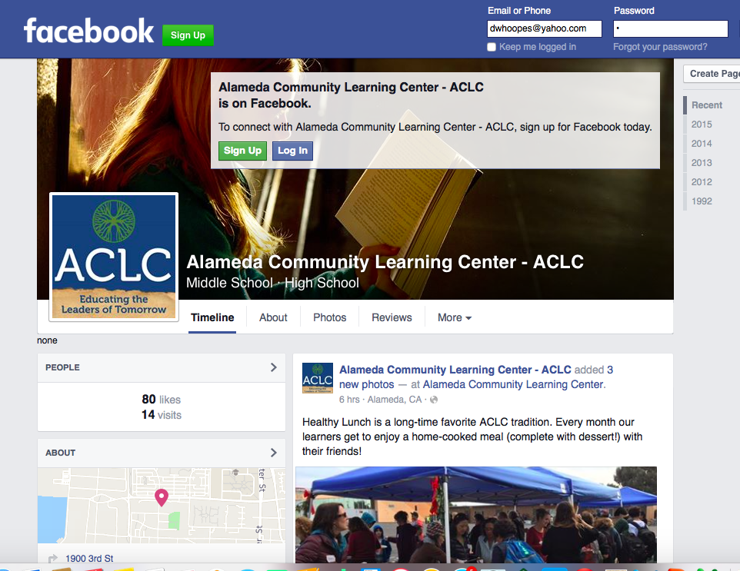

Staffing update
Heather Miles announced to learners that she will be transitioning to a different school for the second semester of her internship and student teaching. She will remain here for the next few weeks of first semester. Heather is proud of her work at ACLC and will continue her teaching as she completes her program in the new placement. Heather has worked closely with her supervisor at CSUEB and myself over the first semester and we are all in support of this transition.

In anticipation of this transition we posted and held interviews the week prior to break. We have hired Adriana Lombard to facilitate 8th grade science and 7th grade science at ACLC. Adriana taught at Roger Williams Middle School and Kipp S.F. prior to coming to ACLC for second semester. She visited, participated in interviews and was the unanimous selection on our interview panel. Our learners, parents and science facilitators felt she would be a fantastic fit. Her first day will be the 20th for planning, preparation, and on boarding. She will start facilitating the first day of second semester on January 25th.

I also wanted to update you that all of our 8th graders who assessed to Algebra have made that transition and CC3 classes now have under 16 learners. Marc Leone is working very well in CC3 classes. We are all very pleased with his implementation of CPM (College Preparatory Math) and his graceful entry to a difficult situation. Marc is re-teaching some critical concepts from early section and introducing newer common core aligned ideas. In observations he has been excellent. I also get great reviews from learners about his teaching.

Lock Down Reflection
ACLC had a lockdown procedure that went very well. In a few minutes, the entire campus was locked down. The Share 911 tool was a little glitch but all in all the lock down and share 911 made folks feel safer and clear about what to do.
Professional Development
Discussions with ACLC Faculty took place over the last two weeks during professional development. Dr. Franklin led groups of facilitators and staff through a reflective dialogue on the staff culture. Dr. Franklin will provide the staff with a report that will inform our future professional development.
ACLC hosted Navdeep Purewel from the Alameda County Office of Education for a Digital Library and Interim Assessment Clinic: The session provided information and guidance on both the Digital Library and Interim Assessments. The clinic addressed topics such as using formative assessment practices to support teaching and learning in the classroom, promoting use of the Digital Library in LEAs, and considerations in administering interim assessments and interpreting results. Facilitators practiced accessing the digital library of items.

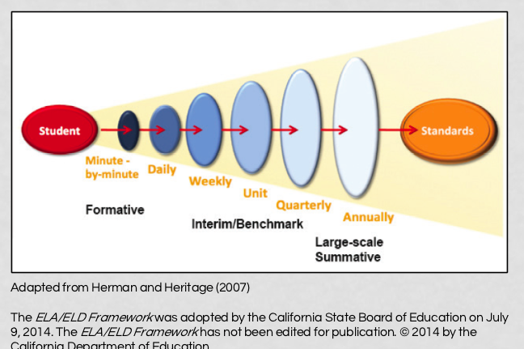

Job description review for LF and ALF
Patti, Lynne and I conducted a complete review of our job descriptions. We identified areas where we are overlapping and areas that needed clarification. The revisions were not significant but it provided us all with clarification of the LF and ALF circles of responsibility. It may be helpful for the Board to review these changes.

WASC School Action Plan update
WASC – WESTERN ASSOCIATION OF SCHOOLS and COLLEGES
WASC work is continuing with staff. Lynne Boone is leading this work along with the WASC Leadership team. In our last professional development day, facilitators established focus groups and began developing assignments and evidence tools for writing the report. The Leadership team has developed surveys and observation tools collect data. Focus groups began to grapple with the prompts and questions that are essential for writing the report.
We are using Drop Box for our assembly of documents and evidence. Currently the Leadership Team has three different self-study data gathering files. During the second semester, self-study data will be used to evaluate our progress on goals.

- Madeleine E. –Quantifiable
  - Parent Mid year surveys
  - Parent End Year surveys
  - PAC surveys
  - Culture surveys
  - Learners mid year surveys
  - Learner end year surveys
- Molly F. -Narrative survey
- Staff interviews (for NARRATIVE data)
  - Commitment to mission: The Alameda Community Learning Center is an educational model that empowers all youth to take ownership of their educational experience, to celebrate their diverse community, and to actively participate as members in a democratic society.
    - How do you demonstrate your commitment to ACLC’s mission in the classes you facilitate?
  - Investment in ACLC community
    - How do you get to know ACLC community members, outside of your classroom?
  - Traditions
    - What is your most valued ACLC tradition and why?
  - Openness to New Ideas
    - How often do you try new things (activities, texts, etc.) in your classroom? Where or from whom do you get new ideas?
  - Flexibility/Willingness to Take Risks
    - How has working at ACLC influenced your flexibility and willingness to take risks in the classroom?
- David H. Danny B.—Observable Data
  - Inter-visitation tracking
  - Questioning
  - Project planning tools
  - Project tracking tools
  - Student centered instruction
  - Class size tracker
  - Learner Engagement

Additional work is being done by Lynne Boone and myself to write the updated school profile. The profile includes student and community profile demographics, test results, governance and operations.

Enrollment Plans for ACLC
Immediate enrollment planning is moving forward. We started the year above enrollment targets and are now sitting at our budgeted enrollment number. In the past two years ACLC has been a little higher than our budgeted number at this time of the year. We have had strong turnouts at information nights thus far. We have picked up some applications for our immediate high school spots as a result of our open house and parent information nights.
    - ACLC will be sending another mailing in January to attract interest in our immediate high school spots as well as inviting folks to apply for next year.
    - ACLC will accept wait list learners for our middle school openings at semester.
    - ACLC will continue to hold information sessions and tours monthly to attract applicants in a timely manner. Monthly sessions are a significant commitment but this results in additional applications
    - ACLC will reach out to AOA for eighth grade information nights in January.
    - ACLC will be running advertisements to increase immediate interest. See attached

    - 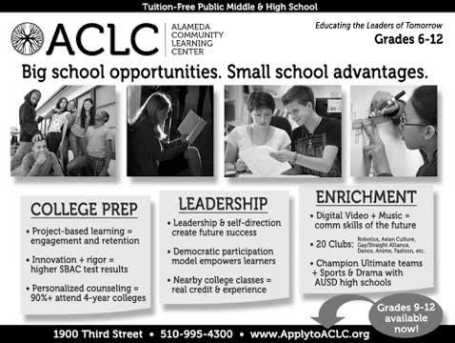
Suspensions and Expulsions
 | December 2015 | Trends
Expulsions | Zero | None
Suspensions by Grade Level | One Suspension | None

IEP and 504 update
 | December 2015 | Pending
504’s | 36 | 1
IEP’s | 31 | 2

