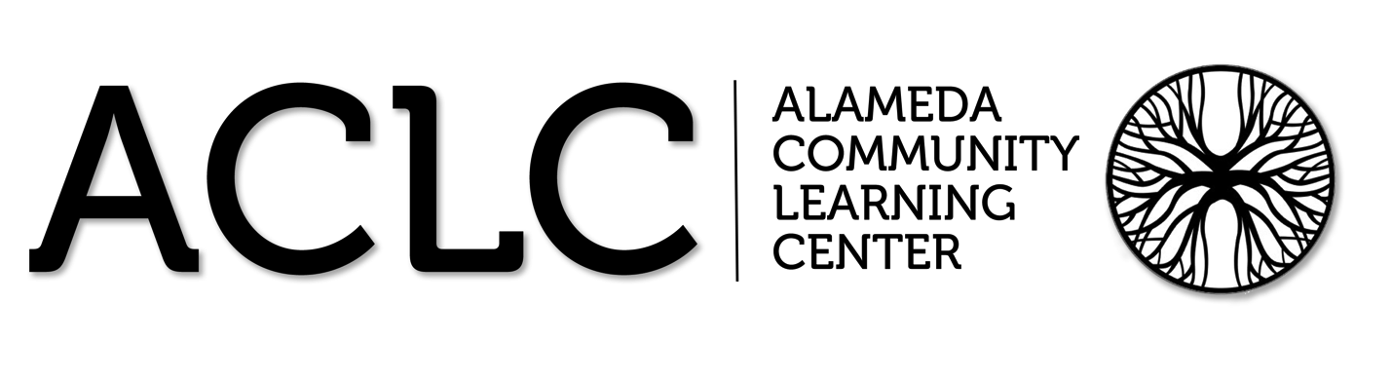

ACLC Lead Facilitator Report – David Hoopes
ACLC Board of Directors
January 17th, 2017

Great Schools update
I wanted to share that ACLC Great Schools rating has increased to a 10. This is largely due to our exceptional results on state testing. Thank you to our amazing facilitator team, our amazing parent community and learners for continuing to make ACLC great.
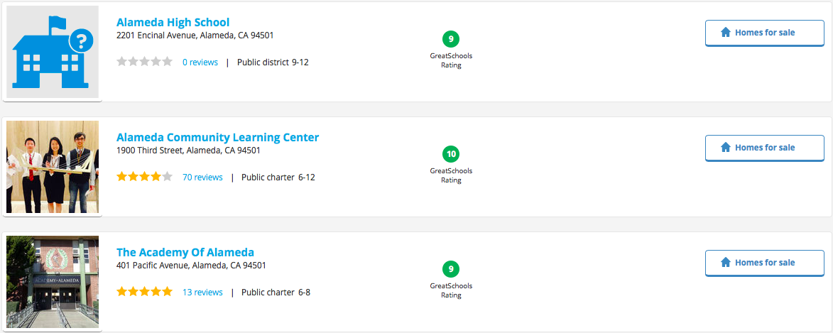
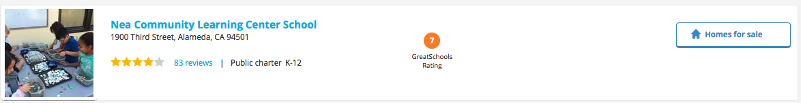

Learner Led Conference Update:
ACLC learners parents and staff participated in our fall Learner Led Conference. Conferences well held across the school during minimum days last week. The fall topic was selected by Leadership Learners as it is annually. I have provided the document for you to read and think about.
Learner-Led Conference Topic Fall Semester, 2016-2017
ACLC’s mission statement reads, in part, “The Alameda Community Learning Center is an educational model that empowers all youth to take ownership of their educational experience...” For your fall semester Learner-Led Conference, you will embody this part of the mission statement by teaching yourself a skill or concept of your choice during your free periods and/or outside of school from now until the end of fall semester.
REQUIREMENTS
Teach yourself a skill or concept
o Learn anything as long as it is safe and does not violate school rules. It could be something artistic, athletic, intellectual, practical, scientific, technological, etc. For example, write a short story, learn how to juggle or make cheesecake, teach yourself how to play a song on the guitar, or research a topic you have always wanted to learn more about. Pick something that interests you.
Present what you have learned at your LLC. Your presentation must include: o An artifact: a product that demonstrates what you learned. For example:
- ▪  A PowerPoint or other prepared presentation that teaches your LLC panel about the concept
- ▪  A demonstration or performance
- ▪  A portfolio or finished piece of artistic work or creative writing
- ▪  A website or computer program you create that your LLC panel can
interact with on school Chromebooks or personal devices
- ▪  Your artifact may not be anything you have submitted to a class for a grade. You are learning this skill or concept for you, not because a facilitator told you it would be on an assessment.
o A written reflection: describe the process of teaching yourself this particular skill or concept. How did you decide on it? What did you do to learn it? What can you do or do you know now that you could not do or did not know at first? How satisfied are you with your progress? Why? What challenges did you face?
Winter Warming Hut
On the last day of school before Winter Break at lunchtime ACLC and NEA's Upper Village shared some good cheer and celebrated everyone's hard work in this first part of the year. They were on the blacktop with the two schools sharing hot chocolate and treats. Caterer, Pacific Fine Food is once again generously donating hot cocoa and cider.

Thank you to all of the families for sharing baked goodies (lots of them) from our fabulous. The PAC event prepared 800 servings in all. This event was free to all youth and staff.

JC Elections Coming soon
If learners are interested in running to be a Judicial Committee Clerk you need to put your first and last name on a piece of paper along with the reason you would like to become a JC Clerk. To be placed on the ballot learners need to submit this paper to the JC box.

