ACLC Lead Facilitator Report – David Hoopes
ACLC Board of Directors
March 15th, 2016

2017 Pi Contest

Congratulations to Ayce mangapit (3nd Place), Lola Teeters (2nd Place), and Ben Dang (1st Place) for finishing in the top 3 of our Pi Contest. As you can see, they won a Pie. Ben set a record with over 350 digits. WOW!

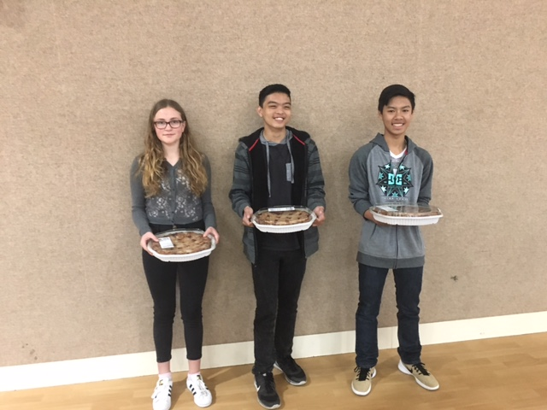
Lola Ayce Ben

ACLC Science Fair
ACLC learners participated in the Alameda County Science and Engineering Fair (ACSEF). These learners qualified to compete in this fair by winning first place at the ACLC Science Fair held in December. Learners spent the weekend talking to scientists and engineers about the science experiments they developed as part of their ACLC science classes. Learners came back from the experience with lots of enthusiasm and new insights for science.

11th grader Mai Corkins won 2nd place for her project titled: Secret Superpowers: Garlic Reveals Another Hidden Talent. When asked about why one should participate in the ACSEF, she said the interaction with scientists “opened up my mind to the possibility of being a scientist.”

Justin Kelly-Cahill asked the question: Do virtual reality goggles manipulate your feelings and make you feel unsafe? Justin said that going to the ACSEF allows “you to go into a lot more depth on your project.” Justin also said it was fun and that he would definitely would do it again.

Aidan Gleason won 2nd place for his Oil Spill Containment Apparatus. Aidan likes to share about his projects. Going to ACSEF was fun for him because he got to share again, and the fair is a big deal. He said that so often you do a project and then it’s all over. Keynote speaker, Sarah Richardson (Founder, Chief Scientific Officer, Ignition Genomics) impressed Aidan. Sarah gave a talk on how she uses DNA to train bacteria to do tricks.

This is Erika Badalyan’s 4th time going to ACSEF. She was awarded Honorable Mention for her project: Are All Chi Created Equal? Erika finds the experience good motivation for creating high quality work. She says the fair “ignites a fire” that helps young people figure out what they want to do with their future.

George Hofstetter and Luana Cardenas won Honorable Mention for their project they coded themselves called: Are You Safe? George said that the experience was “eye opening and perspective changing”. When asked how the experience was for her Luana said, “Reading about science doesn’t compare to seeing people your own age leaving their mark in science with you walking along with them.”

7th graders Deniz Akin and Morna Mandic won 2nd place for their project on Eco-Fertilizers. Deniz enjoyed the fair because “you get to look at everyone else’s projects and you learn a lot from that.” Deniz also said next time she would start earlier.

The following ACLC learners also participated:

• Nuriel Cahigas won Honorable Mention for his project titled: Hot Vs. Cold: How to Live Longer
• Katherine Kovach entered her project on Body Temperature and Blood Sugar
• Matthew Dang studied: Homemade Vs. Industrial: Comparing the Carbon Emission of Biodiesels
• Katherine Jensen was awarded Honorable Mention for her project on Hydration Station: The Most Absorbent Ratio of Soil to Orange and Avocado Peel Soil Additive
• Fiona Abrams-McCabe won Honorable Mention for, Powering a Cell Phone
• Gabrielle Bena quista and Parker Rose entered their project, Icky Ingredients
• William Noboe won Honorable Mention for his project on Cloudy with a Chance of Solar Power
• Kathy Su’s did a project on: Does Font Type Affect the Speed of Reading?
• Katie Angstadt-Leto entered her project on The Effect of Colors on Heart Rate
• Susanna Tsay entered her project titled: Overtones in an Acoustic Piano
• Michael Phan's project was titled: Sugar Crystal

Congratulations to all the ACLC Alameda County Science and Engineering Fair participants!!!

Preview of 17-18 Calendar
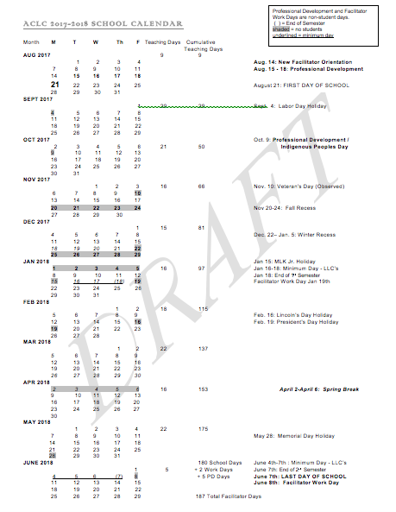

Chilly Cook Off: Please attend the Chili Cook Off
Enrollment Update:
- The following letters have gone out to invite accepted families to our ACLC Ice Cream Social. Our goal is to engage new families early and often so they know ACLC is their next home. This gives future learns an opportunity to become familiar with each other and the school. The CLCS Board is welcome to attend this event as well.
You Are Invited to ACLC’s New Learner Ice Cream Social
Dear New ACLC Parents and Learners,

Welcome to the ACLC family—we are thrilled to welcome such a wonderful group of families to the upcoming 2017-18 school year! We would like to invite you to attend our New Learner Ice Cream Social on Thursday, March 30th from 6:30 – 7:30 pm.

Several of you have already toured or shadowed at our school, but this will be our first opportunity to come together as a community. Facilitators and current ACLC learners will be at this event to answer your questions and lead games for your children. Also, our administration team will be on hand to welcome you, answer questions and support you in wrapping up final enrollment details.

This is a perfect opportunity to finish up the registration process. Before the Ice Cream Social, please complete your on-line registration by logging in to your SchoolMint account. If, under status, you see “Registration Completed” then you are all done with the online portion! If you need help completing the online portion, we will have staff at this event to assist you.

If you have not already turned in your hard copy documentation at the ACLC office, please bring the following documents with you to this event:

• Parent/Guardian Photo ID (or a copy of same)
• Your Learner’s Birth Certificate (or other proof of guardianship)
• TWO different recent Utility Bills from this list: Electricity, Gas, Garbage, or Water
• Your Lease/Rental Agreement or your Property Tax Statement for your home
• Learner Shots/Vaccination Records (Tdap is required for all learners 7th grade and above)
• Middle School and High School Transcripts (required for learners starting Grade 7 or above)

If you have decided not to attend ACLC, please log in to your SchoolMint account immediately to withdraw your child from ACLC or email our Admissions Director with your change of plans. This will help us finalize our enrollment lists, avoid confusion with enrollment at other schools, and offer the next family on our waitlist a spot in a timely manner.

I look forward to meeting each of you at the Ice Cream Social on Thursday, March 30th at 6:30 pm, and to getting to know you better during the upcoming school year. Thank you for choosing ACLC for your child!

Warmly,

David Hoopes
ACLC Lead Facilitator

Total Applications:
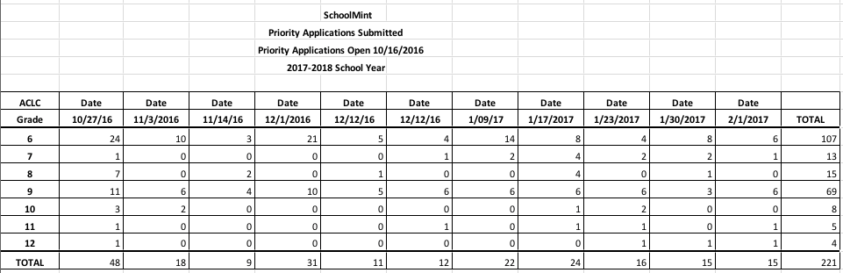

ACLC Intent to return data
The intent to return data is coming. The results here are typical. It is interesting to look at undecided and not returning numbers. Thus far, we have 4 not returning and 191 responses. We feel very good about that indicator.
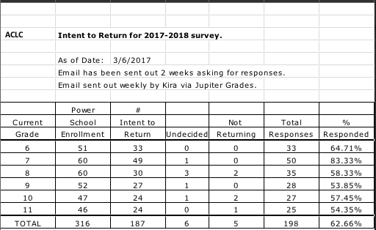

This is the letter being sent home to invite folks to participate.

Dear ACLC Parents,

As you may know, ACLC has started the enrollment process for the 2017-2018 school year. The priority application period closed on January 31, 2017 and the enrollment lottery was held on February 1. We have a wait list of families eager to find out whether there will be space for their learners at ACLC next year.

For our waiting families and for school planning purposes, please let us know whether your learner plans to attend ACLC next year by filling out our Intent to Return 2017-2018 form on the ACLC website. You will be able to respond with "yes", "no" or "undecided". If your learner's plans change, you can fill out the form again. You can find this form on the ACLC web site under the "Join Our Community" tab or by clicking this link:

www.clcschools.org/page.cfm?p=746&LockSSL=true

Committee Structure at ACLC
Working with the WASC Leadership team and ACLC, we have discussed better utilizing the committee structure to support our ongoing WASC and LCAP work. In working with the CLCS Administrative team we propose the following restructure:
Curriculum -> Curriculum -> (Staff stipend)
Personnel -> Personnel and Instruction -> (Lead Facilitator)
Program Evaluation -> School Culture and Support -> (Staff stipend)
Finance -> Finance and Organization -> (Executive Director)
Assessment and Accountability -> (Assistant Lead)

Below is the WASC Self Study school report framework
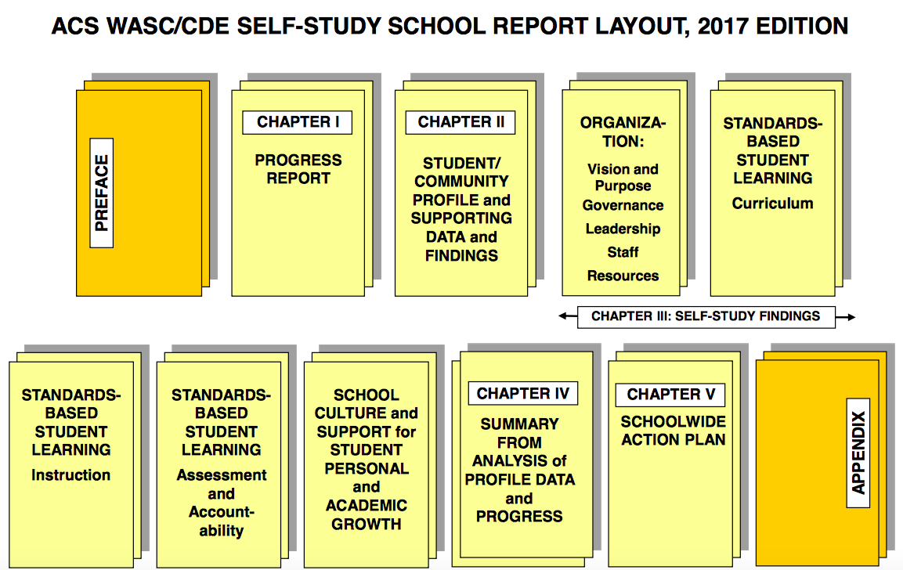

Local Control Accountability Plan (LCAP) Timeline:
Prior to July 1, 2017, the ACLC Governing Board and the CLCS Governing Board shall adopt a Local Control and Accountability Plan (LCAP) using a template adopted by the State Board, effective for 1-3 years with annual updates. It will include the ACLC’s annual goals for all learners and for each subgroup in regard to eight state priorities and any local priorities, as well as the plans for implementing actions to achieve those goals.
- January-April 2017: Develop proposed plan
- March and April 2017: Solicit recommendations and comments at ACLC Governing Board Meeting, CCC/L2L, PAC, staff meetings, and ACLC PAC meeting
- April and May: Revise plan based on stakeholder feedback
- May: Submit LCAP for adoption at ACLC Governing Board
- June: Submit LCAP for adoption at CLCS Board Meeting
- July: Submit LCAP to AUSD Board of Education for their records

8 State Priorities:
- Basic Services Providing all students with access to fully credentialed teachers in their subject areas, as well as instructional materials that align with state standards and safe, properly maintained school facilities.
- Implementation of State Standards Ensuring school programs and services enable all students, including English learners, to access California’s academic content and performance standards, including California’s State Standards for English language arts and math, Next Generation Science Standards and English Language Development Standards.
- Course Access Ensuring all students have access to a broad course of study in all required subject areas including math, social science, science, visual and performing arts, health, physical education, career and technical education and others, that prepares them for college and careers, regardless of what school they attend or where they live.
- Student Achievement Improving achievement and outcomes for all students as measured in multiple ways such as test scores, English proficiency and college- and career preparedness.
- Other Student Outcomes Measuring other important indicators of student performance in all required areas of study
- Student Engagement Providing students with engaging programs and course work that keeps them in school, as measured in part by attendance rates, dropout rates and graduation rates.
- Parent Involvement Efforts by the school district and schools to seek input from all parents, and to engage parents in decision-making, as well as promoting parent participation in programs that meet the needs of their students and all students. (See the PTA National Standards for Family-School Partnerships Assessment Guide for suggested ways to measure progress.
- School Climate Factors both inside and outside the classroom that impact student success such as health, safety, student discipline and school connectedness, as measured in part by suspension and expulsion rates, and surveys of students, teachers and parents.

Online Report Elements include:
- Focus Statement - 1-3 short sentences, state your focus in serving your students and community. Briefly explain how your LCAP demonstrates your LEA’s overall vision for student success.
- Key Objectives of LCAP - Identify and briefly summarize the key objectives of this year’s LCAP that are aligned with at least one of the 8 state priorities.
- Summary of Progress – Briefly describe how your progress on the focus areas has affected the development of the goals, actions/services, and expenditures described in this year’s LCAP.
- Increased or Improved Services – Identify two to three most significant ways that you will increase or improve services for low-income students, English learners, and foster youth.
- Greatest Progress – Based on a review of sate and local indicators of student performance included in the evaluation rubrics, local self-assessments, stakeholder input, or other information, what progress are you most proud of and how do you plan to maintain or build upon that success?
- The Greatest Needs – Referring to the LCFF Evaluation Rubrics, address any state or local performance indicator where overall performance was in the “Red” or “Orange” performance category or received a “Not Met for Two or More Years” rating. What steps are you planning to take to address these areas with the greatest need for improvement?
- Equity – Identify modifications to the goals, actions/services and/or expenditures within the LCAP to improve these performance levels.
- Budget Summary
- Annual Update

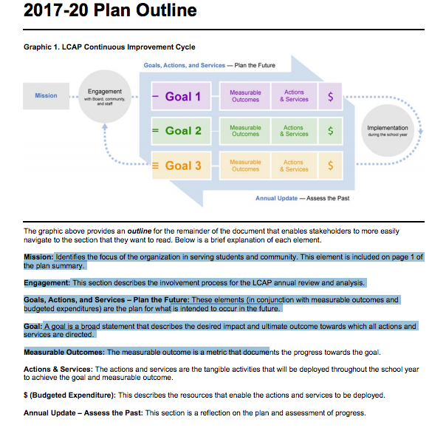

ACLC Proposed Goals: 16-17 Goals

GOAL: 1 | Goal 1 revised - Culture  Provide all parents and learners with an exceptional educational culture and expanded opportunities within our school and the wider public school system. |  |  |  |  |  |  | Related State and/or Local Priorities:
 |  |  |  |  |  |  |  | 1__ 2__ 3__ 4__ 5__ 6__ 7__ 8__
 |  |  |  |  |  |  |  | COE only: 9__ 10__
 |  |  |  |  |  |  |  | Local: Specify _____________________
Identified Need: |  | - Equity and fairness in the Judicial Committee process as seen in JC referrals and identified in parent feedback  - Increase emotional and academic support for learners  - Increase acceptance and equity across all stakeholder groups
Goal Applies to: |  | Schools: |  | Alameda Community Learning Center
 |  | Applicable Pupil Subgroups: |  |  | Traditionally underserved populations – Low income and targeted subgroups
LCAP Year 1: 2016-7
Expected Annual  Measurable Outcomes: |  |  | Increased graduation rates for target subgroups  Increased college acceptance rates  Increased Learner Participation in Leadership  Increased JC and proposal participation across the school  Decreased suspensions, detentions, expulsions, discipline contracts
Actions/Services |  |  |  |  |  | Scope of Service | Pupils to be served within identified scope of service |  | Budgeted  Expenditures
Increased access to academic counseling, peer mediation and emotional counseling |  |  |  |  |  | School wide | _x_ALL  ------------------------------------------------------------------------------------  OR:  _x_Low Income pupils _x_English Learners  _x_Foster Youth __Redesignated fluent English proficient __Other Subgroups:(Specify)________________________ |  | 7K College Advisor  14 K School Psychologist  12 K Family counseling
We will increase the effectiveness of our Judicial Committee for all learners. |  |  |  |  |  | School wide | x_ALL  ------------------------------------------------------------------------------------  OR:  _x_Low Income pupils _x_English Learners  _x_Foster Youth __Redesignated fluent English proficient __Other Subgroups:(Specify)________________________ |  | 4 hours of staffing for our JC facilitator
Increase electives and enrichment that compliment our program and engage a higher number of learners. |  |  |  |  |  | School wide | x_ALL  ------------------------------------------------------------------------------------  OR:  _x_Low Income pupils _x_English Learners  _x_Foster Youth __Redesignated fluent English proficient __Other Subgroups:(Specify)________________________ |  | Enrichment stipends = 9 K  Elective facilitator salary = 8 K

GOAL: 2 | Goal 2 revised - PD and Curriculum  Provide specific common core curriculum support and professional development for beginning and experienced facilitators. Professional growth opportunities will enable facilitators to better serve all learners |  |  |  |  |  |  | Related State and/or Local Priorities:
 |  |  |  |  |  |  |  | 1__ 2__ 3__ 4__ 5__ 6__ 7__ 8__
 |  |  |  |  |  |  |  | COE only: 9__ 10__
 |  |  |  |  |  |  |  | Local: Specify _____________________
Identified Need: |  | - We need to develop formative and summative assessments to know if students are learning. Specifically, to know if we are serving learners. WASC visiting committed identified this as a critical area of need for ACLC.  - The academic achievement gap as identified in STAR and GPA data.  - We need to develop formative and summative assessments to know if students are learning. Specifically, to know if we are serving learners. WASC visiting committed identified this as a critical area of need for ACLC.  - Facilitators need strategies to support learning and provide intervention.
Goal Applies to: |  | Schools: |  | Alameda Community Learning Center
 |  | Applicable Pupil Subgroups: |  |  | African American, ELL and Low Income Learners
LCAP Year 1: 2016-7
Expected Annual  Measurable Outcomes: |  |  | - Common Curriculum Professional Development Goals for facilitators and Lead Facilitator  - School wide Professional Development Goal  - SRI or Lexil for all learners at ACLC to be used in professional development  - Provide coaching every new facilitator to ACLC  - Develop criteria for an effective academic support strategies to support ELL, LI and FY and underserved learners  - Development of 3 formative assessments to know if students are learning. Specifically, to know if we are serving learners. WASC visiting committed identified this as a critical area of need for ACLC.
Actions/Services |  |  |  |  |  | Scope of Service | Pupils to be served within identified scope of service |  | Budgeted  Expenditures
Identify and recruit outside professional to deliver training to support ACLC facilitators with PBL and supporting ELL and other traditionally underserved learners in project work. |  |  |  |  |  | School wide | _x_ALL  ------------------------------------------------------------------------------------  OR:  _x_Low Income pupils _x_English Learners  _x_Foster Youth __Redesignated fluent English proficient __Other Subgroups:(Specify)________________________ |  | Expenditure: 4K from professional development budget  Buck Institute PD training for new Facilitators  ELL position to .2 (8K) FTE.  2K for workshops in Illuminate assessment
Develop formative and summative assessments to track progress of learning in classes. |  |  |  |  |  | School wide | x_ALL  ------------------------------------------------------------------------------------  OR:  _x_Low Income pupils _x_English Learners  _x_Foster Youth __Redesignated fluent English proficient __Other Subgroups:(Specify)________________________ |  | Expenditure: 3K for sight license of assessment tool  Expenditure: $500 Power School consulting to pull demographic and support data
Create a successful after school Academic Support model that identified and supports Learners of concern |  |  |  |  |  | School wide | x_ALL  ------------------------------------------------------------------------------------  OR:  _x_Low Income pupils _x_English Learners  _x_Foster Youth __Redesignated fluent English proficient __Other Subgroups:(Specify)________________________ |  | none

GOAL: 3 | - Increase learning opportunities and achievement for all pupils, with special emphasis on expanded learning experiences for pupils who historically are academically low achieving. |  |  |  |  |  |  | Related State and/or Local Priorities:
 |  |  |  |  |  |  |  | 1_x_ 2_x_ 3_x_ 4_x_ 5_x_ 6_x_ 7_x_ 8_x_
 |  |  |  |  |  |  |  | COE only: 9__ 10__
 |  |  |  |  |  |  |  | Local: Specify _____________________
Identified Need: |  | - Achievement gap identified in GPA and STAR result  - Increase learner achievement by building facilitator capacity to differentiate and support learning directly in the classroom  - WASC visiting committee identified a clear need for additional Data need to improve intervention  - Increase learner achievement through greater parent awareness of and involvement in learner’s academic performance and development of an academic support system for all learners.
Goal Applies to: |  | Schools: |  | Alameda Community Learning Center
 |  | Applicable Pupil Subgroups: |  |  | Traditionally underserved populations – Low income and targeted subgroups
LCAP Year 1: 2016-7
Expected Annual  Measurable Outcomes: |  |  | Increase in LLC parent participation  Increase Family Forum, PAC and Back to School Night Attendance  GPA Increase  College Acceptance Rates  Attendance Rates  Parent Education Events  Academic Support Participation  Retention Rates  Increase academic achievement for Foster Youth, ELL and Low Income learner  Program Evaluation survey participation
Actions/Services |  |  |  |  |  | Scope of Service | Pupils to be served within identified scope of service |  | Budgeted  Expenditures
Improve on the quality and implementation of MTSS supports and interventions for struggling learners scoring not college ready, and/or GPA of less than 2.0 |  |  |  |  |  | School wide | __ALL  ------------------------------------------------------------------------------------  OR:  _x_Low Income pupils _x_English Learners  _x_Foster Youth _x_Redesignated fluent English proficient __Other Subgroups:(Specify)__x_academically underperforming_ |  | Expenditure: 5K from professional development budget for facilitator coaching and training  Expenditure: 3K for training on assessment and data analysis  Expenditure: 2K for workshops in Illuminate assessment to utilize benchmark tools
Develop system of supports and interventions to strengthen and inspire academic engagement across the school for the target populations and learners who are academically low achieving. Examples include:  - Bevy groups  - Cultural affinity groups (BSU or Asian Culture club)  - MAS – More Academic Support  - ELL support  - Small support groups  - PD for differentiation  - PD for Positive Behavior Management  - MTSS |  |  |  |  |  | School wide | __ALL  ------------------------------------------------------------------------------------  OR:  x_Low Income pupils _x_English Learners  _x_Foster Youth _x_Redesignated fluent English proficient __Other Subgroups:(Specify)___academically underperforming_ |  | Bevy and clubs budget of 10K to support engagement across the school  Expenditure: K from professional development budget for facilitator coaching and training in Positive Behavior Management and differentiation  ELL support of a .2 FTE (8) staffing role

GOAL: 4 | Goal 4 revised - Instruction  - ACLC will utilize progressive instructional methods to excel on measurable learner outcomes that exceed AUSD results. We will encourage the use of different and innovative teaching methods (PBL, Socratic, CPM, technology integration and others). |  |  |  |  |  |  | Related State and/or Local Priorities:
 |  |  |  |  |  |  |  | 1__ 2__ 3__ 4__ 5__ 6__ 7__ 8__
 |  |  |  |  |  |  |  | COE only: 9__ 10__
 |  |  |  |  |  |  |  | Local: Specify _____________________
Identified Need: |  | - Increase engagement and deeper learning at ACLC during project time  - Increase classroom engagement by increasing real world application of skills
Goal Applies to: |  | Schools: |  | Alameda Community Learning Center
 |  | Applicable Pupil Subgroups: |  |  | All learners
LCAP Year 1: 2016-7
Expected Annual  Measurable Outcomes: |  |  | - Increase in projects that include more than one subject area  - Increase in classroom engagement as measured by facilitator inter-visitations  - Adopted project tools and best practices to create successful projects  - PD Agendas will reflect presentation of best projects for facilitators and share milestones and assessments in professional development
Actions/Services |  |  |  |  |  | Scope of Service | Pupils to be served within identified scope of service |  | Budgeted  Expenditures
Two projects per class will incorporate concepts and content integrated with additional classes |  |  |  |  |  | School-wide | _x_ALL  ------------------------------------------------------------------------------------  OR:  __Low Income pupils __English Learners  __Foster Youth __Redesignated fluent English proficient __Other Subgroups:(Specify)________________________ |  | 3K new facilitator CPM training and updating  25K for technology upgrades and improvement  5k in professional development for new facilitator PD on PBL
Adopt project tools and formative assessments practices to create successful projects and measure learning. |  |  |  |  |  | School-wide | _x_ALL  ------------------------------------------------------------------------------------  OR:  __Low Income pupils __English Learners  __Foster Youth __Redesignated fluent English proficient __Other Subgroups:(Specify)________________________ |  | 2K for workshops in Illuminate assessment

Mid Year Parent Survey
